**Web-based Reservation Management System for Flash Reception Hall**

**P. B. D. Kumaranathunge**

**June 2024**

**Web-Based Reservation Management System for Flash Reception Hall**

**Name: P. B. D. Kumaranathunge**

**IM Number: IM/2017/042**

**Name of the Client: Flash Reception Hall**

**Name of the Supervisor: Dr. Chathura Rajapaksa**

**June 2024**

**This interim report is submitted in partial fulfillment of the requirement of the**

**Degree of B. Sc. Management and Information Technology of the**

**University of Kelaniya.**

# ABSTRACT

A recently opened venue called Flash Reception Hall offers two functional halls for special occasions such as weddings, birthdays, meetings, launches, and other parties. It is operated by a team of around 10 permanent employees. However, the current process relies on manual paper-based methods, which present several challenges that need to be addressed. These challenges include difficulty in tracking availability and bookings, inefficient communication with customers, limited data analysis capabilities, problems in managing payment and customer information, and errors or delays in the booking process that need to be overcome. To address these challenges, a web-based reservation management system has been implemented at Flash Reception Hall. The system includes modules for customer management, reservation management, employee management, report generation, user management, menu and services management, package management, and supplier record management. These modules address issues such as tracking availability and bookings, managing customer information, managing payments, and analyzing data more accurately and efficiently than the current method. This web-based reservation management system has been developed using a variety of technologies, including HTML, CSS, and Bootstrap 5 for design and styling, PHP for server-side scripting, JS, jQuery, and AJAX for dynamic and responsive elements, and NetBeans as the IDE. During the development phase, the system was hosted locally using the WAMP server, and MySQL was utilized as the DBMS. The utilization of these technologies enabled the development of an effective web-based reservation management system. The modern waterfall method has been used as the process model of system development after considering various aspects. The project is expected to be completed within the allocated timeline, with anticipated significant benefits in terms of improved customer experience and more efficient operations for Flash Reception Hall. The proposed system has been able to finish successfully and also received overall positive feedback from the client.

# Table of Content

ABSTRACT iii

Table of Content iv

List of Figures vi

List of Tables x

Chapter 01 – Introduction 1

1.1. Project Motivations 1

1.2. Project Objectives 3

1.3. Project Scope 4

1.4. Outline of the Dissertation 7

Chapter 02 –Analysis 8

2.1. Explaining the Current System Using Flow Chart 8

2.1.1. Explaining the Current System Using Flow Chart 8

2.1.2. Explaining the Current System Using Use Case Diagram 9

2.2. Review of Similar Systems with References 9

2.1.1. Website of Sanora Restaurant and Pub 9

2.1.2. Online Hotel Reservation and Booking Management System of Hotel Javson 10

2.1.3. Website of Jetwing Hotels 10

2.1.4. Comparison Between the Similar Systems and the Proposed System 12

2.3. Identifying the Functional and Non-Functional Requirements 13

2.3.1. Functional Requirements 14

2.3.2. Non-Functional Requirements 18

2.4. Justification for the Choice of the Development Life Cycle 19

Chapter 03 – Design 20

3.1. Comparison of Alternative Design Strategies 20

3.1.1. Standalone System 20

3.1.2. Web-based Reservation Management System 20

3.1.3. Mobile App-based Solution 20

3.2. Justification for the Selected Design Strategy 20

3.3. Architectural Design of the System 20

3.1.1. Use Case Diagrams for the Proposed System 21

3.1.2. Use Case Narratives of the Identified Use Cases 25

3.1.3. Activity Diagrams for the Use Cases 73

3.1.4. Database Design 104

3.4. User Interface Design 105

Chapter 04 – Implementation 110

4.1. Implementation Environment 110

4.1.1. Software Environment 110

4.1.2. Hardware Environment 113

4.2. Module Structure 113

4.3. Important Code Segments 114

4.4. Reuse of the Existing Codes 120

4.5. Implementation of the Design 125

4.6. Use of Best Practices 131

Chapter 05 – Evaluation 133

5.1. Testing approaches 133

5.2. Test Plan 133

Chapter 6 - Conclusion 143

6.1. Critical evaluation of the system 143

6.2 Future Work 143

6.3. Lessons learned 144

Appendices 145

Appendix A - System Manual 145

Appendix B - User Manual 147

Appendix C - Management Reports 150

Appendix D – Test Result 152

References 155

# List of Figures

Figure 2. 1: Current System as a Flow Chart 8

Figure 2. 2: Current System as a Use Case Diagram 9

Figure 2. 3: Reservation Form from Sanora Restaurant Website 9

Figure 2. 4:Admin Dashboard from Javson Hotel System 10

Figure 2. 5:Reservation Request form from Jetwing Hotels website 11

Figure 2. 6:Check Availability form from the Jetwing Hotels website 11

Figure 2. 7:Modern Waterfall Process Model 19

Figure 3. 1:Use Case Diagram for Customer 21

Figure 3. 2:Use Case Diagram for Booking Manager 22

Figure 3. 3:Use Case Diagram for Receptionist 23

Figure 3. 4:Use Case Diagram for Director and Hall Manager 23

Figure 3. 5:Use Case Diagram for Accountant 24

Figure 3. 6:Activity Diagram for Customer Registration and Login: 73

Figure 3. 7:Activity Diagram for View Hall in System User 74

Figure 3. 8:Activity Diagram for View Hall in Website 74

Figure 3. 9:Activity Diagram for View Package Details in Website 75

Figure 3. 10:Activity Diagram for View Menu Item in System 75

Figure 3. 11:Activity Diagram for View Menu Item in Website 75

Figure 3. 12:Activity Diagram for View Payment History 76

Figure 3. 13:Activity Diagram for View Menu Package in System 76

Figure 3. 14:Activity Diagram for View Reports 77

Figure 3. 15:Activity Diagram for View Refund Payment 77

Figure 3. 16:Activity Diagram for View Reservation Update Request 78

Figure 3. 17:Activity Diagram for View Reservation History 78

Figure 3. 18:Activity Diagram for View Services in System 79

Figure 3. 19:Activity Diagram for View Services in Website 79

Figure 3. 20:Activity Diagram for View Reservations in System 79

Figure 3. 21:Activity Diagram for View User 80

Figure 3. 22:Activity Diagram for Add New Employee 80

Figure 3. 23:Activity Diagram for Add New Menu Item 81

Figure 3. 24:Activity Diagram for Add New Hall 81

Figure 3. 25:Activity Diagram for Add New Service 82

Figure 3. 26:Activity Diagram for Add New Package 82

Figure 3. 27:Activity Diagram for Approve or Reject Reservation Update Requests 83

Figure 3. 28:Activity Diagram for Add New User 83

Figure 3. 29:Activity Diagram for Approve or Reject Refund Payment Requests 84

Figure 3. 30:Activity Diagram for Change Password 85

Figure 3. 31:Activity Diagram for Cancel Reservation 85

Figure 3. 32:Activity Diagram for Confirm or Reject Reservations 86

Figure 3. 33:Activity Diagram for Check Hall Availability 86

Figure 3. 34:Activity Diagram for Login 87

Figure 3. 35:Activity Diagram for Hall Arrangements 87

Figure 3. 36:Activity Diagram for Make Reservation - Part 1 88

Figure 3. 37:Activity Diagram for Issue Refund Payments 88

Figure 3. 38:Activity Diagram for Make Reservation - Part 2 89

Figure 3. 39:Activity Diagram for Make Payment 89

Figure 3. 40:Activity Diagram for Make Reservation - Part 4 90

Figure 3. 41:Activity Diagram for Make Reservation - Part 3 90

Figure 3. 42:Activity Diagram for Register as a Customer 91

Figure 3. 43: Activity Diagram for Make Reservation - Part 5 91

Figure 3. 44:Activity Diagram for Request Refund Payments 92

Figure 3. 45:Activity Diagram for Reply to Customer Reviews 92

Figure 3. 46:Activity Diagram for Request Reservation Update - Part 2 93

Figure 3. 47:Activity Diagram for Request Reservation Update - Part 1 93

Figure 3. 48:Activity Diagram for Reset Password 94

Figure 3. 49:Activity Diagram for Update Customer Payment 95

Figure 3. 50:Activity Diagram for Submit a Review 95

Figure 3. 51:Activity Diagram for Update Employee 96

Figure 3. 52:Activity Diagram for Update Customer Profile 96

Figure 3. 53:Activity Diagram for Update Package 97

Figure 3. 54:Activity Diagram for Update Menu Item 97

Figure 3. 55:Activity Diagram for Update Hall 97

Figure 3. 56:Activity Diagram for Update User 98

Figure 3. 57:Update Service 98

Figure 3. 58:Activity Diagram for View Approved Refund Payments 99

Figure 3. 59:Activity Diagram for Verify Received Customer Payments 99

Figure 3. 60: Activity Diagram for View Customer Payments 100

Figure 3. 61:Activity Diagram for View Customer Details 100

Figure 3. 62:Activity Diagram for View Customer Review 101

Figure 3. 63:Activity Diagram for View Customer Profile 101

Figure 3. 64: Activity Diagram for View Employee 102

Figure 3. 65:Activity Diagram for Making a Reservation 103

Figure 3. 66:Entity Relationship Diagram for Proposed System 104

Figure 3. 67:Customer Registration Form 105

Figure 4. 1:Component Diagram for New Reservation Management System 113

Figure 4. 2:Code of the Login Authentication in System 114

Figure 4. 3:Code of the Customer Registration in the System - part 1 115

Figure 4. 4:Code of the Customer Registration in the System - part 2 116

Figure 4. 5:Code of the Checking Availability of Hall 117

Figure 4. 6:Capturing Event Details of a Reservation 118

Figure 4. 7:Capturing the Selection of Package for the Reservation 118

Figure 4. 8:Capturing Additional Item Requirements for the Reservation 119

Figure 4. 9: Clean Input Function 120

Figure 4. 10:dbConn Function 120

Figure 4. 11:Upload Files Function 121

Figure 4. 12:Validate Password Function 122

Figure 4. 13:Function for Text Field Validating 122

Figure 4. 14:Function for Contact Number Format Validation 123

Figure 4. 15:Function for Validate the Format of an Email 123

Figure 4. 16: Function for Validating NIC 123

Figure 4. 17: Function for Get the Fields Updated by the User 124

Figure 4. 18:Function for Generating a Random Password 124

Figure 4. 19:Wireframe of the Login Form 125

Figure 4. 20:Implemented UI for the Login 125

Figure 4. 21:users Entity in the ER Diagram 126

Figure 4. 22:Database table for the users 126

Figure 4. 23:Wireframe for the Dashboard of Booking Manager 127

Figure 4. 24:Implemented Dashboard for the Booking Manager 127

Figure 4. 25:Add Form of the Menu Items 128

Figure 4. 26:Implemented UI for the Add Form of the Menu Items 129

Figure 4. 27:Implemented UI for the Menu Item View 129

Figure 4. 28:Menu Item Table in the Database 130

Figure 4. 29:Menu Item Entity in the ER Diagram 130

Figure 4. 30:Line Indentations in Code 131

Figure 4. 31:Meaningful Naming Convention Practice Used in a Function 131

Figure 4. 32: Meaningful Naming Convention Used in Variable Definition 132

Figure 4. 33:Commenting Used in the Code of Login Page 132

Figure 5. 1:User Evaluation Form - Director 135

Figure 5. 2:User Evaluation Form - Booking Manager 136

Figure 5. 3:User Evaluation Form - Hall Manager 137

Figure 5. 4:User Evaluation Form - Accountant 138

Figure 5. 5:User Evaluation Form - Receptionist 139

Figure 5. 6:User Evaluation Form - Customer 1 140

Figure 5. 7:User Evaluation Form - Customer 2 141

Figure 5. 8:Client Certificate 142

Figure B. 1:Login Form 147

Figure B. 2:Landing Page of the Booking Manager 147

Figure B. 3:Package View Page 148

Figure B. 4:Create New Package Page 148

Figure B. 5:Update Package Page 149

Figure C. 1:Total Registered Customer Report 150

Figure C. 2: Canceled Reservations Report 150

Figure C. 3: Total Income Report of Flash Reception Hall 150

# List of Tables

Table 2. 1: Comparison between similar systems and the proposed system 12

Table 2. 2: Details of the Interviews Held 13

Table 2. 3: Functional Requirements for the Proposed System 14

Table 2. 4: Prioritization and Justification of Functional Requirements 18

Table 2. 5:Non - Functional Requirements for the Proposed System 18

Table 3. 1:Use Case Narrative for Login 26

Table 3. 2:Use Case Narrative for Reset Password 27

Table 3. 3:Use Case Narrative for Change Password 29

Table 3. 4:Use Case Narrative for Register as a Customer 31

Table 3. 5:Use Case Narrative for View Profile 32

Table 3. 6:Use Case Narrative for Edit Customer Profile 33

Table 3. 7:Use Case Narrative for Check Hall Availability 34

Table 3. 8:Use case Narrative for Add New Menu Item Category 35

Table 3. 9:Use Case Narrative for Add New Menu Item 37

Table 3. 10:Use Case Narrative for Creating New Menu 39

Table 3. 11:Use Case Narrative for Add New Service 40

Table 3. 12:Use Case Narrative for Creating a New Package 42

Table 3. 13:Use case Narrative for Browse Packages 42

Table 3. 14:Use case Narrative for Place a Reservation 44

Table 3. 15: Use Case Narrative for Upload an Image of a Pay Slip 45

Table 3. 16:Use Case Narrative for Verify Customer Payment 46

Table 3. 17:Use Case Narrative for Add Customer Payment 47

Table 3. 18:Use case Narrative for Register a New Supplier 49

Table 3. 19:Use case Narrative for Add New Hall 51

Table 3. 20:Use case Narrative for Add New Employee 52

Table 3. 21:Use Case Narrative for Add New User Role 54

Table 3. 22:Use Case Narrative for Create a New User Account 55

Table 3. 23:Use Case Narrative for View Customer Details 56

Table 3. 24:Use Case Narrative for View Hall Details 56

Table 3. 25:Use Case Narrative for View Menu Item Details 57

Table 3. 26:Use Case Narrative for View Menu Item Category Details 58

Table 3. 27:Use Case Narrative for Package Details 58

Table 3. 28:Use Case Narrative for View Menu Details 59

Table 3. 29:Use Case Narrative for View Services Details 59

Table 3. 30:Use Case Narrative for View Supplier Details 60

Table 3. 31:Use Case Narrative for View Reservations 61

Table 3. 32:Use Case Narrative for View Employee Details 61

Table 3. 33:Use Case Narrative for View Customer Payments 62

Table 3. 34:Use Case Narrative for Create an Arrangement Plan 64

Table 3. 35:Use Case Narrative for Create a Purchase Order 65

Table 3. 36:Use Case Narrative for Define/Approve Supplier Payments 67

Table 3. 37:Use Case Narrative for View Approve Supplier Payments 67

Table 3. 38:Use Case Narrative for Make Supplier Payments 69

Table 3. 39:Use Case Narrative for View Supplier Payments 70

Table 3. 40:Use Case Narrative for View User Details 70

Table 3. 41:Use Case Narrative for View Roles 71

Table 3. 42:Use Case Narrative for Provide Customer Reviews 71

Table 3. 43:Use Case Narrative for View Customer Reviews 72

Table 5. 1:Test Plan for Login 134

Table 5. 2:Test Plan for Register Customer Form 134

Table A. 1:Hardware Requirements 145

Table A. 2:Software Requirements 145

Table D. 1:Test result for Login 153

Table D. 2:Test Results for Register Customer Form 154

# Chapter 01 – Introduction

In this chapter, an introduction will be provided to explore the motives behind developing a web-based system for the Flash Reception Hall. The objectives expected to be achieved through the proposed system will be discussed, along with specifications of the project scope in and out of limits covered by the developed system. Furthermore, the overall result and impact of the system on the business environment will be examined, and a brief outline of the dissertation will be presented.

## Project Motivations

Flash Reception Hall provides exceptional service and experiences to customers as a recently established banquet and reception venue. However, its operations rely on a paper-based manual process, limiting efficiency, accuracy, and growth potential. Major flaws have been identified in the current system, including:

1. **Inefficient and time-consuming processes** – Manual processes in reception halls require more resources and can be inefficient compared to digital systems. Physical storage space for paper records takes up valuable office space and requires careful organization. Manual data entry is time-consuming and prone to errors. These inefficiencies result in delays, inaccuracies, and difficulties in retrieving and updating information.
2. **Increased fuel and transport costs** – Multiple visits to the venue for reservations, amendments, and payments pose an additional expense, and inconvenience, and reduce flexibility for customers, potentially leading to slight dissatisfaction. Moreover, customers incur increased costs due to high fuel prices and transportation fares resulting from the country's economic situation.
3. **Higher risk of errors** - Errors can occur in manual processes due to human error or illegible handwriting, leading to misinterpreting reservation details, incorrect or incomplete records, missed reservations, or inaccurate payment records.
4. **Limited accessibility** - Information retrieval from paper-based records can be cumbersome and time-consuming, leading to missed opportunities and customer dissatisfaction.
5. **Difficulty in scaling** - Manual processes are challenging to scale based on demand. If the reception hall’s operations expand or the volume of reservations increases, the manual system might struggle to handle the growing workload effectively, resulting in delays in reservations, inquiries, or amendments, difficulties in managing customer data, and lost business opportunities. Scaling up becomes a complex task, requiring additional resources, reorganization, and potentially disruptive changes to keep up with the growing demand.
6. **Inadequate security** - Paper-based records can be lost, damaged, destroyed, or stolen, leading to a loss of confidential customer or business information, and unauthorized access to critical and sensitive data could easily occur.
7. **Lack of data analysis and limited reporting** - Paper-based manual systems cannot often generate comprehensive reports and perform effective data analysis. This limitation hinders the reception hall's ability to gain insights into crucial aspects of the business, such as sales, revenue, and customer preferences. The absence of robust reporting capabilities hampers decision-making processes and restricts the identification of booking patterns and trends necessary for informed business decisions. Without proper reporting and analysis, the reception hall may miss out on growth opportunities and fail to optimize its operations effectively.
8. **Limited customer engagement and communication** – Paper-based systems may lack automated communication features, such as confirmation emails or reminders, which can impact customer satisfaction and engagement.

## Project Objectives

The development of a reliable and efficient web-based reservation management system is the primary goal of this project, intending to streamline business processes, enhance customer satisfaction, and increase the overall competitiveness of the business in the market. The following specific objectives have been identified for the project:

1. Automate various management processes, such as customer, reservation, employee, user, payment, menu, service, supplier, and package management.
2. Improve efficiency, accuracy, and ease of managing reservations and payments.
3. Increase customer satisfaction by providing easy and efficient reservation, package, service, and payment options.
4. Increase employee productivity by automating processes and reducing manual effort.
5. Improve data accuracy and reliability for better decision-making.
6. Reduce costs associated with manual data entry and storage.
7. Offer a competitive advantage with a modern, web-based reservation management system.
8. Eliminate time-consuming paper-based work procedures.
9. Ensure reliable communication between stakeholders.
10. Enable validated and automated data entry to avoid errors.
11. Enhance security features to improve data security and privacy.
12. Improve reporting processes.
13. Reduce the possibility of data losses.
14. Improve the efficiency and effectiveness of reservation processes.
15. Guide staff members to achieve the business's maximum potential.

## Project Scope

The objectives mentioned earlier will be achieved through the following components that are included in the scope of the project:

1. **Customer Management:** A customer management system with registration and login functionality is included in the project. Accounts can be created by customers, personalized information can be accessed, and reservations and payments can be conveniently accessed. The customer management capabilities are enhanced by this enhancement, ensuring a seamless and personalized experience throughout their interactions with the reservations of the reception hall.
2. **Reservation Management:** The project will encompass a robust reservation management module that will enable customers to have their reservations checked for availability, reservations placed, reservation update requests made, and reservations canceled. Flexibility will be offered to customers for requesting updates or modifications to their existing reservations, as well as conveniently canceling reservations if necessary. Real-time synchronization of reservation data will be ensured by the system, allowing efficient management and allocation of resources based on confirmed reservations by the reception hall.
3. **Package Management:** The project includes a comprehensive package management module that allows the reception hall to create various packages based on event types and affordability, including menu packages and services. The reception hall has the flexibility to edit and modify existing packages, adjusting package inclusions as needed. This enables the reception hall to tailor packages to meet specific customer needs and preferences, enhancing the overall customer experience. Within the project scope, it will not be providing a customizable package creation option at the customer end for the moment.
4. **Menu Management:** The reception hall will be enabled by the menu management module to create, update, and view menu packages. An interface will be provided by the system for the easy creation of fixed menu packages, and define customizable menu packages including the name, list of menu items, and specification of price. Flexibility will be given to the reception hall to adapt menu packages to changing culinary trends, seasonal availability, or customer preferences, with features for the addition of new menu items, modification of existing items, and adjustment of prices.
5. **Service Management:** The reception hall will be enabled to create, update, and view services by the service management module. Flexibility will be given to the reception hall for adapting services to seasonal availability or customer preferences, with features for adding new service items, modifying existing items, and adjusting prices.
6. **User Management:** The project will include a user management component that allows the reception hall to define roles and access levels for different users. This includes features like creating and managing user accounts, setting permissions, and ensuring secure access to the system based on user roles.
7. **Record Customer Payments:** This functionality will be incorporated into the project to record and manage customer payments. This involves capturing payment details, associating payments with specific reservations, and maintaining a comprehensive payment history for each customer. Integration of the online payment gateway to this module will not be covered within the project scope.
8. **Record Customer Payment Refunds:** The project will feature functionality to record and manage customer payment refunds. This includes capturing refund details, associating refunds with specific transactions or reservations, and maintaining a record of refund history for each customer.
9. **Record Supplier Details:** The project will involve a supplier management module that allows the reception hall to maintain a database of supplier details. This includes recording supplier contact information and managing vendor relationships. The supplier will not be considered as a user in the system so the supplier directly would not be engaged with the system to maintain his profile within the selected scope of the project.
10. **Record Supplier Payments:** This functionality will be incorporated into the project to record and manage supplier payments. This involves capturing payment details, associating payments with specific services, and maintaining a comprehensive payment history for each supplier.
11. **Record Employee Details:** This component will provide the capability to maintain employee records, including personal information, and contact details. In this module, the employee schedules, attendance, performance evaluation, and payroll parts are excluded from the scope.
12. **Generate Reports:** This component will allow the business to generate reports to aid business analysis and decision-making. This includes generating daily, weekly, monthly, and annual reports on income, expenses, revenue, etc. These will allow management to track business performance.

The present work introduces a novel approach to online reservation processes by implementing a web-based system that actively involves customers in the booking process. Through extensive background research, it was found that such a customer-centric online reservation system has not been widely adopted by reception halls in the region, with most establishments relying on third-party online booking sites.

The implemented system, designed specifically for the Flash Reception Hall, has yielded significant positive outcomes. The effectiveness of the system was evaluated through rigorous testing and evaluation methodologies. To gather valuable feedback, a questionnaire was administered to users who had experienced the new reservation process. Their responses provided crucial insights into the user experience, highlighting the system's advantages and areas for further enhancement.

The findings underscore the transformative impact of the implemented web-based system, demonstrating its potential to revolutionize the reception hall industry in Sri Lanka and deliver exceptional value to both customers and the business.

## Outline of the Dissertation

1. **Chapter 2 – Analysis**

An analysis of the current processes within the business will be presented in this chapter, which will include a literature review on similar systems in the context. The techniques used for requirement gathering to identify both functional and non-functional requirements will also be discussed. Furthermore, the selected process model for system development will be introduced.

1. **Chapter 3 – Design**

In this chapter, a summary of alternative design strategies will be provided, and data modeling diagrams will be used to illustrate the system's structure and the user interface designs.

1. **Chapter 4 – Implementation**

A detailed account of the system implementation process will be provided in this chapter, including explanations of the module interactions within the system. The incorporation of best practices during implementation will also be discussed.

1. **Chapter 5 – Evaluation**

The evaluation chapter will outline the testing plan, present the test results achieved throughout the project, and include an analysis of user acceptance testing. A comprehensive summary of the overall impact and effectiveness of the system will be offered.

1. **Chapter 6 – Conclusion**

The achievements and failures encountered during the development process will be summarized in the conclusion chapter. Suggestions for future enhancements to the system will be provided, and any limitations that were encountered will be discussed.

1. **Appendices**

Additional relevant details about the project that are not covered in the main chapters but are essential for understanding the development process will be included in the appendices.

# Chapter 02 –Analysis

Before the development of a new system is commenced, a thorough study must be conducted on the current process flow and similar systems utilized in the present context. The identification of strengths and weaknesses inherent in the existing process and systems is enabled through this background research. Such understanding becomes particularly valuable when the proposed system is designed as it allows strengths to be leveraged while weaknesses are mitigated or eliminated. The initial step in the development of a new system involves the identification of crucial requirements that need to be addressed. In this chapter, an overview of the current system will be provided, similar systems will be reviewed with the proposed system, the techniques used for gathering functional and non-functional requirements will be described along with the gathered requirements, and the selected process model for the development of the proposed system will be outlined.

## Explaining the Current System Using Flow Chart

### Explaining the Current System Using Flow Chart

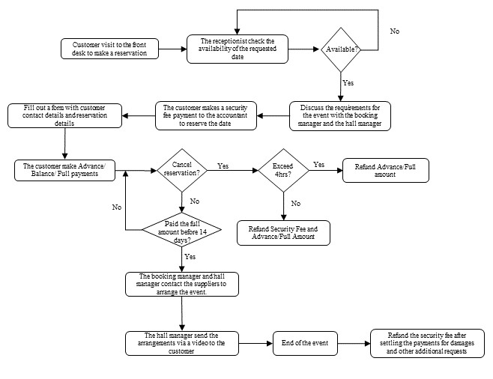

Figure 2. 1: Current System as a Flow Chart

### Explaining the Current System Using Use Case Diagram

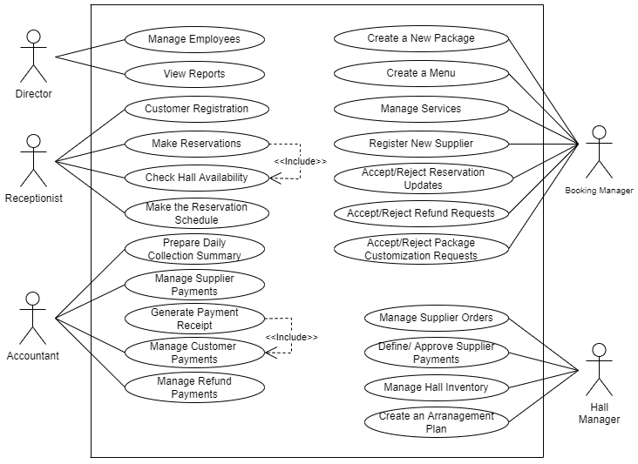

Figure 2. 2: Current System as a Use Case Diagram

## Review of Similar Systems with References



### Website of Sanora Restaurant and Pub

Figure 2. 3: Reservation Form from Sanora Restaurant Website

A multi-cuisine family restaurant located in Colombo. A single-page website is maintained by them to introduce their services and enable customers to make reservations for their special occasions. The content provided is simple and focused. However, real-time availability checking is not offered, and customers are not allowed to make menu and service decisions at the time of reservation. Furthermore, visual content for menu items and services that can be requested by customers is not provided. The facility for customers to register and maintain their profiles for making reservations and payments is also not available. [1]

### Online Hotel Reservation and Booking Management System of Hotel Javson

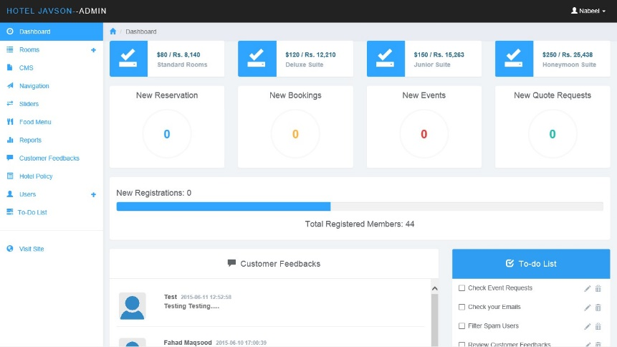This system has a website that contains informative content about the hotel’s features offered to the customer. It is enabling customers to create an account and maintain a reservation history of their reservations. The customers could get instant confirmation on their reservations and bookings. It also enables customers to make their payments through the payment gateway which was a limitation in our project. Overall, the system has been established to provide customers with a better reservation experience, enable employees to manage all services efficiently and effectively, and allow management to make better decisions by analyzing various reports generated through the system. [2]

Figure 2. 4:Admin Dashboard from Javson Hotel System

### Website of Jetwing Hotels

One of the largest hotel chains in the Sri Lankan context is represented by this establishment. Local and international hotels, as well as villas around Sri Lanka, are possessed by Jetwing. Facilities for holding events and accommodation are being provided by them. An informative website is maintained by them, which encompasses every aspect of the questions that could be posed by a customer. Additionally, a real-time availability checking option is offered to guests seeking accommodation. However, a real-time availability checking option for event reservations has not been provided by them. Instead, a form is offered for sending reservation requests. Nevertheless, within our system, the implementation of this feature has been proposed. A highly user-friendly system is in place. Furthermore, an online payment gateway has been provided to them, enabling customers to make payments via an online gateway. It is important to note that this falls outside the scope of the current project. [3]

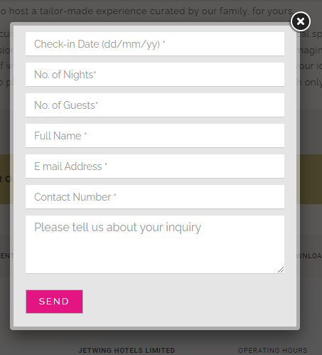

Figure 2. 5:Reservation Request form from Jetwing Hotels website



Figure 2. 6:Check Availability form from the Jetwing Hotels website

### Comparison Between the Similar Systems and the Proposed System

|  |  |  |  |  |
| --- | --- | --- | --- | --- |
| **Features** | **Sanora Restaurant and Pub (System 1)** | **Hotel Javson (System 2)** | **Jetwing Hotels**  **(System 3)** | **Flash Reception Hall (Proposed System)** |
| Customer Management | 🗶 | ✓ | 🗶 | ✓ |
| Reservation Management | ✓ | ✓ | ✓ | ✓ |
| Package Management | 🗶 | 🗶 | ✓ | ✓ |
| Menu Management | ✓ | ✓ | ✓ | ✓ |
| Services Management | ✓ | ✓ | ✓ | ✓ |
| Hall Management | ✓ | ✓ | ✓ | ✓ |
| Employee Details Management | 🗶 | 🗶 | 🗶 | ✓ |
| User Management | ✓ | ✓ | ✓ | ✓ |
| Supplier Details Management | 🗶 | 🗶 | 🗶 | ✓ |
| Supplier Orders Details Management | 🗶 | 🗶 | 🗶 | ✓ |
| Supplier Payment Detail Management | 🗶 | 🗶 | 🗶 | ✓ |
| Customer Payment Details Management | 🗶 | 🗶 | ✓ | ✓ |
| Customer Payment Refund Details Management | 🗶 | 🗶 | ✓ | ✓ |
| Customer Review and Inquiry Management | ✓ | ✓ | ✓ | ✓ |
| Report Generation | 🗶 | ✓ | ✓ | ✓ |

Table 2. 1: Comparison between similar systems and the proposed system

## Identifying the Functional and Non-Functional Requirements

It is important to choose the requirement-gathering techniques wisely. Because it helps to understand the requirements and the expectations of the system. As for this system, I used the following techniques to grasp the requirements for the system.

1. **Interviews**

This was the most efficient and effective way of collecting the requirements while directly interacting with the client. A few interviews were conducted with the booking manager to understand the business process.

|  |  |  |  |
| --- | --- | --- | --- |
| **Date** | 31st of October 2023 | 15th of November 2023 | 16th of February 2024 |
| **Duration** | 45 minutes | 1 hour | 45 minutes |
| **Interviewees** | Ms. Asma Rismy | Ms. Asma Rismy | Ms. Asma Rismy |
| **Position** | Booking Manager | Booking Manager | Booking Manager |
| **Purpose** | To gather information about the business process and collect requirements | To clear some ambiguous points of the process and sign the agreement form. | To get some resources and discuss some issues |
| **Conducted** | Onsite | Onsite | Onsite |

Table 2. 2: Details of the Interviews Held

1. **Document Sampling**

The paper-based process is full of documenting work such as form-filling and bookkeeping. By referring to those documents it helps to identify the useful inputs that can be used for reporting purposes.

1. **Background Research**

The background research was carried out with some similar systems in the industry and it helps to capture some more requirements and also gave some ideas about how should be some operations performed in the system.

The system will be used by customers, the owner, the booking manager, the hall manager, the accountant, and the receptionist. Real-time updates and engagement will be carried out by the system. The following are the identified requirements during the analysis.

### Functional Requirements

Following are the major functional requirements identified through the above techniques.

|  |  |
| --- | --- |
| **No** | **Requirement** |
| 1. | Shall be able to log in to the System. |
| 2. | Shall be able to register, view, and update the details of the customers. |
| 3. | Shall be able to check the availability of the required date, time, and venue. |
| 4. | Shall be able to make, view, update the details of the reservations, and cancel existing reservations. |
| 5. | Shall be able to add, view, and update the records of customer payments. |
| 6. | Shall be able to make, update and view details of the event schedules. |
| 7. | Shall be able to create, view, and update details of the packages. |
| 8. | Shall be able to add, view, and update details of the menus. |
| 9. | Shall be able to add, view, and update details of the menu items. |
| 10. | Shall be able to add, view, and update details of the services. |
| 11. | Shall be able to add, view, and update details of the supplier orders. |
| 12. | Shall be able to add, view, and update records of supplier payments. |
| 13. | Shall be able to generate receipts and invoices relevant to the received and issued payments. |
| 14. | Shall be able to register, view, and update the details of the suppliers. |
| 15. | Shall be able to add, view, and update details of the employees. |
| 16. | Shall be able to add, view, and update details of the user accounts. |
| 17. | Shall be able to add, view, and update details of the halls. |
| 18. | Shall be able to generate management reports such as income report, profit report, expenses report, reservation report and customer report etc. |
| 19. | Shall be able to send necessary notifications such as reservation placement notification, payment received notification, reservation confirmation notification, reservation cancellation notification etc. |
| 20. | Shall be able to track the guest count using a QR code at the entrance. |

Table 2. 3: Functional Requirements for the Proposed System

|  |  |  |  |
| --- | --- | --- | --- |
| **No** | **Module** | **Priority** | **Justification** |
| 1. | Customer Management | High | Allowing the online registration for customers, reduce the need for physical visits required by the existing system. Data accuracy is improved, personalized services are enabled, and communication with customers is also enhanced. The business can be positively impacted by time-saving, improved efficiency, and enhanced customer satisfaction over the existing system with this module. |
| 2. | Check Availability | High | Allowing the customers to check the availability beforehand making a reservation is reducing the customers’ dissatisfaction and it is more convenient for them than visiting the venue or contacting the reception hall through the phone. |
| 3. | Reservation Management | High | By enabling online reservations to be made, update requests to be sent, reservation history to be viewed, and let bookings to be canceled through the system, The need for customers to visit the hall is reduced, and they are provided with more control over their reservations, resulting in improved efficiency and a better customer experience. |
| 4. | Package Management | High | Easy creation, editing, and removal of pre-defined packages are allowed by this. The business is positively impacted by time savings, increased productivity, and improved customer satisfaction through tailored experiences. |
| 5. | Menu Management | Medium | Easy creation, editing, and removal of pre-defined menus are allowed by this. The business is positively impacted by time savings, increased productivity, and improved customer satisfaction through tailored experiences. |
| 6. | Services Management | Medium | Easy creation, editing, and removal of services are allowed by this module. The business is positively impacted by time savings and increased productivity. |
| 7. | Menu Item Management | Low | Easy creation, editing, and removal of menu items are allowed by this module. The business is positively impacted by time savings and increased productivity. |
| 8. | Customer Payment Management | High | Customers are allowed to pay the amount and upload the bank slip or transfer slip through the payment form in the system instead of sending it through social media or paying in cash at the venue. The business is positively impacted by reducing the possibility of losing data and improving customer convenience compared to the current manual paper-based system. |
| 9. | Supplier Management | Medium | This module allows the storage of supplier details, updating information, and viewing records. It is well-organized and easily accessible within the system. The business is positively impacted by the facility to do timely updates to the records and filtering through the records resulting in improved efficiency |
| 10. | Supplier Order Management | High | Storing supplier order details that were confirmed and received allows rapid access to them via advanced filtering options. Rather than searching through a pile of documents written it is more efficient with the system. |
| 11. | Supplier Payment Details Management | High | Storing supplier payment details allows rapid access to them and also it could be easily used for reporting purposes. Reducing the risk of losing or misplacing data also has a positive impact on the business transaction process. |
| 12. | Hall Management | Low | The hall details can be added, updated, and viewed through the system. In the case of building a new hall, the details can be entered into the system and instantly make available to the customers to reserve. If renovations are done and any of the new facilities were added or removed it can also be updated instantly. |
| 13. | Employee Management | Medium | Keeping the records of employees is important for a business. The system provides an easy registration process through this module and also allows the information to be changed. It allows an advanced search function to access data rapidly. |
| 14. | User Management | High | The employees and the customer would be the users of the system who will perform their tasks. But there should be privilege management towards the users unless the information security might be under threat like in the paper-based process. |
| 15. | Generate Reports | High | The reporting process is a very important function in a system. A business needs to be aware of its day-to-day transaction processes. While analyzing data in a manual paper-based system is messy and difficult, we could allow the users to generate a wide range of reports from the system that could be useful to make decisions. |
| 16. | Send Notifications | High | Same as in the manual system customers and staff should be attentive to the changes and important details so that system will provide a notification system to be alerted the users instantly. |
| 17. | Event Scheduling Management | High | This will provide information about the processing of a reservation. Being able to view these arrangements related to their reservations customers will also be delighted. |

Table 2. 4: Prioritization and Justification of Functional Requirements

### Non-Functional Requirements

|  |  |  |
| --- | --- | --- |
| **No** | **Requirement** | **Justification** |
| 1. | User-friendliness | A clear guide through the functionalities of the system is provided to users. Tooltips and placeholders are included within the data-entering forms to assist in understanding and engaging with the system. The user-friendliness of the system has been measured to be at an acceptable level by the user evaluation process. A user satisfaction score of more than 7/10, a task success rate of at least 99%, and a learning time of less than 3 hours for a system user and less than 15 minutes for a customer are expected. |
| 2. | Reliability | The system must be made dependable. The minimization of system errors and downtimes should be addressed. Error situations throughout the process can be handled with the current resources by informing users about the issue through the delivery of appropriate error messages. The Mean Time Between Failures (MTBF) is expected to be 6 months to 1 year, and the Mean Time to Repair (MTTR) is expected to be less than 1 hour. Additionally, the availability of the system is expected to be 99%. |
| 3. | Usability | Easy navigation, efficient performance of functionalities, and access to relevant information are provided through the system. The Sidebar contains every module that can be accessed by users, and navigation is displayed using breadcrumbs. A usability score of more than 7/10 is expected. |
| 4. | Portability | The system has been developed according to the responsive concepts of the website, ensuring perfect accessibility via different devices. It is expected that compatibility with all browsers will be achieved, with a focus on Chrome, Edge, Firefox, and Safari. |
| 5. | Security | Authorization for all users is provided by the system through the provision of separate user accounts, and the management of privileges is done according to their role in the system. Sensitive data like passwords are protected through the use of encryption. A trusted hosting provider is expected to be used, and with these processes, a 99.9% secure environment is anticipated. |
| 6. | Response Time and Processing Time | The response time of the system is expected to be less than 10 seconds. To achieve this, steps such as the minimization of nested loops and nested conditions will be undertaken during the system implementation. Additionally, optimization techniques and performance tuning will be applied to ensure efficient processing and rapid response times. |
| 7. | Scalability | The adaptability of the system to future amendments required by business expansion is ensured. Additionally, it is anticipated that the handling capacity of up to 500 concurrent users will be supported. |

Table 2. 5:Non - Functional Requirements for the Proposed System

## Justification for the Choice of the Development Life Cycle

The modern waterfall process model was chosen for the web-based reservation management system project based on the analysis that compared it with other process models such as agile and iterative models. It is more structured and sequential and provides a clear framework for software development, with each stage building upon the previous one. Projects with clear and well-understood requirements, such as a web-based reservation management system, are particularly suitable for this model. Additionally, the modern waterfall model incorporates feedback loops and iterative development cycles, making it more adaptable and collaborative than the traditional waterfall model while still retaining the benefits of its structured and systematic approach. This flexibility allows adjustments and refinements during the development process, ensuring that the system can adapt to future amendments and changes. It is also an excellent choice for large-scale software development projects where requirements are well-defined, and changes are not expected to occur frequently. Overall, the project will be delivered on time, within budget, and with a high degree of accuracy and reliability due to the balance between structure and flexibility provided by the modern waterfall process model. [4]

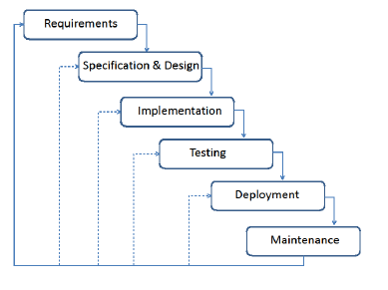

Figure 2. 7:Modern Waterfall Process Model

# Chapter 03 – Design

## Comparison of Alternative Design Strategies

### Standalone System

A standalone system is an alternative design strategy for a reception hall management system that can be operated without an internet connection. However, upfront costs for hardware and software licenses may be higher, and they may not offer the same level of flexibility and scalability as cloud-based solutions.

### Web-based Reservation Management System

A web-based reservation management system can be used by the reception hall to manage reservations, resources, and customers through a web interface. Efficiency, accuracy, and customer experience can be improved with the use of a web-based reservation management system.

### Mobile App-based Solution

A mobile app-based reservation management system can allow the reception hall to manage reservations, events, resources, and customers through a mobile device interface.

## Justification for the Selected Design Strategy

A web-based system has been selected as the most suitable design strategy for Flash Reception Hall's reservation management system. Compared to a standalone or mobile-app-based system, more flexibility, scalability, and accessibility are offered by the web-based system.

## Architectural Design of the System

The non-object-oriented architecture was chosen for the project, as it was deemed more suitable than other architectural designs. And also, the non-object-oriented architecture was considered to be more compatible with the project's existing infrastructure, saving time and resources. [5]

### Use Case Diagrams for the Proposed System

Figure 3. 1:Use Case Diagram for Customer

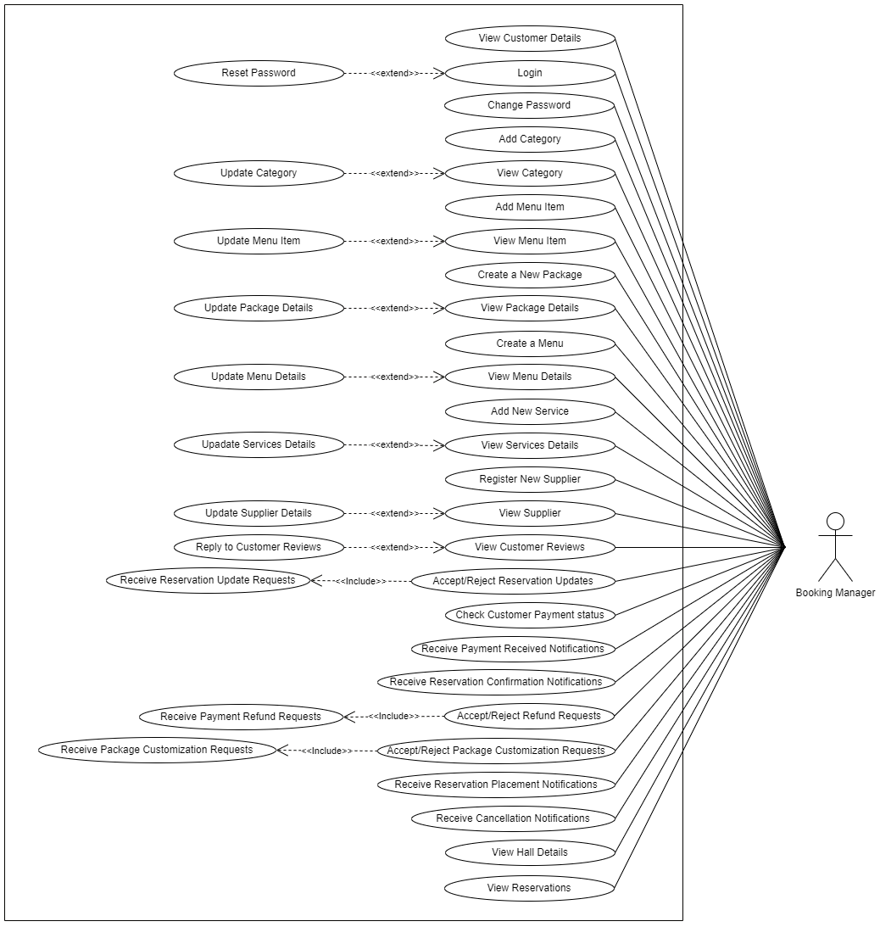

Figure 3. 2:Use Case Diagram for Booking Manager

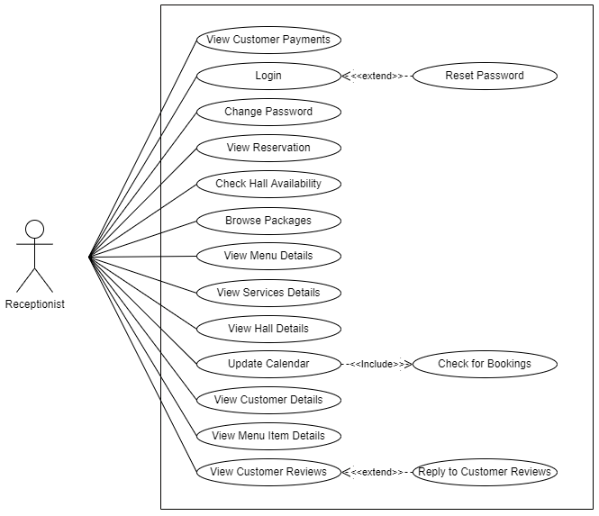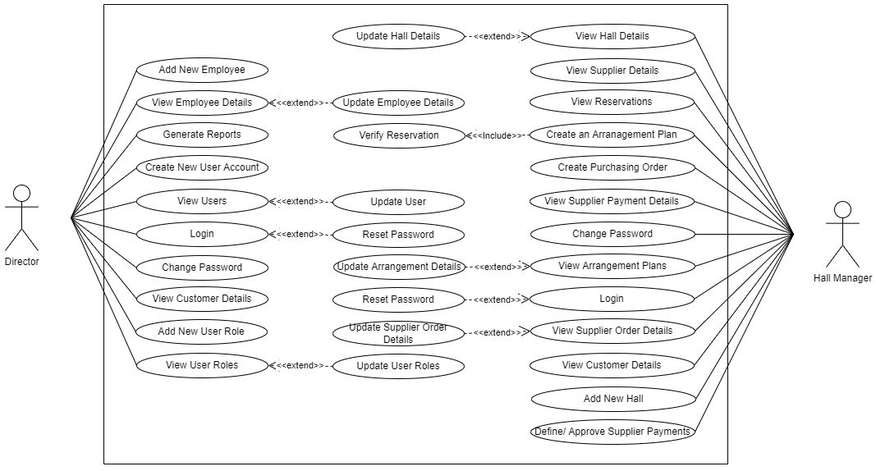

Figure 3. 3:Use Case Diagram for Receptionist

Figure 3. 4:Use Case Diagram for Director and Hall Manager

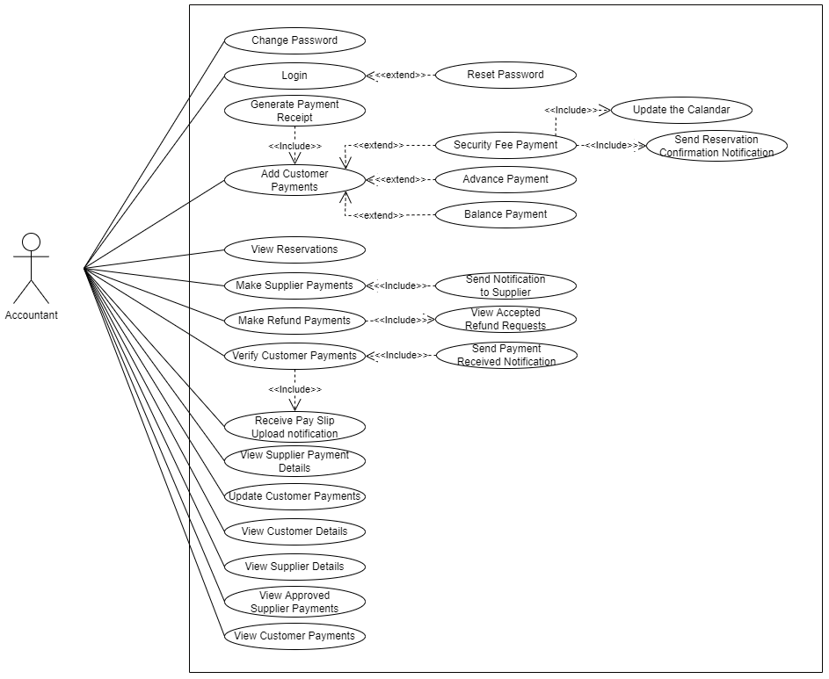

Figure 3. 5:Use Case Diagram for Accountant

### Use Case Narratives of the Identified Use Cases

|  |  |  |
| --- | --- | --- |
| **1. Use case Narrative for Login** | | |
| **Use case Number** | UC-01 | |
| **Use case Name** | Log in to the System | |
| **Priority** | High | |
| **Actors** | Customer, Owner, Operations Manager, Hall Manager, Accountant, Receptionist | |
| **Description** | This use-case indicates how the users can log in to the system. | |
| **Pre - Conditions** | The user must have registered in the system. | |
| The user must have a valid username and a password. | |
| **Post - Conditions** | If the user entered valid credentials user should be directed to the relevant user account with privileged access to the functionalities and features. | |
| If the user entered invalid credentials, the user should be redirected to the login page to prompt to retry. | |
| **Basic Course of Action** | **User Action** | **System Response** |
| 1. User opens the web browser and navigates to the login page of the reservation management system. | 2. The system loads the login page with a form consisting of fields to enter username and password. |
| 3. User enters a username and a password in the appropriate fields. | 5. Check if the username field is filled. |
| 4. User clicks on the "Login" button. | 6. Check if the password field is filled. |
|  | 7. System validates and verifies the credentials with the system database. |
|  | 8. If the credentials are authenticated, load the main dashboard of the relevant user account. |
|  | 9. Display the message "Successfully Logged in or Welcome [Name]!!!" |
|  | 10. User successfully logged into the system. |
|  | 11. End of the use case |
| **Alternate Course of Action** | 3.1. If the user forgets the password, click on the "Forget password?" link to proceed with the "Reset Password" use case. | |
| 3.2. If the user wants to remember his login credentials, then tick on the "Remember me" checkbox to save the credentials in the browser. | |
| 5.1. If the username field is empty, display the message "Username Cannot be Empty" and return to step 3 of the basic course of action. | |
| 6.1. If the password field is empty, display the message "Password Cannot be Empty" and return to step 3 of the basic course of action. | |
| 7.1. If the system is unable to connect to the database, display the message "Try Again Later." | |
| 8.1. If the credentials are not authenticated, redirect to the login page, display the message "Invalid username or password" and return to step 3 of the basic course of action. | |
| 8.2. If the user attempts multiple invalid logins temporarily deactivate the account. | |
| 8.3. If the user account has been deactivated, display the message "Account has been deactivated" | |

Table 3. 1:Use Case Narrative for Login

|  |  |  |
| --- | --- | --- |
| **2. Use case Narrative to Reset Password** | | |
| **Use case Number** | UC – 02 | |
| **Use case Name** | Reset Password | |
| **Priority** | High | |
| **Actors** | Customer, Director, Operations Manager, Hall Manager, Accountant, Receptionist | |
| **Description** | This use-case indicates how a user can reset their current password to a new password in case of forgetting the current password. | |
| **Pre - Conditions** | The user must have registered in the system. | |
| The user should have access to the email registered in the system. | |
| **Post - Conditions** | Users could log into the system with the new password. | |
| **Basic Course of Action** | **User Action** | **System Response** |
| 1. User clicks on the "Forgot Password?" link on the login page. | 2. Load the password reset page with a field to enter the email address. |
| 3. Enter the email address into the field provided. | 5. Check if the email exists in the system. |
| 4. User clicks on the "Send Password Reset Link" button. | 6. If the email exists, send a password recovery link to the email. |
| 7. Click on the recovery link in the email. | 8. Load the password reset page with two fields to enter a new password and confirm it. |
| 9. Enter the new password and confirm it in the appropriate fields. | 11. Check if the value entered in the new password field isn't the same as the current password in the database. |
| 10. Clicks on the "Reset Password" button. | 12. Check if the new password is satisfying the required password length and complexity. |
|  | 13. If the new password matches the expected format check whether the values entered in the two fields are identical. |
|  | 14. If the values are identical then encrypt the password and update the database. |
|  | 15. Redirect to the login page or login into the account. |
|  | 16. User successfully resets the password. |
|  | 17. End of the use case. |
| **Alternate Course of Action** | 6.1. If the email doesn't exist in the database display the message "Email hasn't registered" and return to step 3 of the basic course of action. | |
| 6.2. If the user attempts multiple invalid requests temporarily disable the account. | |
| 6.3. If the system is unable to send the password recovery email, the system displays the message "Password reset request failed" | |
| 7.1. If the user didn't receive the email, display the message "If you didn't receive the email, check your spam folder and then resend the email if necessary." | |
| 11.1. If the value entered in the new password field is the same as the current password in the database display message "New Password Cannot be same as the Current password" | |
| 12.1. If the value entered in the new password field doesn't satisfy the required length and complexity, display the message "Invalid Password. Password should be more than 8 characters, including letters, numbers, and special characters" and return to step 9 of the basic course of action. | |
| 13.1. If values entered in both password fields aren't identical display the message "Password doesn't match" and return to step 9 of the basic course of action. | |

Table 3. 2:Use Case Narrative for Reset Password

|  |  |  |
| --- | --- | --- |
| **3. Use case Narrative to Change Password** | | |
| **Use case Number** | UC – 03 | |
| **Use case Name** | Change Password | |
| **Priority** | Low | |
| **Actors** | Customer, Director, Operations Manager, Hall Manager, Accountant, Receptionist | |
| **Description** | This use-case indicates how a user can change their current password to a new password. | |
| **Pre - Conditions** | The user should be logged into the system. | |
| **Post - Conditions** | The user password is successfully updated. | |
| **Basic Course of Action** | **User Action** | **System Response** |
| 1. User clicks on the "Change Password" link on the dropdown menu. | 2. Loads the change password page with the form for changing the password. |
| 3. Fill out the form with relevant details. (Current Password, New Password, Confirm Password) | 5. Verify the value entered as the current password with the existing password in the database. |
| 4. Click on the "Change Password" Button. | 6. Check if the new password is not the same as the current password. |
|  | 7. Check if the new password is satisfying the required password length and complexity. |
|  | 8. If the new password met the requirements check if both values are entered in the new password and confirm password fields are identical. |
|  | 9. If the current password matches the existing password and the values entered in the new password and confirm password fields are identical then update the database. |
|  | 10. Display the message "You have successfully changed the password". |
|  | 11. Redirects to the login page or return to the dashboard. |
|  | 12. Password has successfully changed. |
|  | 13. End of the use case. |
| **Alternate Course of Action** | 5.1. If the value entered in the current password field doesn't match the existing password in the database display the message "Current Password is Incorrect". | |
| 6.1. If the value entered in the new password field is the same as the current password in the database display message "New password cannot be same as the current password" | |
| 7.1. If the value entered in the new password field doesn't satisfy the required length and complexity, display the message "Invalid Password. Password should be more than 8 characters, including letters, numbers, and special characters" and return to step 8 of the basic course of action. | |
| 8.1 If the values entered in the new password field and confirm password field is identical display the message "Password doesn't match". | |

Table 3. 3:Use Case Narrative for Change Password

|  |  |  |
| --- | --- | --- |
| **4. Use case Narrative for Register as a Customer** | | |
| **Use case Number** | UC – 04 | |
| **Use case Name** | Register as a Customer | |
| **Priority** | High | |
| **Actor** | Customer | |
| **Description** | This use-case indicates how a new customer can create an account in the system. | |
| **Pre - Conditions** | The customer should have an accessible email. | |
| **Post - Conditions** | Create a new account or profile. | |
| The customer should be able to log in to the system using the created username and password. | |
| **Basic Course of Action** | **User Action** | **System Response** |
| 1. Click on the "Register" link on the website or the login page. | 2. System loads the customer registration page with the customer registration form. |
| 4. Fill out the form with relevant details. (Title, Name [First Name, Last Name], Contact Number [Mobile Number, Land Number], Email, NIC, Address, username [same as email/user defined], password, Accept/Agree to the privacy policy and terms and conditions). | 3. System auto-generates the customer registration number [Customer_No] in the form. |
| 5. Click on the "Register" button | 6. Check if the required fields are filled. |
| 11. Check the entered details and click on confirm button. | 7. Validate the entries with the expected formats. (Contact Number, Email, NIC) |
| 14. Clicks on the confirmation link in the email. | 8. Check if the client is already existing. (Using NIC, Email, and Contact Numbers, Username) |
|  | 9. If all required fields are filled, the values are according to the expected formats, and the customer doesn't already register then display the message of confirmation. |
|  | 10. Encrypt the password. |
|  | 12. If confirmed, save details in the database. |
|  | 13. Send a confirmation email to the provided email. |
|  | 15. Create a user profile and direct customers to the registration page. |
|  | 16. Display the message "Successfully Registered" with the registration number. |
|  | 17. Redirect to the empty registration form/ User Account or login page. |
|  | 18. Customer successfully Registered in the system. |
|  | 19. End of the use case. |
| **Alternative Course of Action** | 6.1. If the mandatory fields are empty, display the message "[Required Field] Cannot be Empty" and return to step 3 of the basic course of action. | |
| 7.1. If the values entered are in incorrect format, display the message "Invalid" and correct format with an example and return to step 3 of the basic course of action. | |
| 8.1. If the input values already exist in the system, display the message "This [Field Name] is already registered" and return to step 3 of the basic course of action or proceed with the "Log in to the System" use case. | |
| 13.1. If the system is unable to send the registration confirmation email, the system displays the message "Registration failed." | |

Table 3. 4:Use Case Narrative for Register as a Customer

|  |  |  |
| --- | --- | --- |
| **5. Use case Narrative to View the Profile** | | |
| **Use case Number** | UC – 05 | |
| **Use case Name** | View Profile | |
| **Priority** | Moderate | |
| **Actor** | Customer | |
| **Description** | This use-case indicates how a customer can retrieve the data in his profile. | |
| **Pre - Conditions** | The user must have logged in to the system. | |
| **Post - Conditions** | Users can view all their details and their reservation history. | |
| **Basic Course of Action** | **User Actions** | **System Response** |
| 1. Customer clicks on the "My Account" link. | 2. The system loads the profile page including the personal information. |
| 3. Customer can review their profile information. | 4. End of the use case. |
| **Alternative Course of Action** | 3.1. Any of the information is outdated or incorrect proceed with the "Edit Profile" use case. | |

Table 3. 5:Use Case Narrative for View Profile

|  |  |  |
| --- | --- | --- |
| **6. Use case Narrative to Edit Customer Profile** | | |
| **Use case Number** | UC – 06 | |
| **Use case Name** | Edit Customer Profile | |
| **Priority** | Low | |
| **Actor** | Customer | |
| **Description** | This use-case indicates how a customer can change previously added data in his profile when necessary. | |
| **Pre - Conditions** | The user must have logged into the system. | |
| The user should proceed with the view profile use case. | |
| **Post - Conditions** | Users can edit the details they entered previously. | |
| **Basic Course of Action** | **User Actions** | **System Response** |
| 1. Customer clicks on the "Edit Profile" button. | 2. Loads the update form with already entered data. |
| 3. Change the details necessary to be changed. | 5. Check if the required fields are filled. |
| 4. Click on the "Save Changes" button. | 6. Check if the values already associated with another user exist in the system. |
| 9. Check the information and confirm the modifications. | 7. Validate the Information according to the patterns. |
|  | 8. Display a message with changed information to get confirmation. |
|  | 10. If confirmed update the necessary fields in the database and reload the profile page. |
|  | 11. Customer successfully updated the profile details. |
|  | 12. End of the use case. |
| **Alternative Course of Actions** | 4.1. If the user clicked "Cancel" in the form display message "Do you want to discard the changes?". | |
| 4.2. If click “No" return to step 3 of the basic course of action. | |
| 4.3. If click "Yes" return to step 12 of the basic course of action. | |
| 5.1. If the mandatory fields are empty, display the message "[Required Field] is Empty" and return step 3 of the basic course of action. | |
| 6.1. If the entered unique values are associated with another user existing in the system display message "This [Field name] is already in use" and return to step 3 of the basic course of action. | |
| 7.1. If the values entered are in incorrect format, display the message "Invalid" and correct format with an example and return to step 3 of the basic course of action. | |
| 10.1. If the user didn't confirm the changes return to step 3 of the basic course of action. | |

Table 3. 6:Use Case Narrative for Edit Customer Profile

|  |  |  |
| --- | --- | --- |
| **7. Use case Narrative for Check Hall Availability** | | |
| Use case Number | UC – 07 | |
| Use case Name | Check Hall Availability | |
| Priority | High | |
| Actors | Customer, Receptionist | |
| Description | This use-case indicates how to check the availability of the venue for a reservation. | |
| Pre - Conditions | The calendar should be up to date. | |
| Post - Conditions | Users can view the specific date, time, and hall availability for their requirements. | |
| Basic Course of Action | User Action | System Response |
| 1. Clicks on the "Check Availability" button. | 2. Load the form to check availability. |
| 3. Fill out the form with relevant details. (Date [Start Date, End Date], Time [Start Time, End Time], Guest Count, Hall) and click on the "Check" Button. | 4. If the slot is available display the message "Available". |
| 5. if it is available then proceed with the "Place a reservation". | 5. End of the use case. |
| Alternate Course of Action | 4.1. If the slot is unavailable display the message "Sorry. It's Unavailable. Try Another Slot" and return to step 3 of the basic course of action. | |

Table 3. 7:Use Case Narrative for Check Hall Availability

|  |  |  |
| --- | --- | --- |
| **8. Use case Narrative for Add New Menu Item Category** | | |
| Use case Number | UC – 08 | |
| Use case Name | Add New Category | |
| Priority | High | |
| Actor | Operations Manager | |
| Description | This use case indicates how to add a new menu item category to the system. | |
| Pre - Condition | The user must have logged into the system. | |
| Post - Condition | The new menu category should be available to select when a menu is created. | |
| Basic Course of Action | User Action | System Response |
| 1. Clicks on the "Add New Category" link on the menu. | 2. Load the Add New Category form. |
| 4. Fill out the form with relevant details. (Category ID [Auto Generated], Category Name, Description, Availability Status [Active/Inactive - Check Box]). | 3. System auto-generates the Category ID while form loading. |
| 6. Clicks on the "Add" button. | 5. Check if the required fields are filled. |
| 8. Check the entered details and click on confirm button. | 7. If the required fields are filled, then display the message of confirmation. |
|  | 9. If confirmed, save details in the database and display the message "Successfully Added". |
|  | 10. Reload the Add Category form. |
|  | 11. End of the use case. |
| Alternative Course of Actions | 5.1. If the mandatory fields are empty, display the message "[Field Name] Cannot be Empty" and return to step 4 of the basic course of action. | |
| 6.1. If the user clicked cancel in the form display message "Do you want to discard the changes?" | |
| 6.2. If click “No" return to step 4 of the basic course of action. | |
| 6.3. If click "Yes" return to step 10 of the basic course of action. | |
| 9.1. If the user didn't confirm the changes return to step 4 of the basic course of action. | |

Table 3. 8:Use case Narrative for Add New Menu Item Category

|  |  |  |
| --- | --- | --- |
| **9. Use case Narrative for Add a Menu Item** | | |
| Use case Number | UC – 09 | |
| Use case Name | Add a Menu Item | |
| Priority | High | |
| Actor | Operations Manager | |
| Description | This use case indicates how to add a new menu item to the system. | |
| Pre - Condition | The user must have logged into the system. | |
| Post - Condition | The new menu item should be available to select when menus are created. | |
| The new menu items should be available to view and select by the customer | |
| Basic Course of Action | User Action | System Response |
| 1. Clicks on the "Add Menu Item" link on the menu. | 2. Load the Add Menu Item form. |
| 4. Fill out the form with relevant details. (Item ID [Auto Generated], Item Name, Select a Category, Image, Item Price, Portion Price in the additional menu, Availability Status [Active/Inactive - Check Box]). | 3. System auto-generates the Item ID while form loading. |
| 7. Clicks on the "Add" button. | 5. Check if the required fields are filled. |
| 9. Check the entered details and click on confirm button. | 6. Check if the Price, Portion price, and Image in the additional menu are in the correct format. |
|  | 8. If the required fields are filled and the values are according to the expected formats, then display the message of confirmation. |
|  | 10. If confirmed, save details in the database and display the message "Successfully Added". |
|  | 11. Reload the Add Menu Item form. |
|  | 12. End of the use case. |
| Alternative Course of Actions | 5.1. If the mandatory fields are empty, display the message "[Field Name] Cannot be Empty" and return to step 4 of the basic course of action. | |
| 6.1. If the values entered are in incorrect format, display the message "Incorrect Format" and correct format with an example and return to step 4 of the basic course of action. | |
| 7.1. If the user clicked cancel in the form display message "Do you want to discard the changes?" | |
| 7.2. If click “No" return to step 4 of the basic course of action. | |
| 7.3. If click "Yes" return to step 11 of the basic course of action. | |
| 10.1. If the user didn't confirm the changes return to step 4 of the basic course of action. | |

Table 3. 9:Use Case Narrative for Add New Menu Item

|  |  |  |
| --- | --- | --- |
| **10. Use case Narrative to Create a Menu** | | |
| Use case Number | UC – 10 | |
| Use case Name | Create a Menu | |
| Priority | High | |
| Actor | Operations Manager | |
| Description | This use case indicates how to create a new menu for the system. | |
| Pre - Condition | The user must have logged into the system. | |
| The menu items should have been added to the system. | |
| Post - Condition | The system should display the menu while creating the packages. | |
| Basic Course of Action | User Action | System Response |
| 1. Clicks on the "Create Menu" link on the menu. | 2. Load the add menu form. |
| 4. Fill out the form with relevant details. (Menu ID [Auto Generated], Menu Name, select a Category, Item [Check box selection], Plate Value [Maximum Plate Value, Minimum Plate Value, Auto Calculated], Total [Auto Calculated], Service Charge, Profit, Last Price [Auto Calculated], Availability Status [Active/Inactive - Check Box]) | 3. System auto-generates the Menu ID while form loading. |
| 7. Clicks on the "Add" button. | 5. Check if the required fields are filled. |
| 9. Check the entered details and click on confirm button. | 6. Check if the values are in the correct format. |
|  | 8. If the required fields are filled, then display the message of confirmation. |
|  | 10. If confirmed, save details in the database and display the message "Successfully Added". |
|  | 11. Return to the Menu packages Page. |
|  | 12. End of the use case. |
| Alternative Course of Actions | 5.1. If the mandatory fields are empty, display the message "Required Fields Cannot be Empty" and return to step 4 of the basic course of action. | |
| 6.1. If the values entered are in incorrect format, display the message "Incorrect Format" and correct format with an example and return to step 4 of the basic course of action. | |
| 7.1. If the user clicked cancel in the form display message "Do you want to discard the changes?" | |
| 7.2. If click “No" return to step 3 of the basic course of action. | |
| 7.3. If click "Yes" return to step 9 of the basic course of action. | |
| 10.1. If the user didn't confirm the changes return to step 4 of the basic course of action. | |

Table 3. 10:Use Case Narrative for Creating New Menu

|  |  |  |
| --- | --- | --- |
| **11. Use case Narrative for Add New Service** | | |
| Use case Number | UC – 11 | |
| Use case Name | Add New Service | |
| Priority | High | |
| Actor | Operations Manager | |
| Description | This use case indicates how to add a new service to the system. | |
| Pre - Condition | The user must have logged into the system. | |
| Post - Condition | The system should display the menu while creating the packages. | |
| Basic Course of Action | User Action | System Response |
| 1. Clicks on the "Add New Service" link on the menu. | 2. Load the add service form. |
| 4. Fill out the form with relevant details. (Service ID [Auto Generated], Service Name, Price, Availability Status [Active/Inactive - Check Box]) | 3. System auto-generates the Service ID while form loading. |
| 7. Clicks on the "Add" button. | 5. Check if the required fields are filled. |
| 9. Check the entered details and click on confirm button. | 6. Check if the Price is in the correct format. |
|  | 8. If the required fields are filled and the values are according to the expected formats, then display the message of confirmation. |
|  | 10. If confirmed, save details in the database and display the message "Successfully Added". |
|  | 11. Reload the Add New Service form. |
|  | 12. End of the use case. |
| Alternative Course of Actions | 5.1. If the mandatory fields are empty, display the message "Required Fields Cannot be Empty" and return to step 4 of the basic course of action. | |
| 7.1. If the user clicked cancel in the form display message "Do you want to discard the changes?" | |
| 7.2. If click “No" return to step 4 of the basic course of action. | |
| 7.3. If click "Yes" return to step 12 of the basic course of action. | |
| 10.1. If the user didn't confirm the changes return to step 4 of the basic course of action. | |

Table 3. 11:Use Case Narrative for Add New Service

|  |  |  |
| --- | --- | --- |
| **12. Use case Narrative for Create a New Package** | | |
| Use case Number | UC – 12 | |
| Use case Name | Create a New Package | |
| Priority | High | |
| Actor | Operations Manager | |
| Description | This use case indicates how to create a new package for a reservation. | |
| Pre - Condition | The user must have logged into the system. | |
| The available menus should have been added to the system. | |
| The available services should have been added to the system. | |
| Post - Condition | The new package should be available to the customers to place reservations. | |
| Basic Course of Action | User Action | System Response |
| 1. Clicks on the "Create a New Package" link on the menu. | 2. Load the Create a New Package form. |
| 4. Fill out the form with relevant details. (Package ID [Auto Generated], Package Name, Description, select a Menu, Select Services, select a Hall, Service Charge, Profit, Total Amount [Auto Calculated]) | 3. System auto-generates the Package ID while form loading. |
| 7. Clicks on the "Add" button. | 5. Check if the required fields are filled. |
| 9. Check the entered details and click on confirm button. | 6. Calculate the Total Amount accordingly to the selected menu and services. |
|  | 8. If the required fields are filled, then display the message of confirmation. |
|  | 10. If confirmed, save details in the database and display the message "Successfully Added". |
|  | 11. Return to the Menu packages Page. |
|  | 12. End of the use case. |
| Alternative Course of Actions | 5.1. If the mandatory fields are empty, display the message "Required Fields Cannot be Empty" and return to step 4 of the basic course of action. | |
| 7.1. If the user clicked cancel in the form display message "Do you want to discard the changes?" | |
| 7.2. If click “No" return to step 4 of the basic course of action. | |
| 7.3. If click "Yes" return to step 11 of the basic course of action. | |
| 10.1. If the user didn't confirm the changes return to step 4 of the basic course of action. | |

Table 3. 12:Use Case Narrative for Creating a New Package

|  |  |  |
| --- | --- | --- |
| **13. Use case Narrative for Browse Packages** | | |
| Use case Number | UC – 13 | |
| Use case Name | Browse Packages | |
| Priority | High | |
| Actors | Customer, Receptionist | |
| Description | This use case indicates how to view the available packages for reservations. | |
| Pre - Condition | Available packages should have been added to the system. | |
| Post - Condition | The user could see and select a package that suits their requirements. | |
| Basic Course of Action | User Action | System Response |
| 1. Clicks on the "Packages" link on the website. | 2. Load all currently available packages. |
| 3. View each package information by clicking the "Package Details" link. | 4. Load the detailed view of package details with the hall, menu, and services included. |
|  | 5. If the selected package suits the requirements can proceed with the place a reservation use case. | 6. End of the use case. |
| Alternative Course of Action | 5.1. If the user preferred a customized package, then proceed with the request customize package use case. | |

Table 3. 13:Use case Narrative for Browse Packages

|  |  |  |
| --- | --- | --- |
| 15. Use case Narrative for Place a Reservation | | |
| Use case Number | UC – 15 | |
| Use case Name | Place a Reservation | |
| Priority | High | |
| Actor | Customer | |
| Description | This use-case indicates how a customer can place a reservation. | |
| Pre – Conditions | The user should have logged into the system. | |
| The user should have checked the hall availability. | |
| The user should have selected a package that suits their reservation. | |
| Post – Conditions | The customer could view the placed reservation on his profile. | |
| Basic Course of Action | User Action | System Response |
| 1. Click on the "Make a Reservation" Link. | 2. Load the Reservation Placement Form. |
| 4. Fill out the form with relevant details. (Reservation ID [Auto Generated], Select the Date, Select the Time [Start Time, End Time], Select the Event, Add the guest count, Select the Hall, add additional Menu Items [Optional], Total Amount [Auto Calculated], Discount[optional], Final Amount) | 3. System auto-generates the Reservation ID while form loading. |
| 7. Clicks the "Make Reservation" button. | 5. Check if the Required fields are filled. |
| 9. Check the entered details and click on confirm button. | 6. Calculate the Total Amount according to the selected package, additional menu items, and guest count. |
| 11. Confirm the reservation placement through the received link. | 8. If all required fields are filled and the values are according to the expected formats, then display the message of confirmation. |
|  | 10. If confirmed, send the Reservation Placement Confirmation email to the customer. |
|  | 12. If confirmed, redirect to the reservation placement page, save details to the database, display "Reservation Placed Successfully" and redirect to the payment page. |
|  | 13. Send a reservation placement notification to the booking manager. |
|  | 14. End of the use case. |
| Alternative Course of Action | 5.1. If the mandatory fields are empty, display the message "[Required Field] Cannot be Empty" and return to step 4 of the basic course of action. | |
| 7.1. If the user clicked cancel in the form display message "Do you want to discard the changes?" | |
| 7.2. If click “No" return to step 4 of the basic course of action. | |
| 7.3. If click "Yes" return to step 14 of the basic course of action. (Redirect to the packages page) | |
| 9.1. If the user didn't receive the email, display the message "If you didn't receive the email, check your spam folder and then resend the email if necessary." | |
| 10.1. If the user didn't confirm the changes return to step 4 of the basic course of action. | |

Table 3. 14:Use case Narrative for Place a Reservation

|  |  |  |
| --- | --- | --- |
| **17. Use case Narrative for Upload an Image of a Pay Slip** | | |
| **Use case Number** | UC – 17 | |
| **Use case Name** | Upload an Image of a Pay Slip | |
| **Priority** | High | |
| **Actor** | Customer | |
| **Description** | This use-case indicates how a customer can upload the payment receipts of the made payments for the reservation. | |
| **Pre - Conditions** | The user should have logged into the system. | |
| The user should have an uncompleted placed reservation on the reservation history. | |
| **Post - Conditions** | Send a notification to the accountant about the pay slip upload. | |
| **Basic Course of Action** | **User Action** | **System Response** |
| 1. Click on the "View Detail" link in the relevant reservation record. | 2. Load the whole details about the reservation. |
| 3. Clicks on the "Make a payment" button. | 4. Loads the make payment form. |
| 6. Fill out the form with relevant details. (Reservation ID [Auto Generated], Select a Payment Category [Security Fee, Advance Payment, Balance Payment], Payment method [Cash, Bank, Online transfer], Bank Branch [if a bank payment], Total Amount [Auto Assigned], Paid Amount, Balance Amount [Auto Calculated], Pay Slip Image [If a bank payment or an online transfer]) | 5. System auto-assigns the Reservation ID while the form is loading. |
| 10. Clicks the "Make Payment" button. | 7. Check if the Required fields are filled. |
| 11. Check the entered details and click on confirm button. | 8. Check if the Paid Amount and Pay Slip Image are in the correct format. |
|  | 9. Calculate the balance amount according to the total amount and paid amount. |
|  | 10. If all required fields are filled and the values are according to the expected formats, then display the message of confirmation. |
|  | 12. If confirmed, save the data into the database and display the message "Payment Slip Uploaded Successfully" |
|  | 13. Send payment slip upload notification to the accountant. |
|  | 14. End of the use case. |
| Alternative Course of Action | 7.1. If the mandatory fields are empty, display the message "[Required Field] Cannot be Empty" and return to step 6 of the basic course of action. | |
| 8.1. If the values entered are in incorrect format, display the message "Incorrect Format" and correct format with an example and return to step 6 of the basic course of action. | |
| 10.1. If the user clicked cancel in the form display message "Do you want to discard the changes?" | |
| 10.2. If click “No" return to step 6 of the basic course of action. | |
| 10.3. If click "Yes" return to step 14 of the basic course of action. (Redirect to the reservations page) | |
| 12.1. If the user didn't confirm the changes return to step 6 of the basic course of action. | |

Table 3. 15: Use Case Narrative for Upload an Image of a Pay Slip

|  |  |  |
| --- | --- | --- |
| **18. Use case Narrative for Verify Customer Payment** | | |
| **Use case Number** | UC - 18 | |
| **Use case Name** | Verify Customer Payment | |
| **Priority** | High | |
| **Actor** | Accountant | |
| **Description** | This use-case indicates how the accountant can verify the payments received for a reservation. | |
| **Pre - Conditions** | The user should have logged into the system. | |
| The user should have received a payment slip upload notification. | |
| **Post - Conditions** | Change the pay slip upload status to verified. | |
| **Basic Course of Action** | **User Action** | **System Response** |
| 1. Click on "View Reservation" in the menu. | 2. Load the reservation list. |
| 3. Filter out the relevant reservation by searching for the reservation id mentioned in the notification. | 6. Send the received payment notification to the customer and the operations manager. |
| 4. Check the details on the pay slip image with the bank details and reservation details. | 7. End of the use case. |
| 5. If the relevant payment has been received, then change the pay slip status to verified. |  |
| Alternative Course of Action | 5.1. If the relevant payment hasn't been received by the bank inform the manager. | |
| 5.2. If the payment doesn't relate to the reservation inform the manager. | |

Table 3. 16:Use Case Narrative for Verify Customer Payment

|  |  |  |
| --- | --- | --- |
| **19. Use case Narrative for Add Customer Payment** | | |
| **Use case Number** | UC – 19 | |
| **Use case Name** | Add Customer Payment | |
| **Priority** | High | |
| **Actor** | Accountant | |
| **Description** | This use-case indicates how the accountant can add a received customer payment to the system. | |
| **Pre - Conditions** | The user should have logged into the system. | |
| The payment must have been verified. | |
| **Post - Conditions** | Generate payment receipt. | |
| **Basic Course of Action** | **User Action** | **System Response** |
| 1. Click on the "Add Customer Payment" link in the menu. | 2. Load the add customer payment form. |
| 4. Fill out the form with relevant details. (Receipt ID [Auto Generated], Select Reservation ID, select a Payment Category [Security Fee, Advance Payment, Balance Payment], Payment method [Cash, Bank, Online transfer], Bank Branch [if a bank payment], Total Amount [Auto Assigned], Paid Amount, Balance Amount [Auto Calculated], Pay Slip Image [If a bank payment or an online transfer]) | 3. System auto-generates the Receipt ID while the form is loading. |
| 8. Clicks the "Add" button. | 5. Check if the Required fields are filled. |
| 10. Check the entered details and click on confirm button. | 6. Check if the Paid Amount and Pay Slip Image are in the correct format. |
| 13. Generate Payment Receipt. | 7. Calculate the balance amount according to the total amount and paid amount. |
|  | 9. If all required fields are filled and the values are according to the expected formats, then display the message of confirmation. |
|  | 11. If confirmed, change the payment/reservation status [Secured, Advanced, Paid]. |
|  | 12. Save the data into the database and display the message "Payment Added Successfully" |
|  | 14. End of the use case. |
| Alternative Course of Action | 5.1. If the mandatory fields are empty, display the message "[Required Field] Cannot be Empty" and return to step 6 of the basic course of action. | |
| 6.1. If the values entered are in incorrect format, display the message "Incorrect Format" and correct format with an example and return to step 6 of the basic course of action. | |
| 8.1. If the user clicked cancel in the form display message "Do you want to discard the changes?" | |
| 8.2. If click “No" return to step 6 of the basic course of action. | |
| 8.3. If click "Yes" return to step 14 of the basic course of action. (Redirect to the reservations page) | |
| 11.1. If the user didn't confirm the changes return to step 6 of the basic course of action. | |
| 11.2. If the payment was the security fee, after adding it to the system update the calendar and send the reservation confirmation notification to the customer and operations manager. | |

Table 3. 17:Use Case Narrative for Add Customer Payment

|  |  |  |
| --- | --- | --- |
| **20. Use case Narrative for Register a New Supplier** | | |
| **Use case Number** | UC – 20 | |
| **Use case Name** | Register a New Supplier | |
| **Priority** | High | |
| **Actor** | Operations Manager | |
| **Description** | This use case indicates how to add a new supplier to the system. | |
| **Pre - Condition** | The user must have logged into the system. | |
| **Post - Condition** | The supplier should be available to select when purchase orders are placed. | |
| **Basic Course of Action** | **User Action** | **System Response** |
| 1. Clicks on the "Add New Supplier" link on the menu. | 2. Load the Add Supplier form. |
| 4. Fill out the form with relevant details. (Supplier ID [Auto Generated], Supplier Name, NIC Address, Contact Number, Email, Items/Services Supplied with Price Availability Status [Active/ Inactive - Check Box]). | 3. System auto-generates the Supplier ID while form loading. |
| 8. Clicks on the "Register" button. | 5. Check if the required fields are filled. |
| 10. Check the entered details and click on confirm button. | 6. Check if the NIC, Contact Numbers, Email, and Prices are in the correct format. |
|  | 7. Check if the supplier is already existing. (Using NIC, Email, and Contact Numbers) |
|  | 9. If all required fields are filled, the values are according to the expected formats, and the customer doesn't already register then display the message of confirmation. |
|  | 11. If confirmed, save details in the database and display the message "Successfully Registered". |
|  | 12. Redirect to the View supplier’s page. |
|  | 13. End of the use case. |
| Alternative Course of Actions | 5.1. If the mandatory fields are empty, display the message "[Field Name] Cannot be Empty" and return to step 4 of the basic course of action. | |
| 6.1. If the values entered are in incorrect format, display the message "Incorrect Format" and correct format with an example and return to step 4 of the basic course of action. | |
| 7.1. If the supplier already registered in the system displays the message "This Supplier is already registered in the system" | |
| 8.1. If the user clicked cancel in the form display message "Do you want to discard the changes?" | |
| 8.2. If click “No" return to step 4 of the basic course of action. | |
| 8.3. If click "Yes" return to step 12 of the basic course of action. | |
| 10.1. If the user didn't confirm the changes return to step 4 of the basic course of action. | |

Table 3. 18:Use case Narrative for Register a New Supplier

|  |  |  |
| --- | --- | --- |
| **21. Use case Narrative for Add New Hall** | | |
| **Use case Number** | UC – 21 | |
| **Use case Name** | Add New Hall | |
| **Priority** | High | |
| **Actor** | Hall Manager | |
| **Description** | This use case indicates how to add a new hall to the system. | |
| **Pre - Condition** | The user must have logged into the system. | |
| **Post - Condition** | The hall should be available to select when packages are created. | |
| **Basic Course of Action** | **User Action** | **System Response** |
| 1. Clicks on the "Add a Hall" link on the menu. | 2. Load the Add Hall form. |
| 4. Fill out the form with relevant details. (Hall ID [Auto Generated], Hall Name, Capacity [Maximum Head Count, Minimum Head Count], Air Condition Count, Switch/Plug Count, Hall Map Image, Price, Availability Status [Active/ Inactive - Check Box]). | 3. System auto-generates the Hall ID while form loading. |
| 7. Clicks on the "Register" button. | 5. Check if the required fields are filled. |
| 9. Check the entered details and click on confirm button. | 6. Check if the Price and Hall Map Image are in the correct format. |
|  | 8. If all required fields are filled and the values are according to the expected formats, then display the message of confirmation. |
|  | 10. If confirmed, save details in the database and display the message "Successfully Added". |
|  | 11. Redirect to the View Halls page. |
|  | 12. End of the use case. |
| Alternative Course of Actions | 5.1. If the mandatory fields are empty, display the message "[Field Name] Cannot be Empty" and return to step 4 of the basic course of action. | |
| 6.1. If the values entered are in incorrect format, display the message "Incorrect Format" and correct format with an example and return to step 4 of the basic course of action. | |
| 7.1. If the user clicked cancel in the form display message "Do you want to discard the changes?" | |
| 7.2. If click “No" return to step 4 of the basic course of action. | |
| 7.3. If click "Yes" return to step 12 of the basic course of action. | |
| 10.1. If the user didn't confirm the changes return to step 4 of the basic course of action. | |

Table 3. 19:Use case Narrative for Add New Hall

|  |  |  |
| --- | --- | --- |
| **22. Use case Narrative for Add New Employee** | | |
| **Use case Number** | UC – 22 | |
| **Use case Name** | Add New Employee | |
| **Priority** | High | |
| **Actor** | Director | |
| **Description** | This use case indicates how to add a new employee to the system. | |
| **Pre - Condition** | The user must have logged into the system. | |
| **Post - Condition** | Successfully added the employee details to the system. | |
| **Basic Course of Action** | **User Action** | **System Response** |
| 1. Clicks on the "Add new Employee" link on the menu. | 2. Load the Add Employee form. |
| 4. Fill out the form with relevant details. (Employee ID [Auto Generated], Title, Name [First Name, Last Name], NIC, DoB, Gender, Address, Contact Number [Mobile, Land], Email, Designation, Bank Details, Recruitment Date [Auto assigned], Status [Active/ Inactive - Check Box]). | 3. System auto-generates the Employee ID and fills in the recruitment date as the current date while form loading. |
| 8. Clicks on the "Register" button. | 5. Check if the required fields are filled. |
| 10. Check the entered details and click on confirm button. | 6. Check if the NIC, Contact Number, and Email are in the correct format. |
|  | 7. Check the DoB of the employee matches the NIC. |
|  | 9. If all required fields are filled and the values are according to the expected formats, then display the message of confirmation. |
|  | 11. If confirmed, save details in the database and display the message "Successfully Added". |
|  | 12. Redirect to the View Employee page. |
|  | 13. End of the use case. |
| **Alternative Course of Actions** | 5.1. If the mandatory fields are empty, display the message "[Field Name] Cannot be Empty" and return to step 4 of the basic course of action. | |
| 6.1. If the values entered are in incorrect format, display the message "Incorrect Format" and correct format with an example and return to step 4 of the basic course of action. | |
| 7.1. If the DoB doesn't match with the NIC then display the message "Check NIC and DoB". | |
| 8.1. If the user clicked cancel in the form display message "Do you want to discard the changes?" | |
| 8.2. If click “No" return to step 4 of the basic course of action. | |
| 8.3. If click "Yes" return to step 12 of the basic course of action. | |
| 11.1. If the user didn't confirm the changes return to step 4 of the basic course of action. | |

Table 3. 20:Use case Narrative for Add New Employee

|  |  |  |
| --- | --- | --- |
| **23. Use case Narrative for Add New User Role** | | |
| **Use Case Number** | UC - 23 | |
| **Use Case Name** | Add New User Role | |
| **Priority** | High | |
| **Actor** | Director | |
| **Description** | This use case indicates how to add a new user role to the system. | |
| **Pre - Condition** | The user must have logged into the system. | |
| **Post - Condition** | The role should be available to assign to the users when creating user accounts. | |
| **Basic Course of Action** | User Action | System Response |
| 1. Clicks on the "Add new Role" link on the menu. | 2. Load the Add Role form. |
| 4. Fill out the form with relevant details. (Role ID [Auto Generated], Name, Description, Privileges [check box selection], Status [Active/ Inactive - Check Box]). | 3. System auto-generates the Role ID while form loading. |
| 6. Clicks on the "Add" button. | 5. Check if the required fields are filled. |
| 8. Check the entered details and click on confirm button. | 7. If all required fields are filled and the values are according to the expected formats, then display the message of confirmation. |
|  | 9. If confirmed, save details in the database and display the message "Successfully Added". |
|  | 10. Redirect to the View Roles page. |
|  | 11. End of the use case. |
| **Alternative Course of Actions** | 5.1. If the mandatory fields are empty, display the message "[Field Name] Cannot be Empty" and return to step 4 of the basic course of action. | |
| 6.1. If the user clicked cancel in the form display message "Do you want to discard the changes?" | |
| 6.2. If click “No" return to step 4 of the basic course of action. | |
| 6.3. If click "Yes" return to step 10 of the basic course of action. | |
| 9.1. If the user didn't confirm the changes return to step 4 of the basic course of action. | |

Table 3. 21:Use Case Narrative for Add New User Role

|  |  |  |
| --- | --- | --- |
| **24. Use Case Narrative for Create a New User Account** | | |
| **Use Case Number** | UC – 24 | |
| **Use Case Name** | Add New User Account | |
| **Priority** | High | |
| **Actor** | Director | |
| **Description** | This use case indicates how to add a new user to the system. | |
| **Pre - Condition** | The user must have logged into the system. | |
| **Post - Condition** | The user should be able to perform in the system according to the assigned privileges. | |
| **Basic Course of Action** | User Action | System Response |
| 1. Clicks on the "Create New User Account" link on the menu. | 2. Load the New User form. |
| 4. Fill out the form with relevant details. (User ID [Auto Generated], Employee/ Employee ID [select], Role [select], Username, Password [auto generated], Status [Active/ Inactive - Check Box]). | 3. System auto-generates the User ID while form loading. |
| 6. Clicks on the "Create" button. | 5. Check if the required fields are filled. |
| 8. Check the entered details and click on confirm button. | 7. If all required fields are filled, then display the message of confirmation. |
|  | 9. If confirmed, save details in the database and display the message "Successfully Added". |
|  | 10. Create user account. |
|  | 11. Redirect to the View Roles page. |
|  | 12. End of the use case. |
| **Alternative Course of Actions** | 5.1. If the mandatory fields are empty, display the message "[Field Name] Cannot be Empty" and return to step 4 of the basic course of action. | |
| 6.1. If the user clicked cancel in the form display message "Do you want to discard the changes?" | |
| 6.2. If click “No" return to step 4 of the basic course of action. | |
| 6.3. If click "Yes" return to step 11 of the basic course of action. | |
| 9.1. If the user didn't confirm the changes return to step 4 of the basic course of action. | |

Table 3. 22:Use Case Narrative for Create a New User Account

|  |  |  |
| --- | --- | --- |
| **25. Use Case Narrative for View Customer Details** | | |
| **Use Case Number** | UC - 25 | |
| **Use Case Name** | View Customer Details | |
| **Priority** | High | |
| **Actor** | Director, Operations Manager, Hall Manager, Receptionist, Accountant | |
| **Description** | This use case indicates how to view customer details. | |
| **Pre - Condition** | The user must have logged into the system. | |
| The customer must have registered in the system. | |
| **Post - Condition** | The user should be able to view the customer details. | |
| **Basic Course of Action** | **User Action** | **System Response** |
| 1. Clicks on the "View Customers" link on the menu. | 2. Load the customer details table. |
| 3. User can filter out a specific customer by using customer id, and NIC. | 4. Show the relevant table row. |
| 5. Clicks on the "More" button. | 6. User can view detailed information about the customer. |
|  | 7. End of the use case. |
| **Alternate Course of Action** | None | |

Table 3. 23:Use Case Narrative for View Customer Details

|  |  |  |
| --- | --- | --- |
| **26. Use Case Narrative for View Hall Details** | | |
| **Use Case Number** | UC - 26 | |
| **Use Case Name** | View Hall Details | |
| **Priority** | High | |
| **Actor** | Operations Manager, Hall Manager, Receptionist, Customer | |
| **Description** | This use case indicates how to view hall details. | |
| **Pre – Condition** | The user must have logged into the system. | |
| The hall details must have been added to the system. | |
| **Post – Condition** | The user should be able to view the hall details. | |
| **Basic Course of Action** | **User Action** | **System Response** |
| 1. Clicks on the "View Hall Details" link on the menu. | 2. Load the hall details page. |
| 3. User can see the hall name, minimum and maximum capacities of the hall, and hall map of each hall by clicking on the tile. | 4. End of the use case. |
| **Alternate Course of Action** | None | |

Table 3. 24:Use Case Narrative for View Hall Details

|  |  |  |
| --- | --- | --- |
| **27. Use Case Narrative for View Menu Item Details** | | |
| **Use Case Number** | UC – 27 | |
| **Use Case Name** | View Menu Item Details | |
| **Priority** | High | |
| **Actor** | Operations Manager | |
| **Description** | This use case indicates how to view menu item details. | |
| **Pre - Condition** | The user must have logged into the system. | |
| The menu item details must have been added to the system. | |
| **Post - Condition** | The user should be able to view the menu item details. | |
| **Basic Course of Action** | **User Action** | **System Response** |
| 1. Clicks on the "View Menu Items" link on the menu. | 2. Load the menu item details table. |
| 3. User can see the item name, price, description, and availability of an item. | 4. End of the use case. |
| **Alternate Course of Action** | 3.1. If the user needs to change any of the details previously defined then click on the "Edit" link on the relevant row. | |

Table 3. 25:Use Case Narrative for View Menu Item Details

|  |  |  |
| --- | --- | --- |
| **28. Use Case Narrative for View Menu Item Category Details** | | |
| **Use Case Number** | UC – 28 | |
| **Use Case Name** | View Menu Item Category Details | |
| **Priority** | High | |
| **Actor** | Operations Manager | |
| **Description** | This use case indicates how to view menu item categories. | |
| **Pre - Condition** | The user must have logged into the system. | |
| The menu item category details must have been added to the system. | |
| **Post – Condition** | The user should be able to view the menu item category details. | |
| **Basic Course of Action** | **User Action** | **System Response** |
| 1. Clicks on the "View Menu Item categories" link on the menu. | 2. Load the menu item category details table. |
| 3. User can see the name, description, and availability of a category. | 4. End of the use case. |
| **Alternate Course of Action** | 3.1. If the user needs to change any of the details previously defined then click on the "Edit" link on the relevant row. | |

Table 3. 26:Use Case Narrative for View Menu Item Category Details

|  |  |  |
| --- | --- | --- |
| **Use Case Narrative for Package Details** | | |
| **Use Case Number** | UC - 29 | |
| **Use Case Name** | View Package Details | |
| **Priority** | High | |
| **Actor** | Operations Manager | |
| **Description** | This use case indicates how to view previously defined package details. | |
| **Pre – Condition** | The user must have logged into the system. | |
| The package details must have been added to the system. | |
| **Post – Condition** | The user should be able to view the package details. | |
| **Basic Course of Action** | User Action | System Response |
| 1. Clicks on the "View Packages" link on the menu. | 2. Load the package details table. |
| 3. User can filter out packages by name or package id and see the name, description, and availability of a package. | 4. End of the use case. |
| **Alternate Course of Action** | 3.1. If the user needs to change any of the details previously defined then click on the "Edit" link on the relevant row. | |

Table 3. 27:Use Case Narrative for Package Details

|  |  |  |
| --- | --- | --- |
| **30. Use Case Narrative for View Menu Details** | | |
| **Use Case Number** | UC - 30 | |
| **Use Case Name** | View Menu Details | |
| **Priority** | High | |
| **Actor** | Operations Manager | |
| **Description** | This use case indicates how to view previously defined menu details. | |
| **Pre – Condition** | The user must have logged into the system. | |
| The menu details must have been added to the system. | |
| **Post – Condition** | The user should be able to view the menu details. | |
| **Basic Course of Action** | **User Action** | **System Response** |
| 1. Clicks on the "View menus" link on the menu. | 2. Load the menu details table. |
| 3. User can filter out the menu by name or menu id and see the name, description, and availability of a menu. | 4. End of the use case. |
| **Alternate Course of Action** | 3.1. If the user needs to change any of the details previously defined then click on the "Edit" link on the relevant row. | |

Table 3. 28:Use Case Narrative for View Menu Details

|  |  |  |
| --- | --- | --- |
| **31. Use Case Narrative for View Services Details** | | |
| **Use Case Number** | UC - 31 | |
| **Use Case Name** | View Services Details | |
| **Priority** | High | |
| **Actor** | Operations Manager | |
| **Description** | This use case indicates how to view previously defined services details. | |
| **Pre - Condition** | The user must have logged into the system. | |
| The services details must have been added to the system. | |
| **Post - Condition** | The user should be able to view the services details. | |
| **Basic Course of Action** | **User Action** | **System Response** |
| 1. Clicks on the "View Services" link on the menu. | 2. Load the service details table. |
| 3. User can filter out the service by name or service id and see the name, description, and availability of a service. | 4. End of the use case. |
| **Alternate Course of Action** | 3.1. If the user needs to change any of the details previously defined then click on the "Edit" link on the relevant row. | |

Table 3. 29:Use Case Narrative for View Services Details

|  |  |  |
| --- | --- | --- |
| **Use Case Narrative for View Supplier Details** | | |
| **Use Case Number** | UC - 32 | |
| **Use Case Name** | View Supplier Details | |
| **Priority** | High | |
| **Actor** | Operations Manager, Hall Manager, Accountant | |
| **Description** | This use case indicates how to view supplier details. | |
| **Pre - Condition** | The user must have logged into the system. | |
| The supplier details must have been added to the system. | |
| **Post - Condition** | The user should be able to view the supplier details. | |
| **Basic Course of Action** | **User Action** | **System Response** |
| 1. Clicks on the "View Suppliers" link on the menu. | 2. Load the supplier details table. |
| 3. User can filter out the supplier by name, and items provide and see all the details of the supplier. | 4. End of the use case. |
| Alternate Course of Action | None | |

Table 3. 30:Use Case Narrative for View Supplier Details

|  |  |  |
| --- | --- | --- |
| **33. Use Case Narrative for View Reservations** | | |
| **Use Case Number** | UC - 33 | |
| **Use Case Name** | View Reservations | |
| **Priority** | High | |
| **Actor** | Operations Manager, Hall Manager, Receptionist | |
| **Description** | This use case indicates how to view confirmed reservations. | |
| **Pre - Condition** | The user must have logged into the system. | |
| The reservation details must have been added to the system. | |
| **Post - Condition** | The user should be able to view the reservation details. | |
| **Basic Course of Action** | **User Action** | **System Response** |
| 1. Clicks on the "View Reservations" link on the menu. | 2. Load the reservations details table. |
| 3. User can filter out the reservation, by reservation id, and date ranges and see all the details of the reservations. | 4. End of the use case. |
| **Alternate Course of Action** | None | |

Table 3. 31:Use Case Narrative for View Reservations

|  |  |  |
| --- | --- | --- |
| **34. Use Case Narrative for View Employee Details** | | |
| **Use Case Number** | UC – 34 | |
| **Use Case Name** | View Employee Details | |
| **Priority** | High | |
| **Actor** | Director, Operations Manager | |
| **Description** | This use case indicates how to view existing employee details. | |
| **Pre - Condition** | The user must have logged into the system. | |
| The employee must have been added to the system. | |
| **Post - Condition** | The user should be able to view the employee details. | |
| **Basic Course of Action** | **User Action** | **System Response** |
| 1. Clicks on the "View Employees" link on the menu. | 2. Load the employee details table. |
| 3. User can filter out an employee, by employee id, nic and name and see all the details of the employee. | 4. End of the use case. |
| **Alternate Course of Action** | None | |

Table 3. 32:Use Case Narrative for View Employee Details

|  |  |  |
| --- | --- | --- |
| **35. Use Case Narrative for View Customer Payments** | | |
| **Use Case Number** | UC - 35 | |
| **Use Case Name** | View Customer Payments | |
| **Priority** | High | |
| **Actor** | Accountant, Operations Manager, Receptionist | |
| **Description** | This use case indicates how to view customer payment details. | |
| **Pre - Condition** | The user must have logged into the system. | |
| The received customer payments should have been added to the system. | |
| **Post - Condition** | The user should be able to view the customer payment details. | |
| **Basic Course of Action** | **User Action** | **System Response** |
| 1. Clicks on the "View Customer Payments" link on the menu. | 2. Load the customer payments table. |
| 3. User can filter out a payment by receipt id, customer id, and reservation id and see all the details of the customer payments such as the total amount for the reservation, paid amount and balance amount. | 4. End of the use case. |
| **Alternate Course of Action** | None | |

Table 3. 33:Use Case Narrative for View Customer Payments

|  |  |  |
| --- | --- | --- |
| **36. Use Case Narrative for Create an Arrangement Plan** | | |
| **Use Case Number** | UC – 36 | |
| **Use Case Name** | Create an Arrangement Plan | |
| **Priority** | High | |
| **Actor** | Hall Manager | |
| **Description** | This use case indicates how to create an arrangement plan for a reservation. | |
| **Pre - Condition** | The user must have logged into the system. | |
| The reservation should be verified. | |
| **Post - Condition** | The arrangement plan should be added to the system. | |
| **Basic Course of Action** | **User Action** | **System Response** |
| 1. Clicks on the "New Arrangement Plan" link on the menu. | 2. Load the arrangement plan form. |
| 4. Fill out the form with relevant details. (Arrangement Plan ID [Auto Generated], Reservation ID [select], Event [select], Number of Guests, Table Layouts [Select, Round, Square, Both], Seating Arrangements [Select, Assigned Seating, Open Seating], Special Requests [Special Accommodations that especially need to made], Floor Plan [image/document], Event Date, Event Time, Special Dietary Requests, Decorations [select], quantities, Audio Visual Equipment, Event Staff, Special Notes, Agenda) | 3. Generates arrangement plan id. |
| 7. Clicks on the "Add" Button. | 5. Check if the all required fields are filled. |
| 9. Check all the details entered and click on the "Confirm" Button. | 6. Check if the floor plan image is in correct format. |
|  | 8. If all the required fields are filled and according to the specified formats then display a confirmation message. |
|  | 10. If confirmed, add records to the database and display the message "Successfully Added". |
|  | 11. End of the use case. |
| **Alternate Course of Action** | 5.1. If the required field is empty, display the message "[Required Field] cannot be empty" and return to step 4 of the basic course of action. | |
| 6.1. If the values entered are in incorrect format, display the message "Incorrect Format" and correct format with an example and return to step 4 of the basic course of action. | |
| 7.1. If the user clicked cancel in the form display message "Do you want to discard the changes?" | |
| 7.2. If click “No" return to step 4 of the basic course of action. | |
| 7.3. If click "Yes" return to step 11 of the basic course of action. | |
| 9.1. If the user didn't confirm the changes return to step 4 of the basic course of action. | |

Table 3. 34:Use Case Narrative for Create an Arrangement Plan

|  |  |  |
| --- | --- | --- |
| **37. Use Case Narrative for Create a Purchase Order** | | |
| **Use Case Number** | UC – 37 | |
| **Use Case Name** | Create Purchasing Order | |
| **Priority** | High | |
| **Actor** | Hall Manager | |
| **Description** | This use case indicates how to create a purchasing order. | |
| **Pre - Condition** | The user must have logged into the system. | |
| The arrangement plan for the reservation should be added. | |
| **Post - Condition** | The purchase order details should be added to the system. | |
| **Basic Course of Action** | **User Action** | **System Response** |
| 1. Clicks on the "New purchase Order" link on the menu. | 2. Load the purchase order placement form. |
| 4. Fill out the form with relevant details. (Purchase Order ID [Auto generate], Event [select], Item[select], Description, Supplier [Select], Quantity, Unit Price, Total, Delivery Date, Contact Person [Select], Approver[select]) | 3. Generates purchase order id. |
| 6. Clicks on the "Add" Button. | 5. Check if the all required fields are filled. |
| 8. Check all the details entered and click on the "Confirm" Button. | 7. If all the required fields are filled then display a confirmation message. |
|  | 9. If confirmed, add records to the database and display the message "Successfully Added". |
|  | 10. End of the use case. |
| Alternate Course of Action | 5.1. If the required field is empty, display the message "[Required Field] cannot be empty" and return to step 4 of the basic course of action. | |
| 7.1. If the user clicked cancel in the form display message "Do you want to discard the changes?" | |
| 7.2. If click “No" return to step 4 of the basic course of action. | |
| 7.3. If click "Yes" return to step 10 of the basic course of action. | |
| 9.1. If the user didn't confirm the changes return to step 4 of the basic course of action. | |

Table 3. 35:Use Case Narrative for Create a Purchase Order

|  |  |  |
| --- | --- | --- |
| **38. Use Case Narrative for Define/ Approve Supplier Payments** | | |
| **Use Case Number** | UC – 38 | |
| **Use Case Name** | Define or Approve Supplier Payments | |
| **Priority** | High | |
| **Actor** | Hall Manager | |
| **Description** | This use case indicates how to define/approve supplier payments that have to be paid. | |
| **Pre - Condition** | The user must have logged into the system. | |
| The purchase orders/ Good received should have been placed. | |
| The items and services that the purchase orders were placed should be received. | |
| **Post - Condition** | The approved supplier payments should be added to the system. | |
| **Basic Course of Action** | **User Action** | **System Response** |
| 1. Clicks on the "Received Purchases" link on the menu. | 2. Load the received purchases form. |
| 4. Fill out the form with relevant details. (Received Order ID [Auto Generated], Purchase Order ID [select], Supplier [Select], Item/Service [Select], Quantity, Damage [if returnable item], Damage Fee, Unit Price, Total) | 3. Generates received order id. |
| 6. Clicks on the "Add" Button. | 5. Check if the all required fields are filled. |
| 8. Check all the details entered and click on the "Confirm" Button. | 7. If all the required fields are filled then display a confirmation message. |
|  | 9. If confirmed, add records to the database and display the message "Successfully Added". |
|  | 10. End of the use case. |
| **Alternate Course of Action** | 5.1. If the required field is empty, display the message "[Required Field] cannot be empty" and return to step 4 of the basic course of action. | |
| 7.1. If the user clicked cancel in the form display message "Do you want to discard the changes?" | |
| 7.2. If click “No" return to step 4 of the basic course of action. | |
| 7.3. If click "Yes" return to step 10 of the basic course of action. | |
| 9.1. If the user didn't confirm the changes return to step 4 of the basic course of action. | |

Table 3. 36:Use Case Narrative for Define/Approve Supplier Payments

|  |  |  |
| --- | --- | --- |
| **39. Use Case Narrative for View Approve Supplier Payments** | | |
| **Use Case Number** | UC - 39 | |
| **Use Case Name** | View Approve Supplier Payments | |
| **Priority** | High | |
| **Actor** | Hall Manager, Operations Manager, Accountant | |
| **Description** | This use case indicates how to view approved supplier payments that have to be paid. | |
| **Pre - Condition** | The user must have logged into the system. | |
| The approved received/purchase orders should have been placed. | |
| **Post - Condition** | The user can view approved supplier payments should be added to the system. | |
| **Basic Course of Action** | **User Action** | **System Response** |
| 1. Clicks on the "View Received Purchases" link on the menu. | 2. Load the received purchases table. |
| 4. User can filter out a specific supplier payment to be paid. | 5. End of the use case. |
| **Alternate Course of Action** | None | |

Table 3. 37:Use Case Narrative for View Approve Supplier Payments

|  |  |  |
| --- | --- | --- |
| **40. Use Case Narrative for Make Supplier Payments** | | |
| **Use Case Number** | UC - 40 | |
| **Use Case Name** | Make Supplier Payments | |
| **Priority** | High | |
| **Actor** | Accountant | |
| **Description** | This use case indicates how to add supplier payments that have been paid. | |
| **Pre – Condition** | The user must have logged into the system. | |
| The approved received purchase orders should have been paid. | |
| **Post – Condition** | The supplier payments already been paid should be added to the system. | |
| **Basic Course of Action** | **User Action** | **System Response** |
| 1. Clicks on the "View Received Purchases" link on the menu. | 2. Load the received purchases table. |
| 4. Click on "Make Payment" link. | 5. Load the add payment form |
| 7. Fill out the form with relevant details. (Supplier Payment ID [Auto Generated], Supplier [Select], Approved Supplier Payments [select], Damage Fee, Total [Auto Calculated], Paid Amount, Balance [Auto Calculated], Pay Slip Image) | 6. Auto Generate the Supplier Payment ID while the form is loading. |
| 11. Click on the "Add" button. | 8. Check if the required fields are filled. |
| 13. Check the entered data and click "confirm" | 9. Check if the Damage Fee, Paid amount, and pay slip image are in the correct format. |
| 15. User can download the payment receipt or share it via email. | 10. Calculate the total amount according to the selected approved supplier payments. |
|  | 12. If all the required fields are filled and data are in the correct formats then display a confirmation message. |
|  | 14. if confirmed, then add the record to the database and display the message "Successfully Added" |
|  | 15. Send a Notification to the supplier about the payment that has been made via email. |
|  | 16. End of the use case. |
| **Alternate Course of Action** | None | |

Table 3. 38:Use Case Narrative for Make Supplier Payments

|  |  |  |
| --- | --- | --- |
| **41. Use Case Narrative for View Supplier Payments** | | |
| **Use Case Number** | UC – 41 | |
| **Use Case Name** | View Supplier Payments | |
| **Priority** | High | |
| **Actor** | Accountant, Hall Manager Receptionist | |
| **Description** | This use case indicates how to view supplier payment details. | |
| **Pre – Condition** | The user must have logged into the system. | |
| The received customer payments should have been added to the system. | |
| **Post – Condition** | The user should be able to view the supplier payment details. | |
| **Basic Course of Action** | **User Action** | **System Response** |
| 1. Clicks on the "View supplier Payments" link on the menu. | 2. Load the supplier payments table. |
| 3. User can filter out a payment by receipt id, supplier id, and received purchase order id and see all the details of the supplier payments such as the total amount for the purchase, paid amount, and balance amount. | 4. End of the use case. |
| **Alternate Course of Action** | None | |

Table 3. 39:Use Case Narrative for View Supplier Payments

|  |  |  |
| --- | --- | --- |
| **42. Use Case Narrative for View User Details** | | |
| **Use Case Number** | UC – 42 | |
| **Use Case Name** | View User Details | |
| **Priority** | High | |
| **Actor** | Director | |
| **Description** | This use case indicates how to view existing users in the system. | |
| **Pre - Condition** | The user must have logged into the system. | |
| The user must have been added to the system. | |
| **Post - Condition** | The user should be able to view the user details. | |
| **Basic Course of Action** | **User Action** | **System Response** |
| 1. Clicks on the "View User" link on the menu. | 2. Load the user details table. |
| 3. User can filter out a user, by user id, and the role and see all the details of the user. | 4. End of the use case. |
| **Alternate Course of Action** | None | |

Table 3. 40:Use Case Narrative for View User Details

|  |  |  |
| --- | --- | --- |
| **43. Use Case Narrative for View Roles** | | |
| **Use Case Number** | UC - 43 | |
| **Use Case Name** | View Roles | |
| **Priority** | High | |
| **Actor** | Director | |
| **Description** | This use case indicates how to view existing roles in the system. | |
| **Pre - Condition** | The user must have logged into the system. | |
| The role must have been added to the system. | |
| **Post - Condition** | The user should be able to view the role details. | |
| **Basic Course of Action** | **User Action** | **System Response** |
| 1. Clicks on the "View User Roles" link on the menu. | 2. Load the user roles table. |
| 3. User can filter out a role by name and see all the details of the role. | 4. End of the use case. |
| **Alternate Course of Action** | None | |

Table 3. 41:Use Case Narrative for View Roles

|  |  |  |
| --- | --- | --- |
| **44. Use Case Narrative for Provide Customer Reviews** | | |
| **Use Case Number** | UC - 44 | |
| **Use Case Name** | Provide Customer Reviews | |
| **Priority** | Low | |
| **Actor** | Customer | |
| **Description** | This use case indicates how to provide a customer review about the service received on their occasion. | |
| **Pre - Condition** | None | |
| **Post - Condition** | Reviews can be seen in the website. | |
| **Basic Course of Action** | **User Action** | **System Response** |
| 1. Clicks on the "Add Review" link on the menu. | 2. Load the Add review form. |
| 3. Fill out the form with relevant details. (Star Rate, Your Thoughts) | 5. Save the review in the database and display the message "Successfully Submitted. Thank you" |
|  | 4. Click on the "Submit" button. | 6. Send notifications to other users about the review. |
|  |  | 7. End of the use case. |
| **Alternate Course of Action** | 4.1. If the user Clicks on Cancel then return to step 3 of the basic course of action. | |

Table 3. 42:Use Case Narrative for Provide Customer Reviews

|  |  |  |
| --- | --- | --- |
| **45. Use Case Narrative for View Customer Reviews** | | |
| **Use Case Number** | UC - 45 | |
| **Use Case Name** | View Customer Reviews | |
| **Priority** | Moderate | |
| **Actor** | Operations Manager, Receptionist | |
| **Description** | This use case indicates how to view customer Reviews in the website. | |
| **Pre – Condition** | The review must have been provided by the customer. | |
| **Post – Condition** | The user should be able to view the customer reviews. | |
| **Basic Course of Action** | **User Action** | **System Response** |
| 1. Clicks on the "View reviews" link on the website. | 2. Load the customer reviews. |
| 3. Users can view all the reviews provided by the customers and they can reply to the reviews and questions asked by the customers when necessary. | 4. End of the use case. |
| **Alternate Course of Action** | None | |

Table 3. 43:Use Case Narrative for View Customer Reviews

### Activity Diagrams for the Use Cases

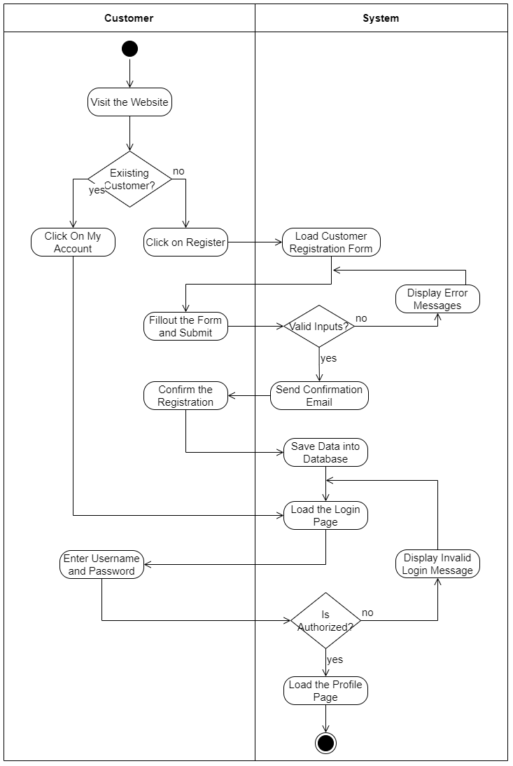

Figure 3. 6:Activity Diagram for Customer Registration and Login:

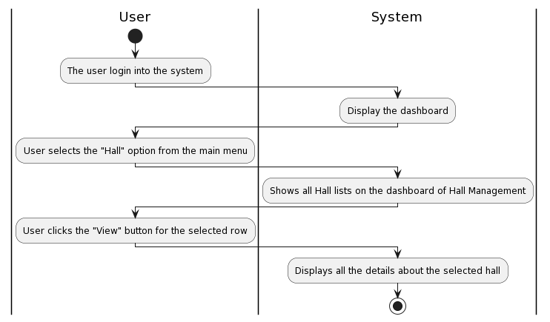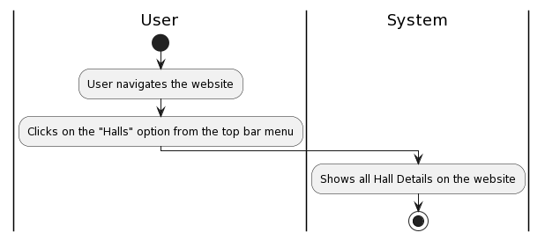

Figure 3. 7:Activity Diagram for View Hall in System User

Figure 3. 8:Activity Diagram for View Hall in Website

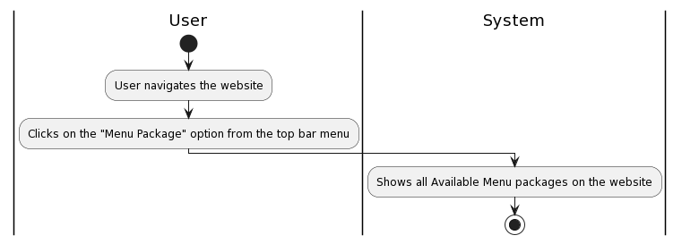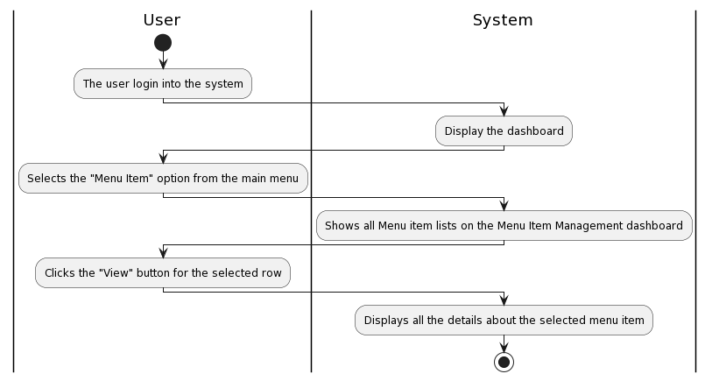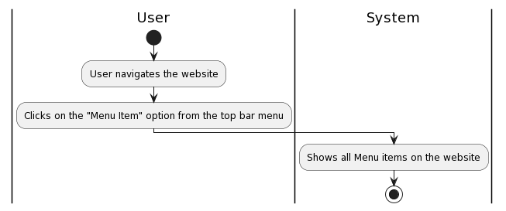

Figure 3. 9:Activity Diagram for View Package Details in Website

Figure 3. 10:Activity Diagram for View Menu Item in System

Figure 3. 11:Activity Diagram for View Menu Item in Website

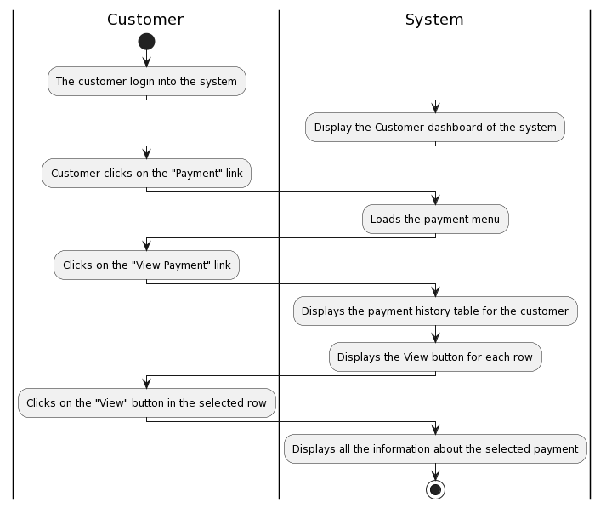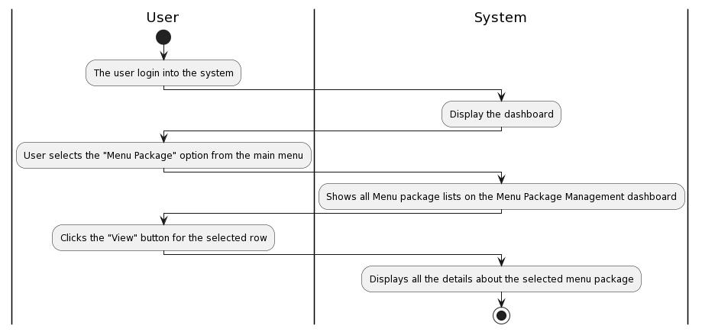

Figure 3. 12:Activity Diagram for View Payment History

Figure 3. 13:Activity Diagram for View Menu Package in System

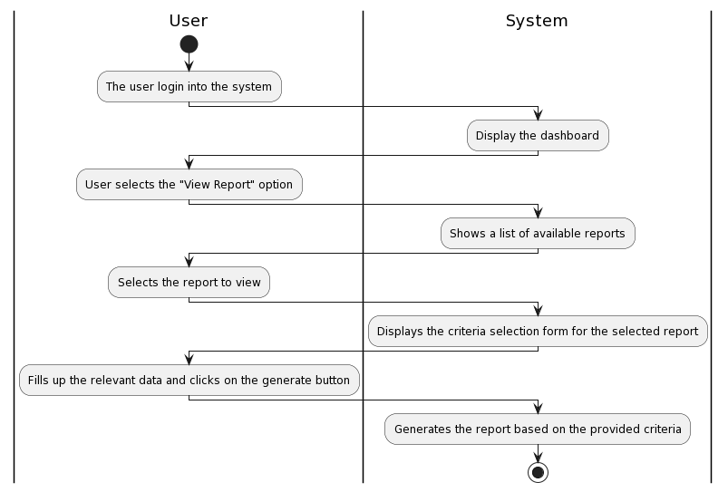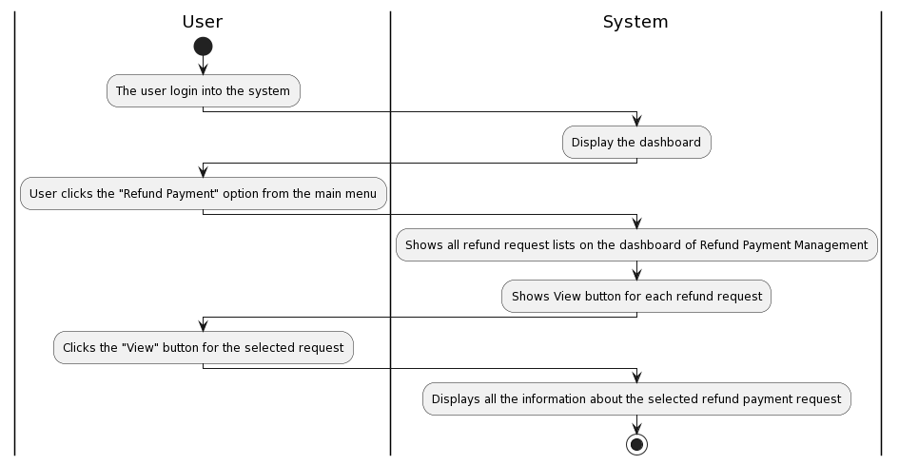

Figure 3. 14:Activity Diagram for View Reports

Figure 3. 15:Activity Diagram for View Refund Payment

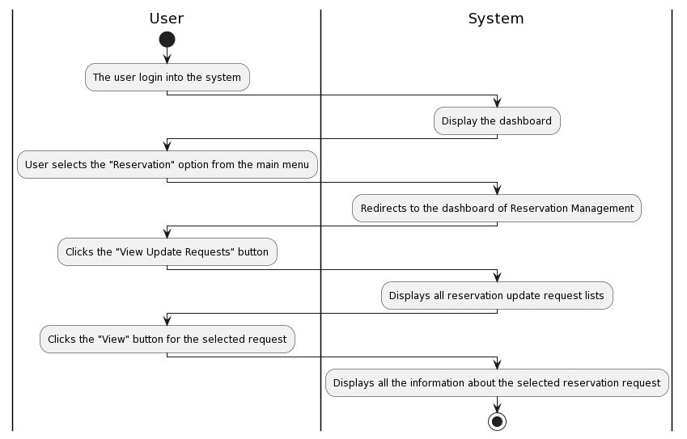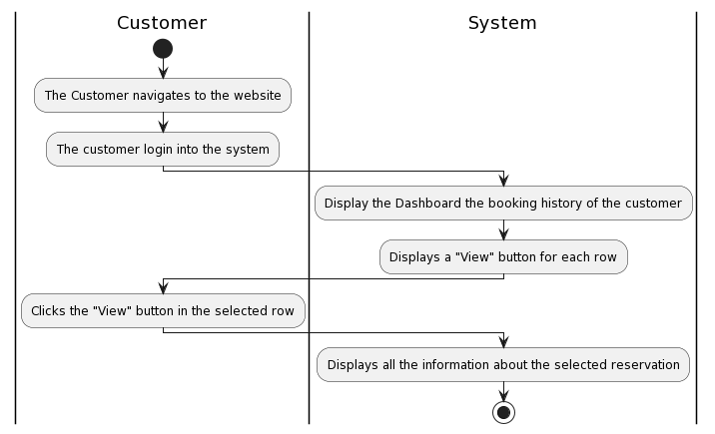

Figure 3. 16:Activity Diagram for View Reservation Update Request

Figure 3. 17:Activity Diagram for View Reservation History

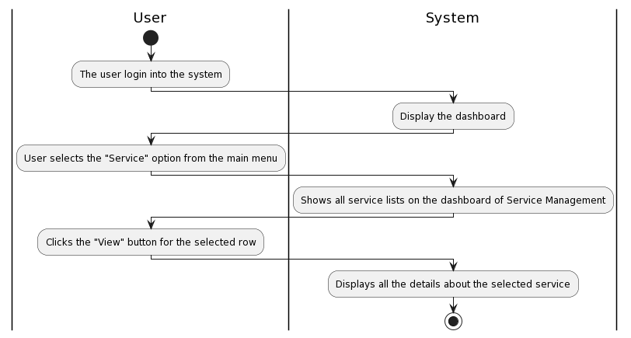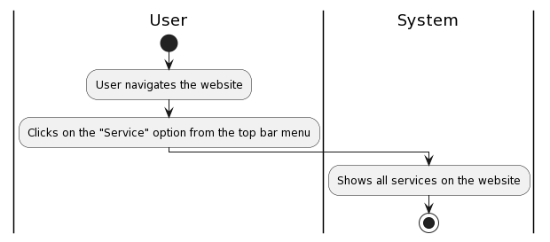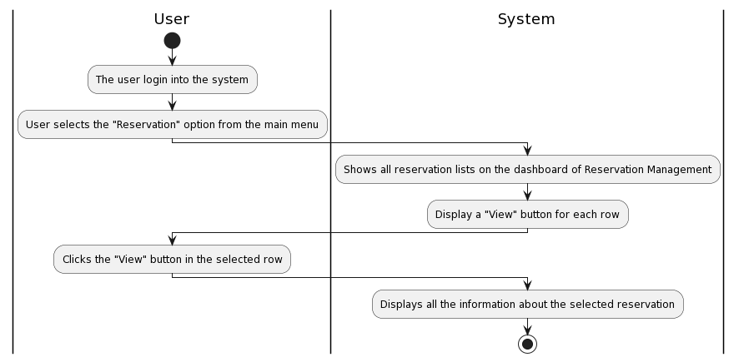

Figure 3. 18:Activity Diagram for View Services in System

Figure 3. 19:Activity Diagram for View Services in Website

Figure 3. 20:Activity Diagram for View Reservations in System

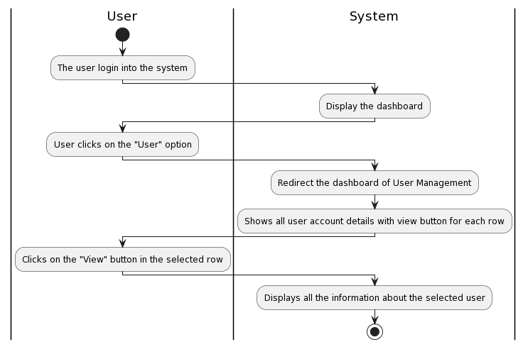

Figure 3. 21:Activity Diagram for View User

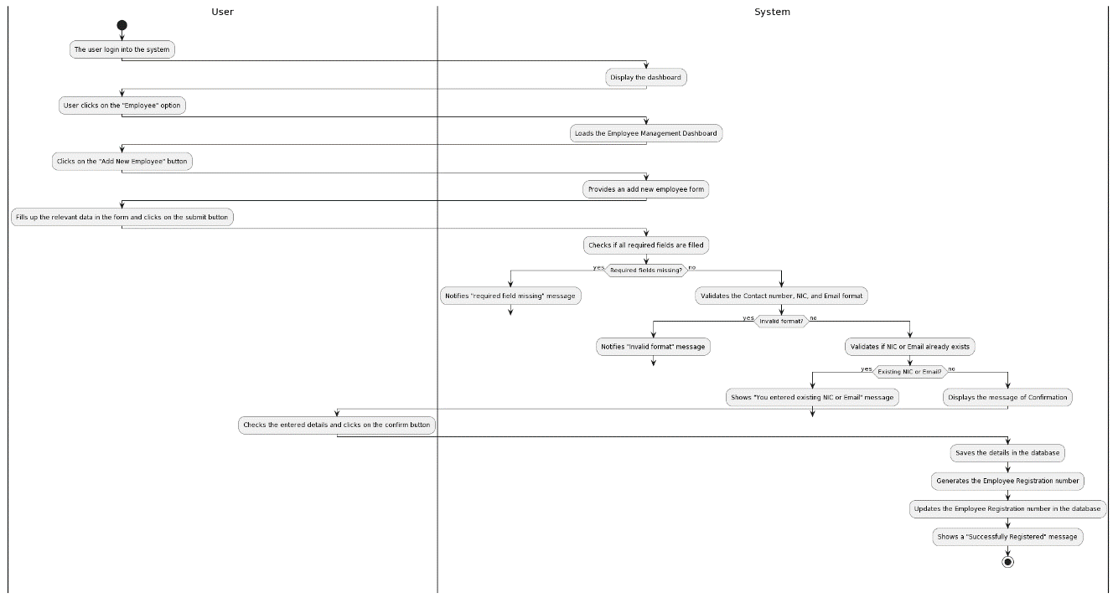

Figure 3. 22:Activity Diagram for Add New Employee

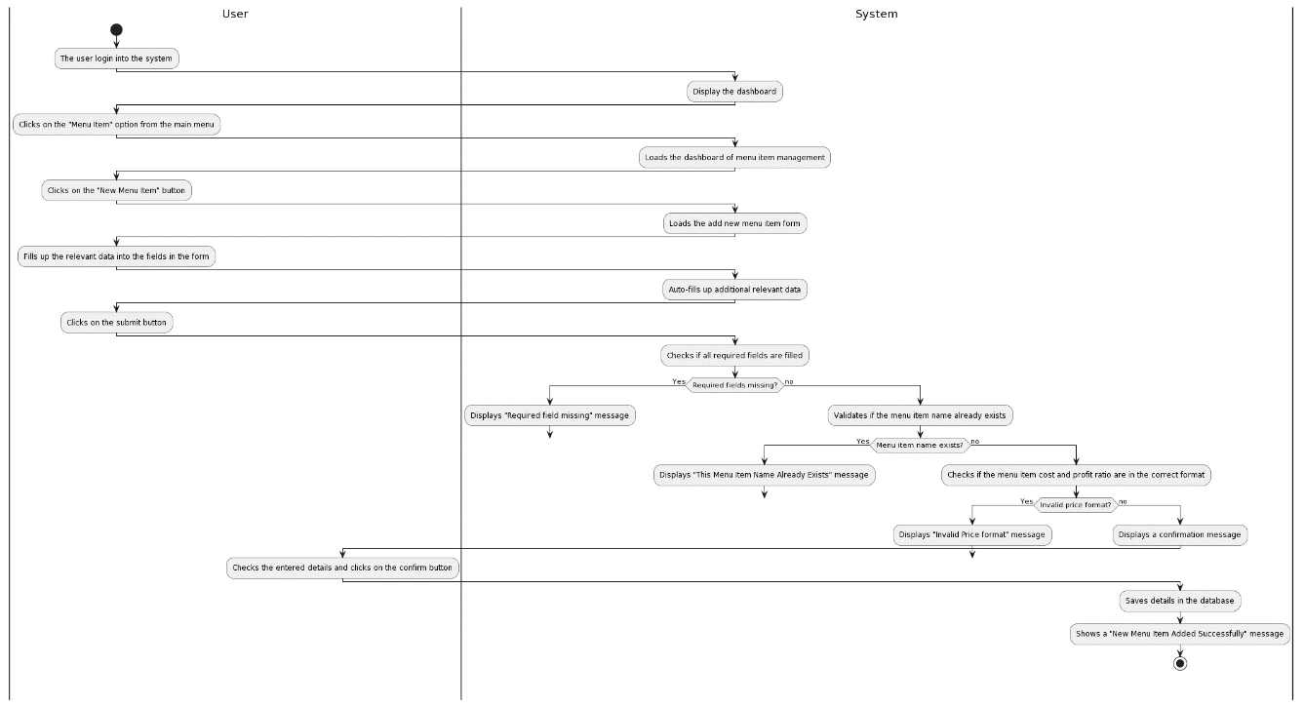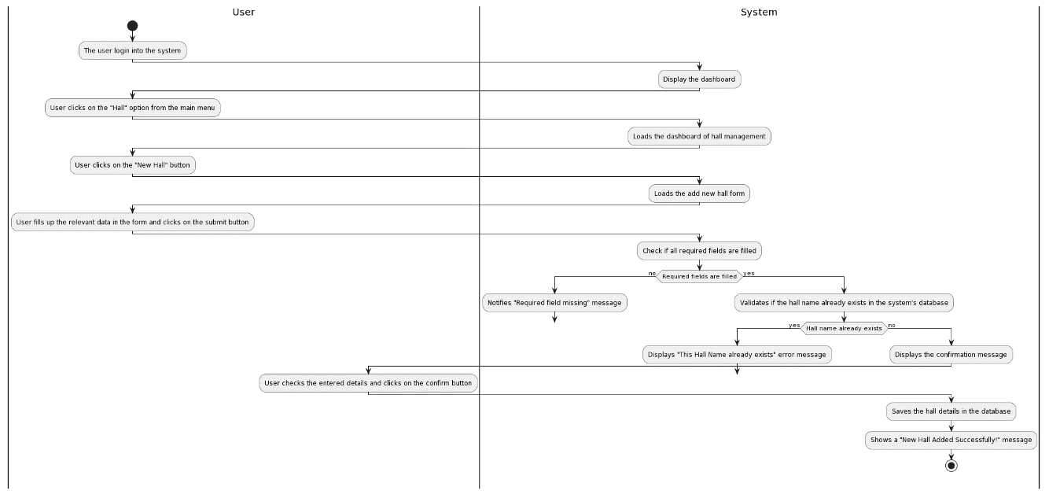

Figure 3. 23:Activity Diagram for Add New Menu Item

Figure 3. 24:Activity Diagram for Add New Hall

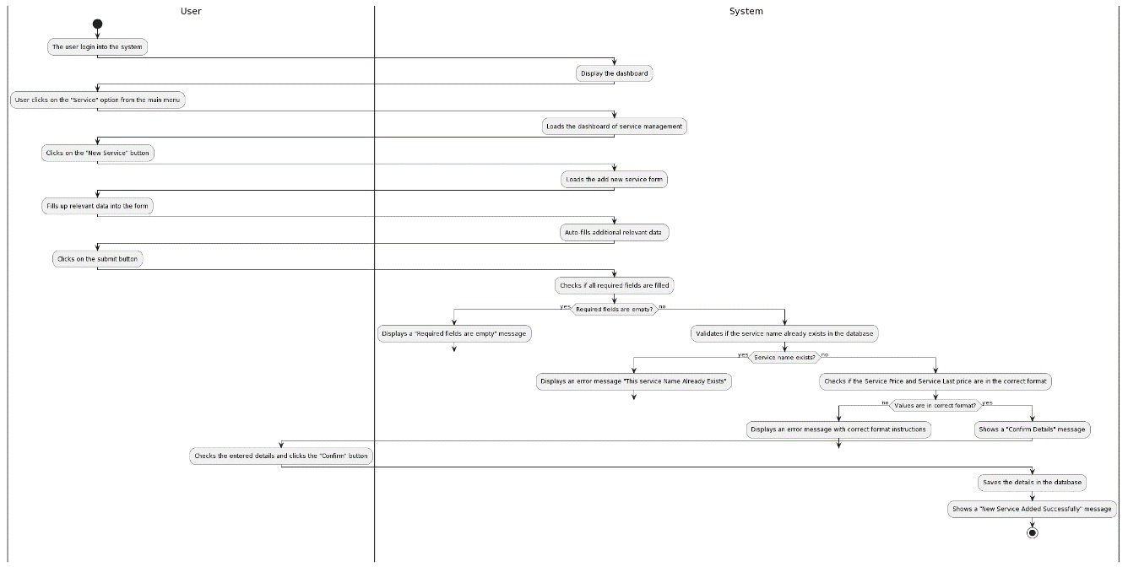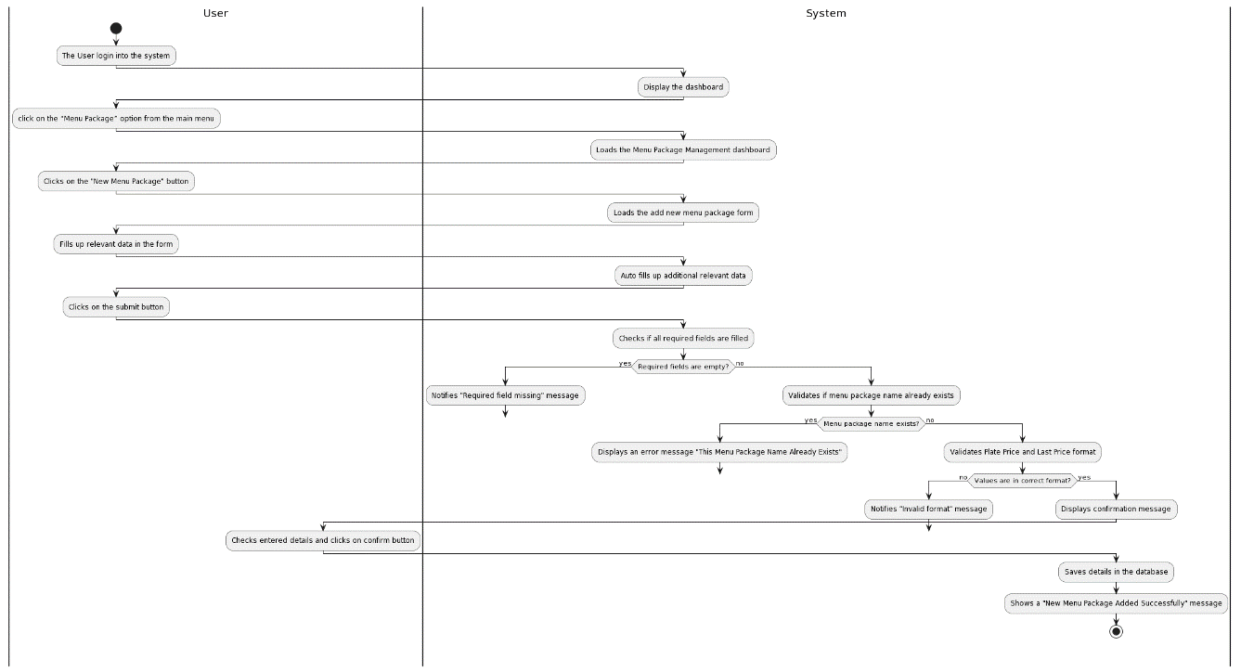

Figure 3. 25:Activity Diagram for Add New Service

Figure 3. 26:Activity Diagram for Add New Package

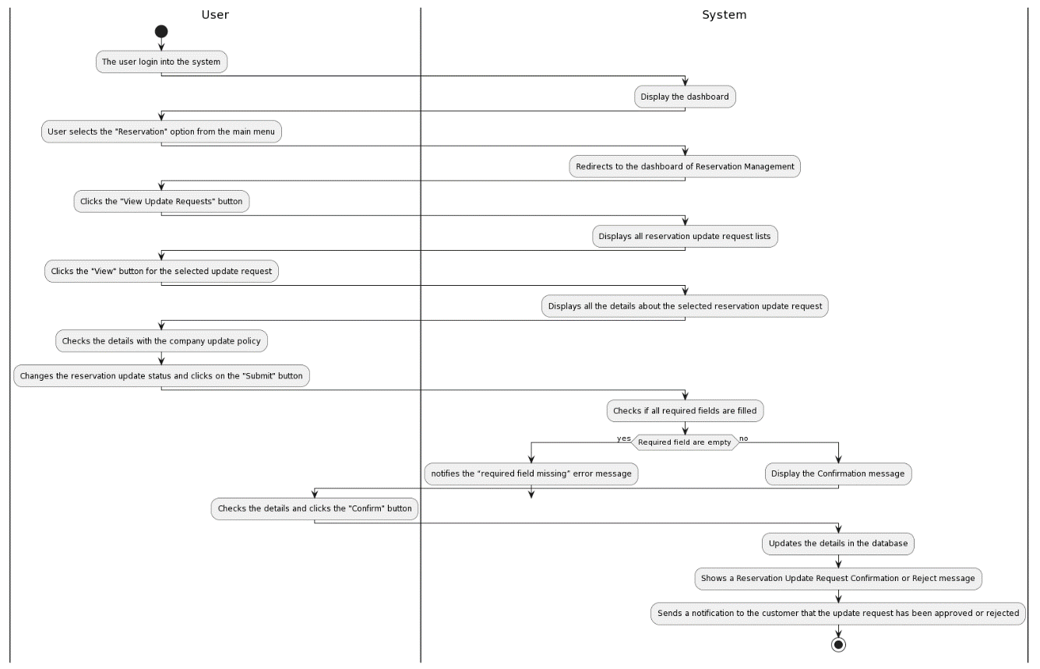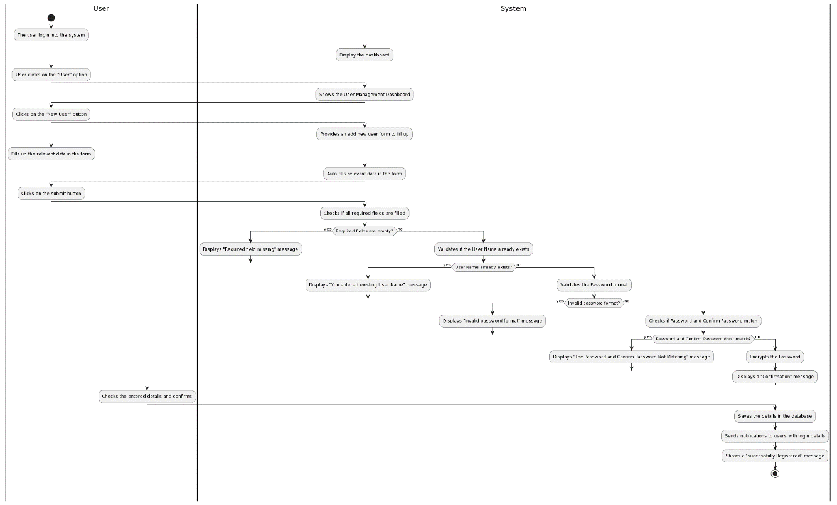

Figure 3. 27:Activity Diagram for Approve or Reject Reservation Update Requests

Figure 3. 28:Activity Diagram for Add New User

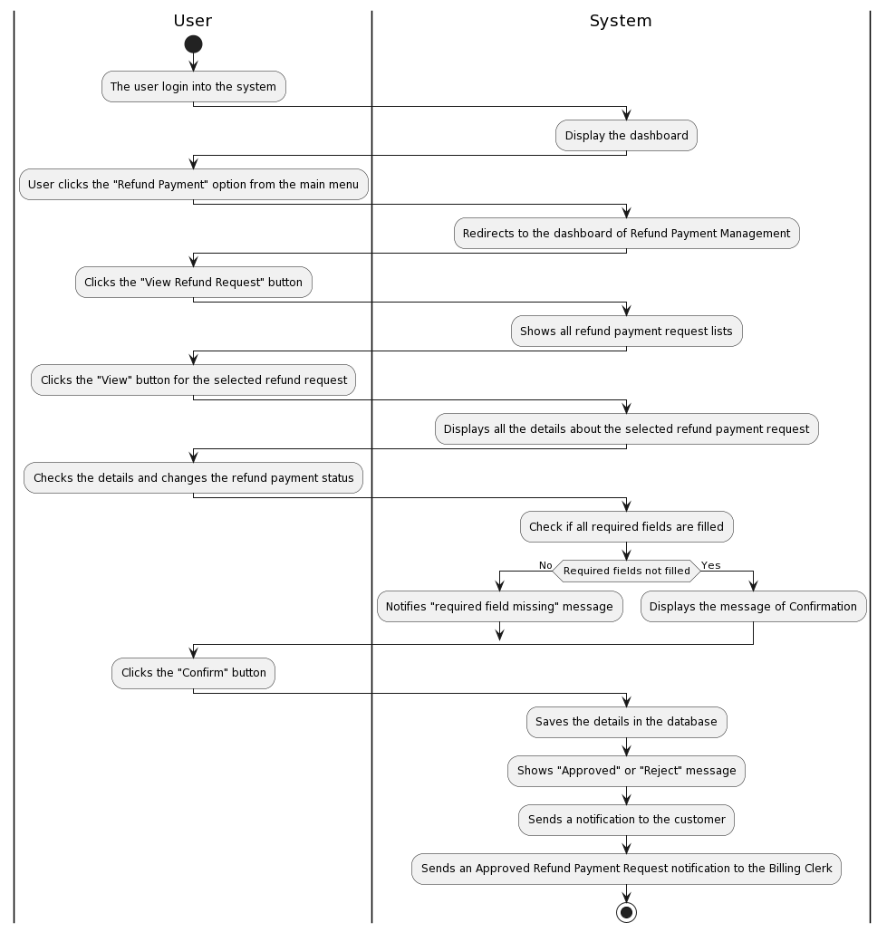

Figure 3. 29:Activity Diagram for Approve or Reject Refund Payment Requests

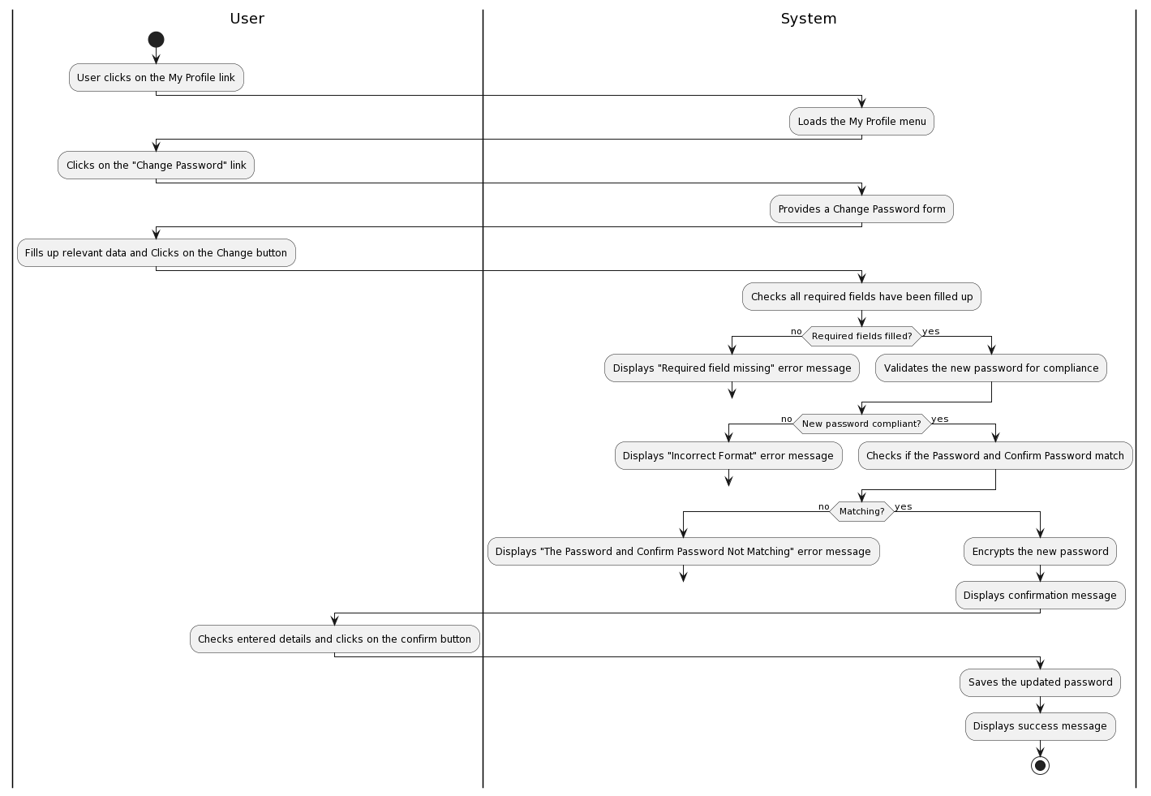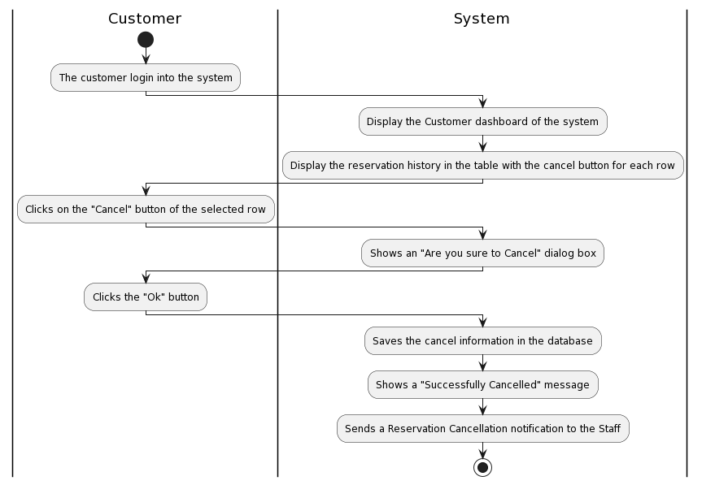

Figure 3. 30:Activity Diagram for Change Password

Figure 3. 31:Activity Diagram for Cancel Reservation

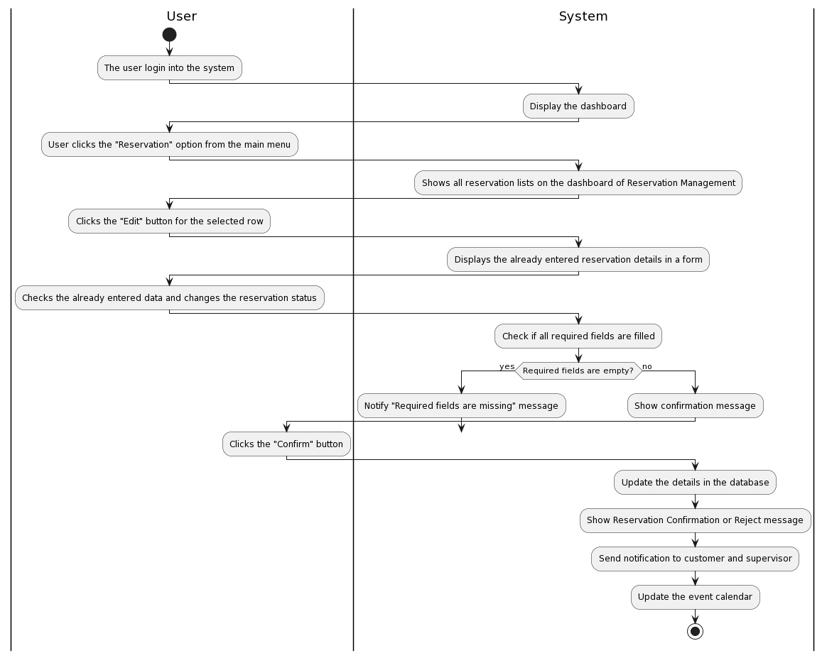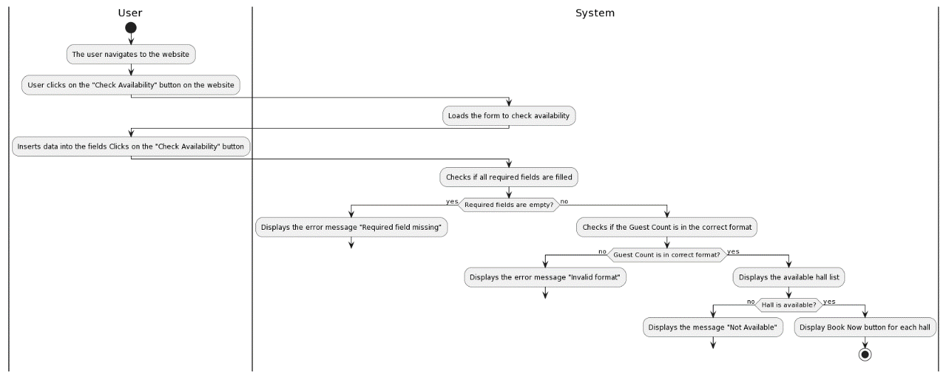

Figure 3. 32:Activity Diagram for Confirm or Reject Reservations

Figure 3. 33:Activity Diagram for Check Hall Availability

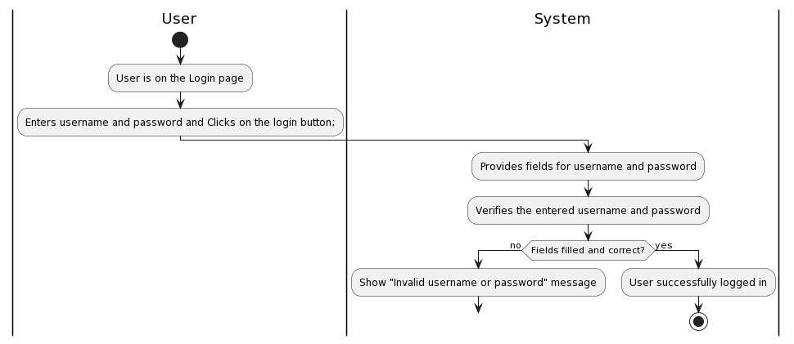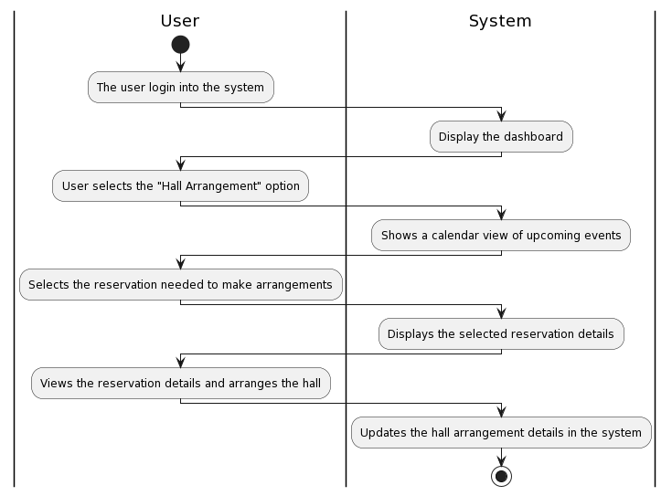

Figure 3. 34:Activity Diagram for Login

Figure 3. 35:Activity Diagram for Hall Arrangements

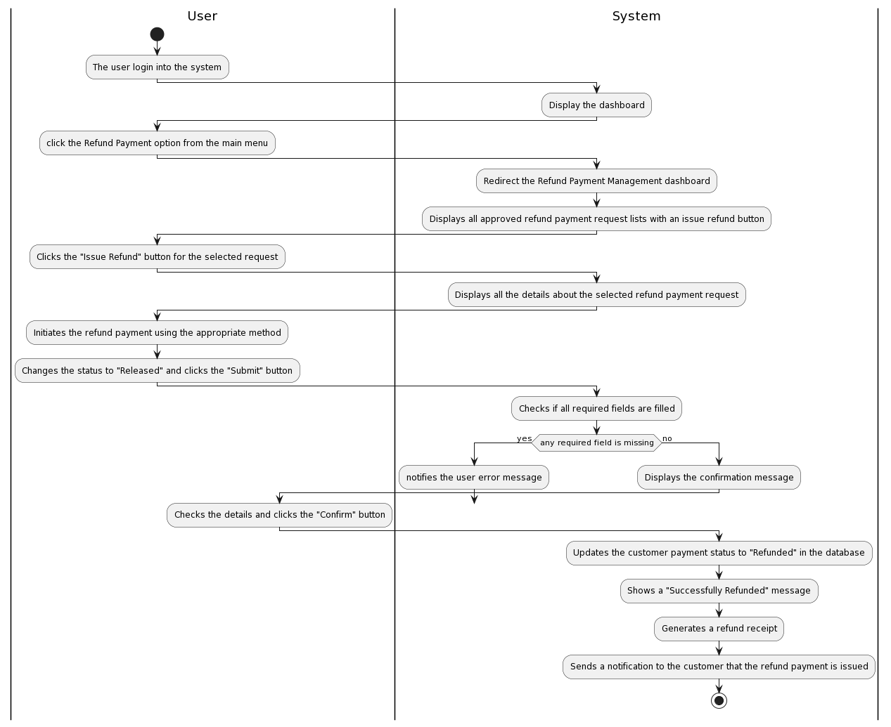

Figure 3. 36:Activity Diagram for Make Reservation - Part 1

Figure 3. 37:Activity Diagram for Issue Refund Payments

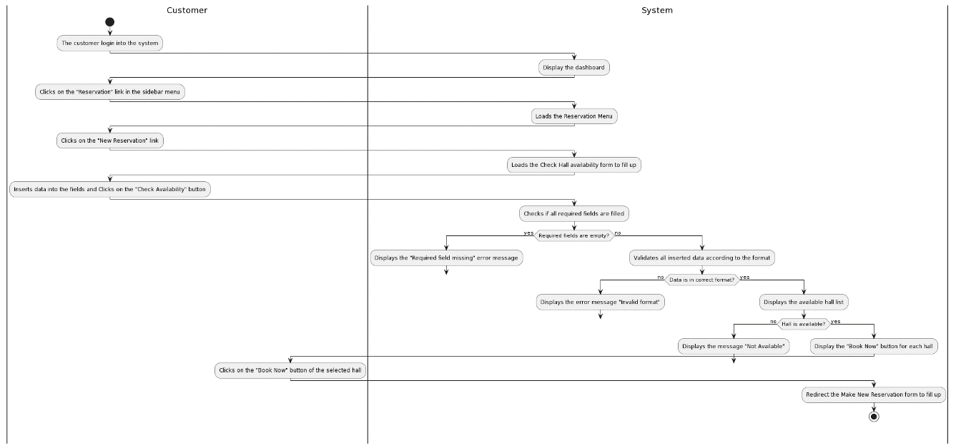

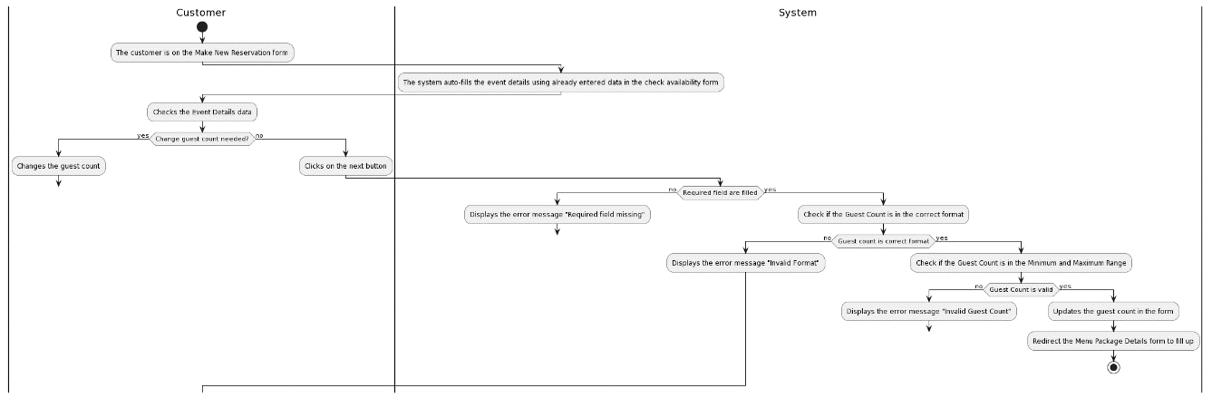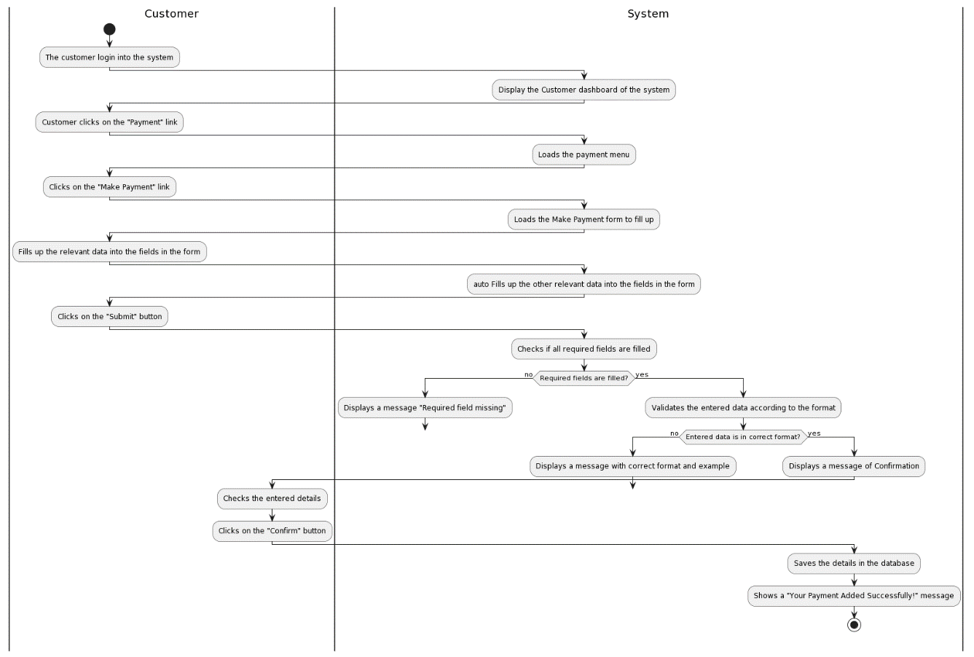

Figure 3. 38:Activity Diagram for Make Reservation - Part 2

Figure 3. 39:Activity Diagram for Make Payment

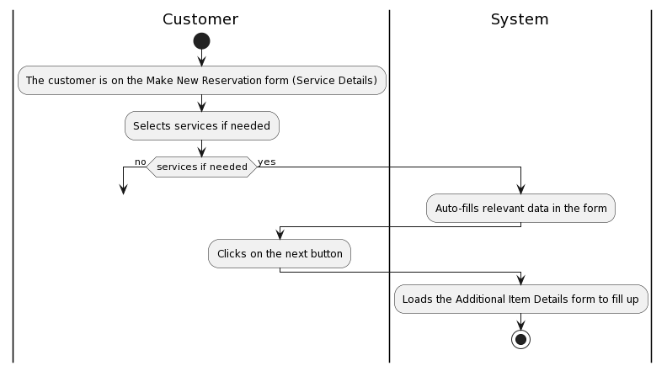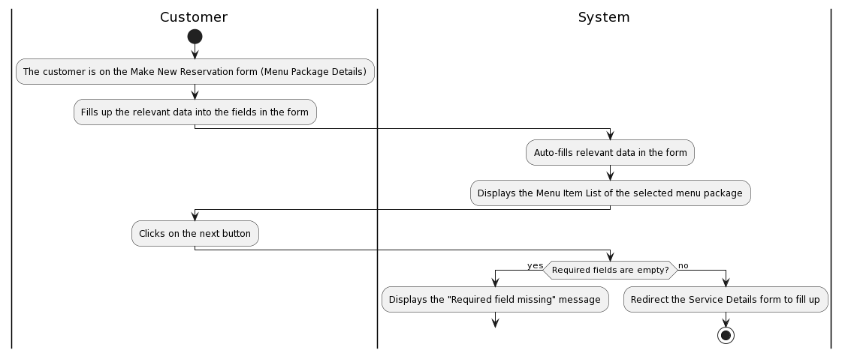

Figure 3. 40:Activity Diagram for Make Reservation - Part 4

Figure 3. 41:Activity Diagram for Make Reservation - Part 3

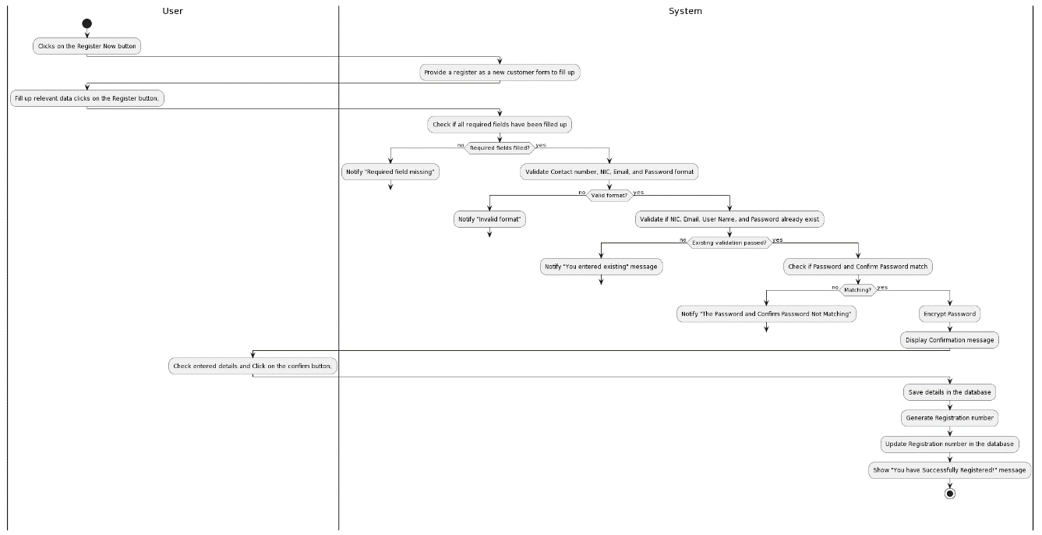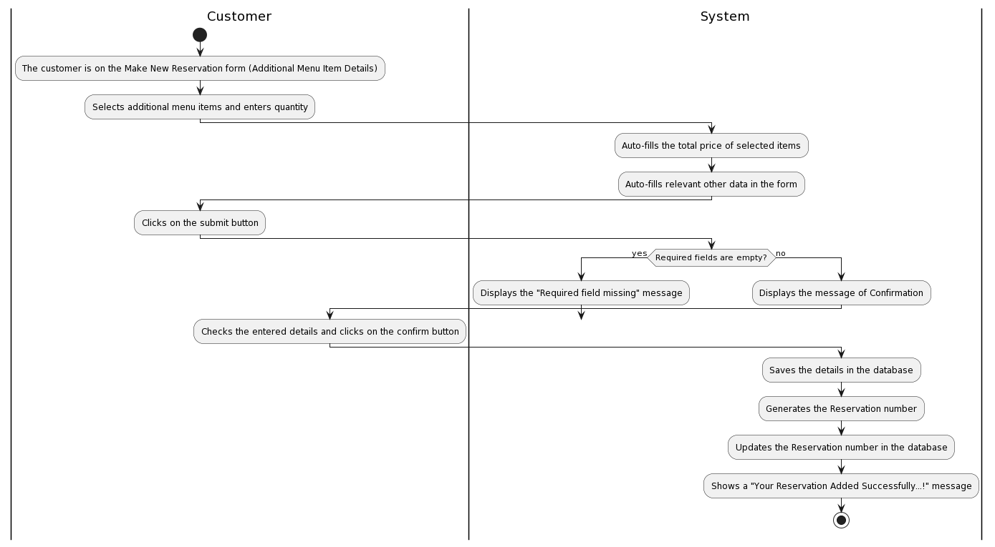

Figure 3. 42:Activity Diagram for Register as a Customer

Figure 3. 43: Activity Diagram for Make Reservation - Part 5

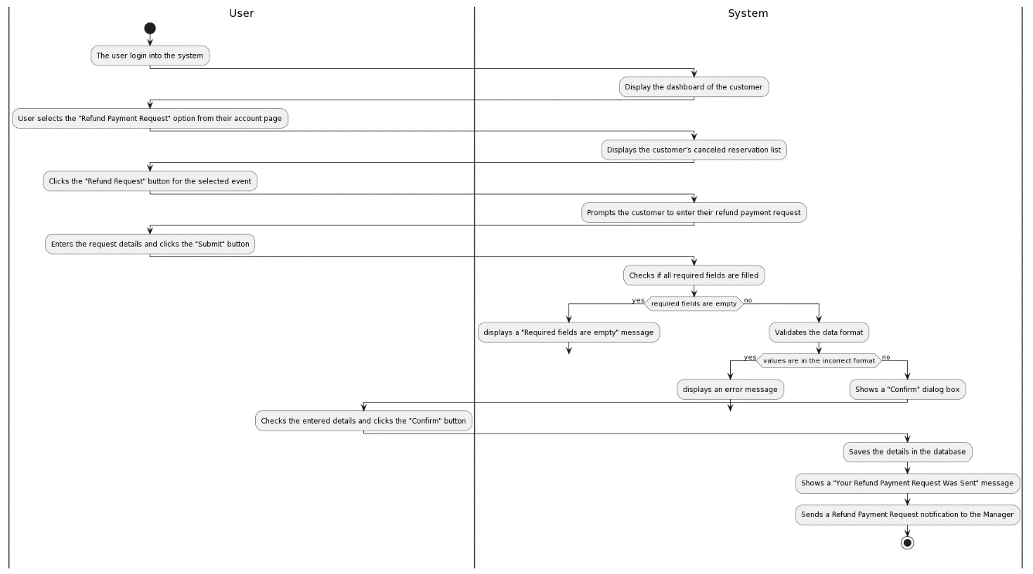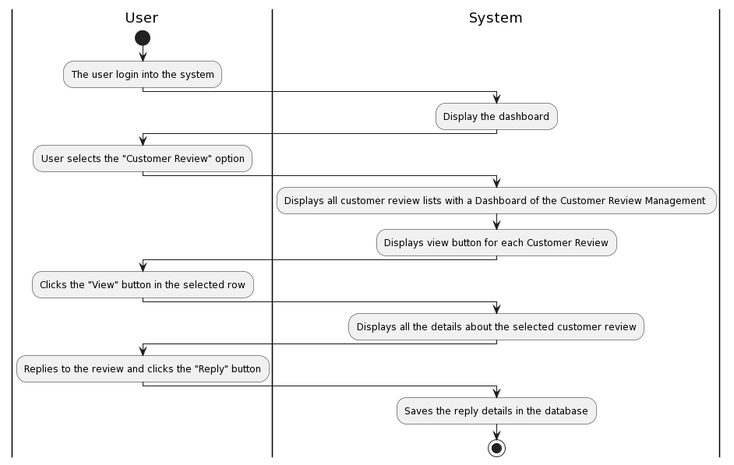

Figure 3. 44:Activity Diagram for Request Refund Payments

Figure 3. 45:Activity Diagram for Reply to Customer Reviews

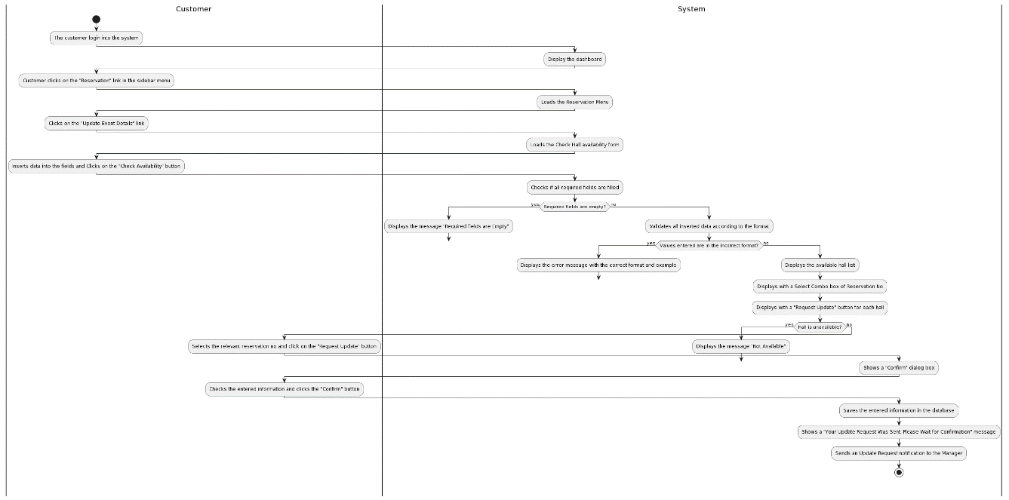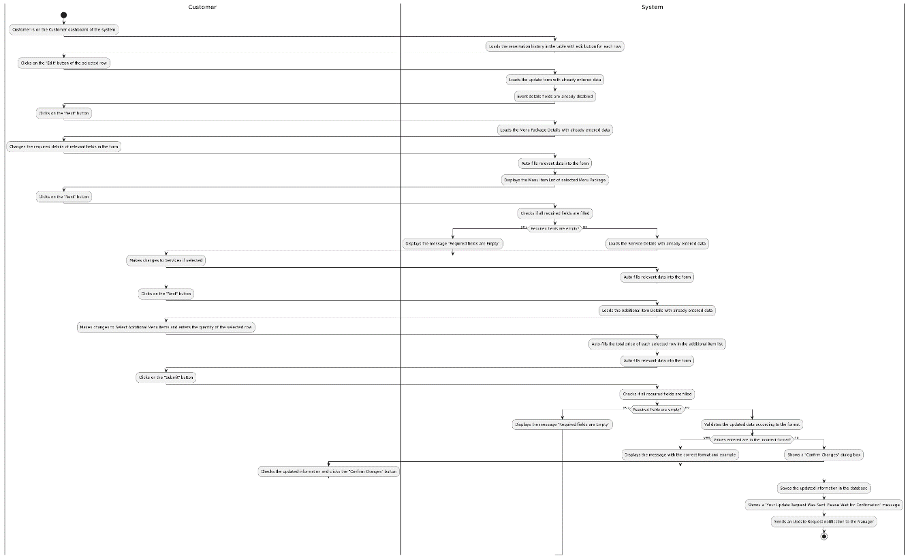

Figure 3. 46:Activity Diagram for Request Reservation Update - Part 2

Figure 3. 47:Activity Diagram for Request Reservation Update - Part 1

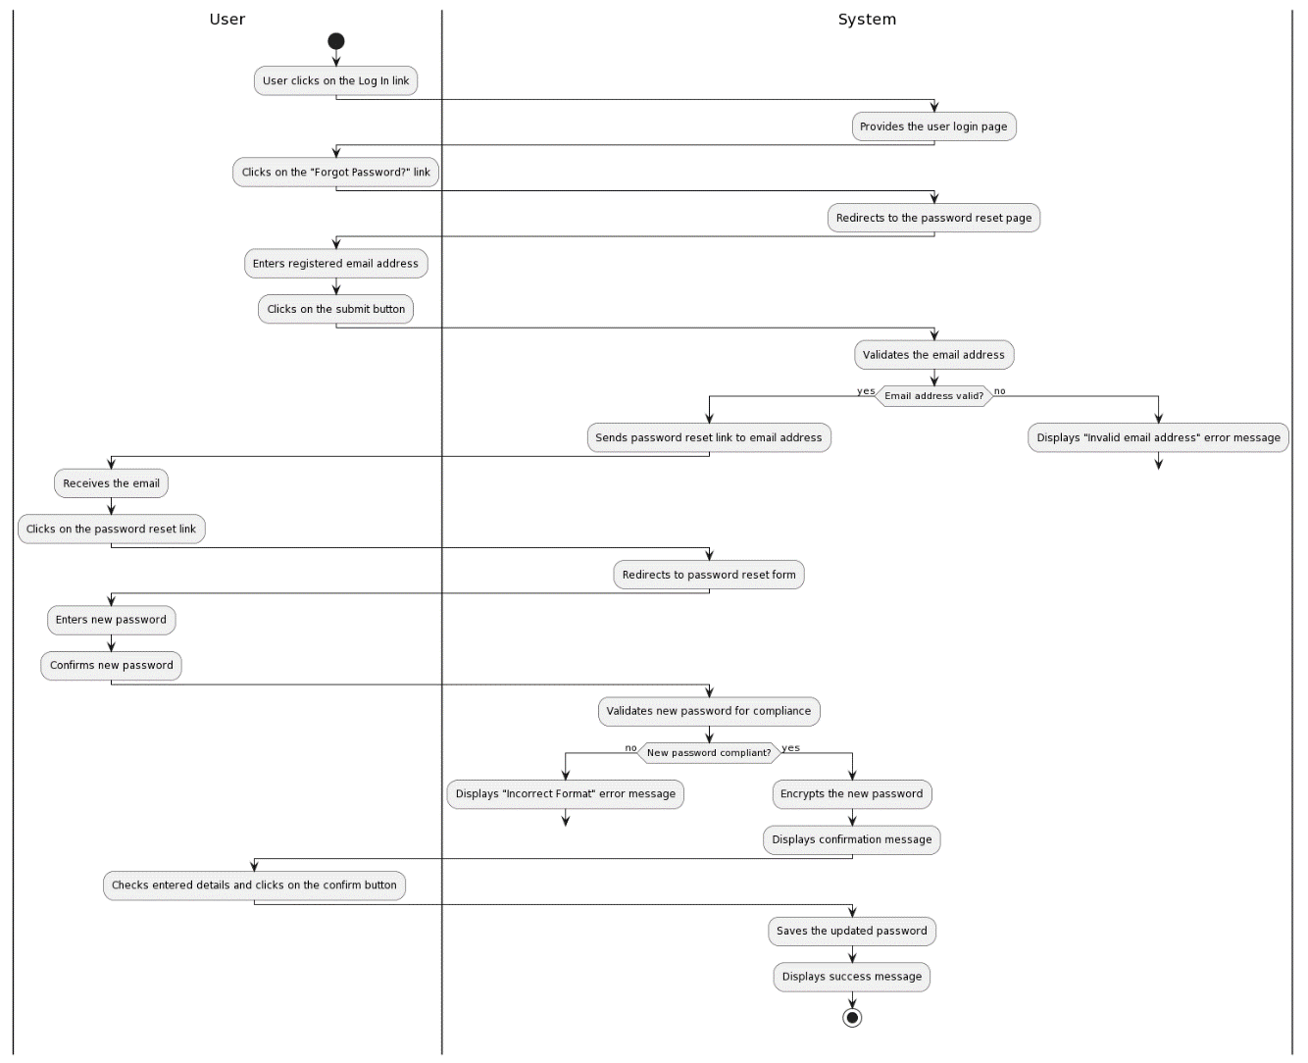

Figure 3. 48:Activity Diagram for Reset Password

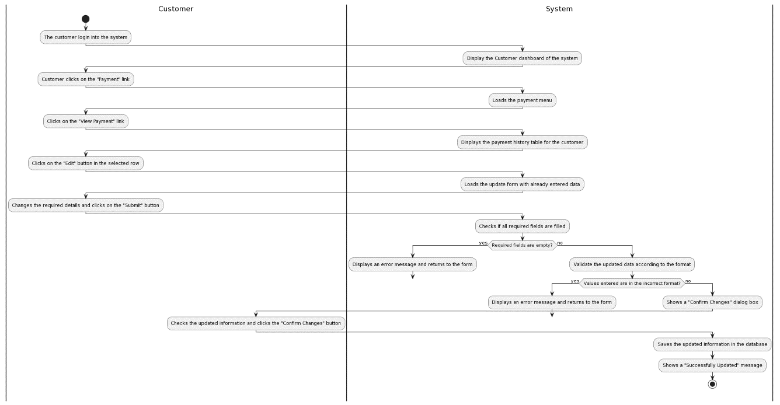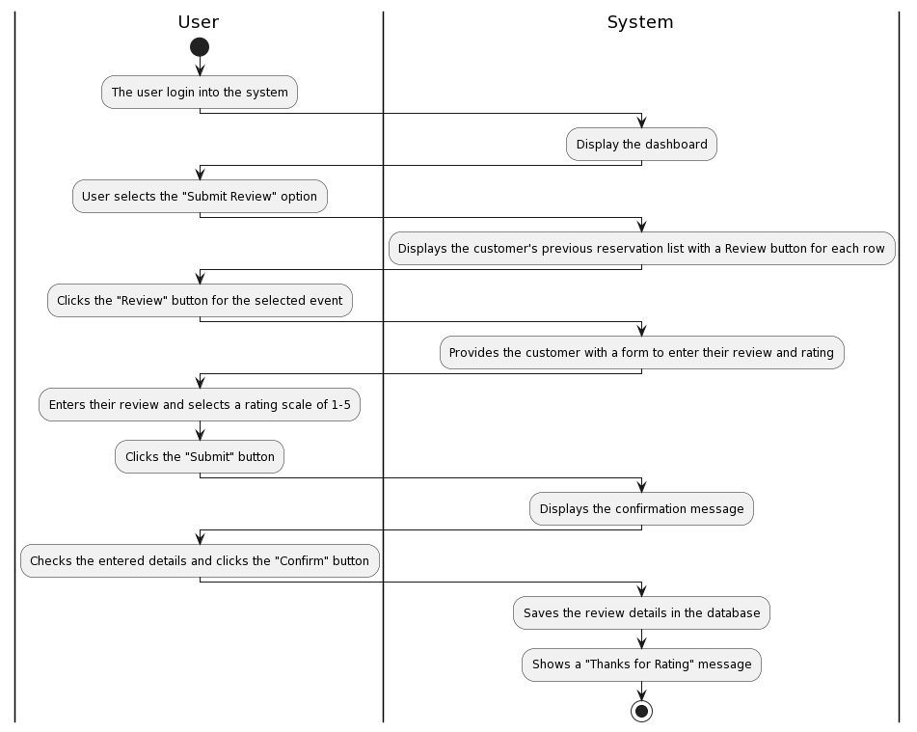

Figure 3. 49:Activity Diagram for Update Customer Payment

Figure 3. 50:Activity Diagram for Submit a Review

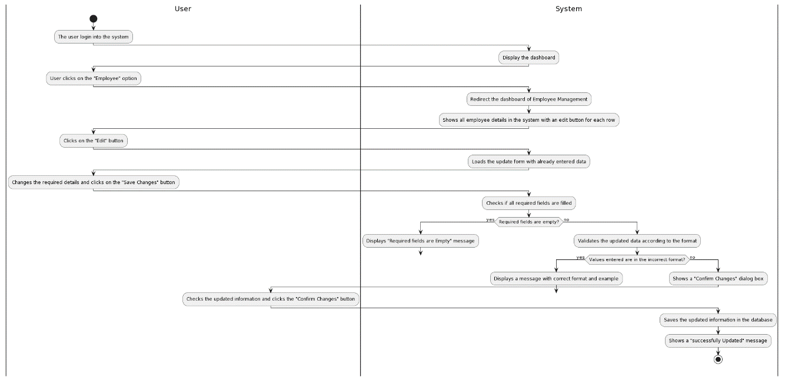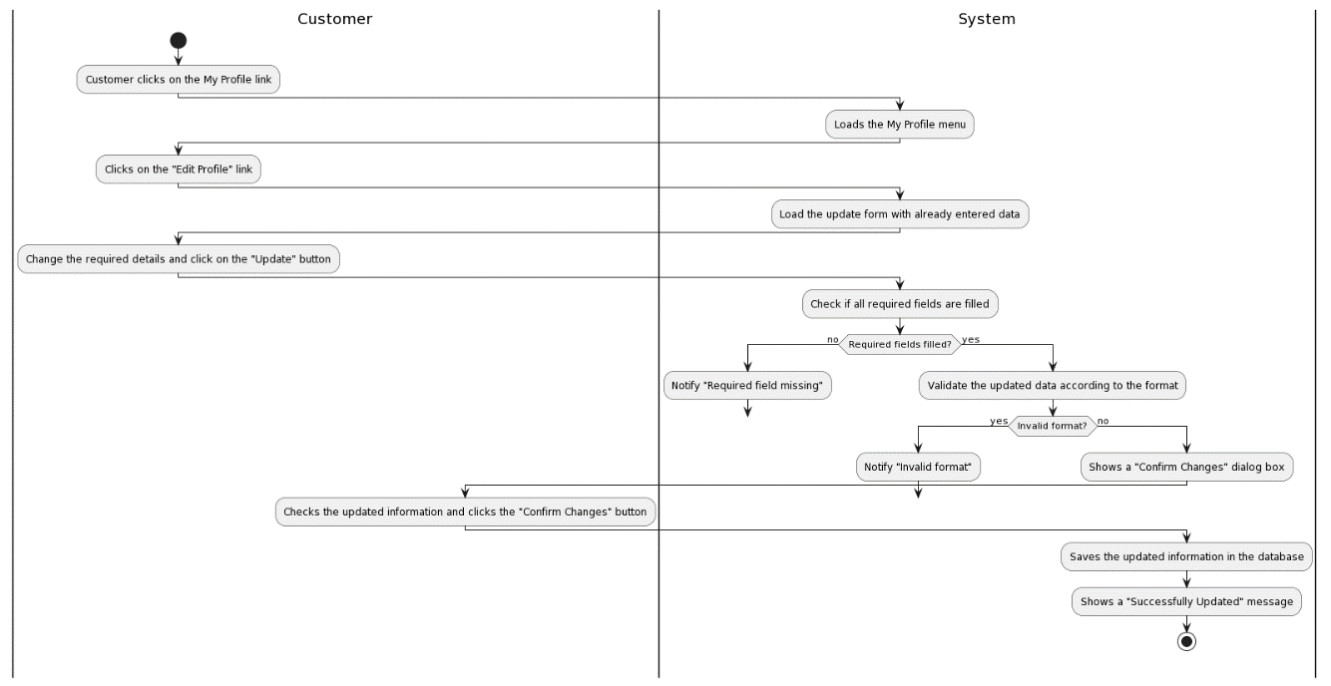

Figure 3. 51:Activity Diagram for Update Employee

Figure 3. 52:Activity Diagram for Update Customer Profile

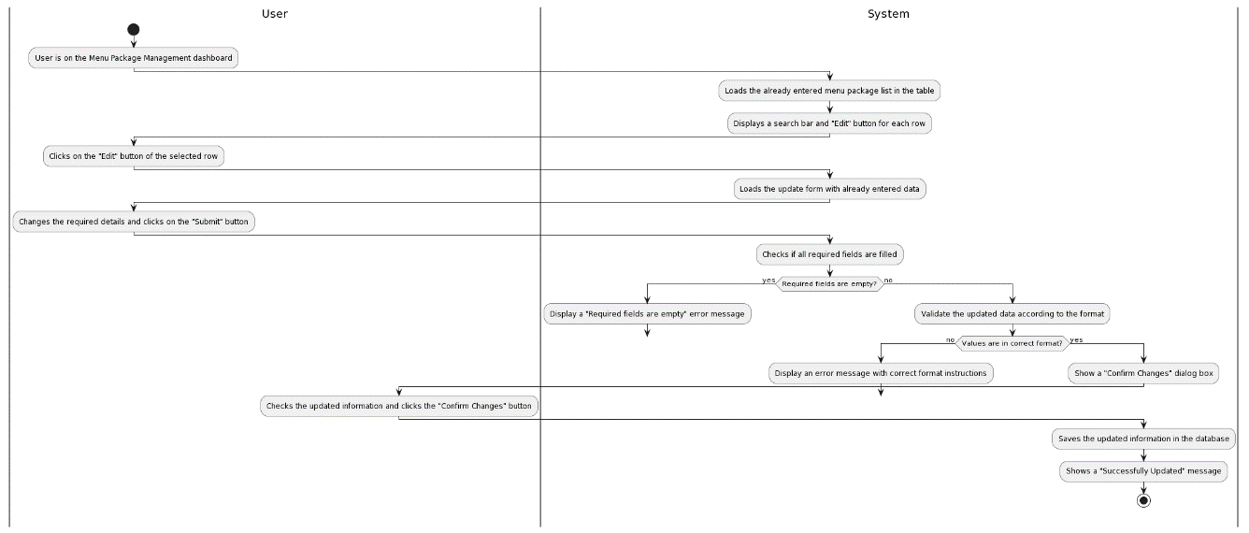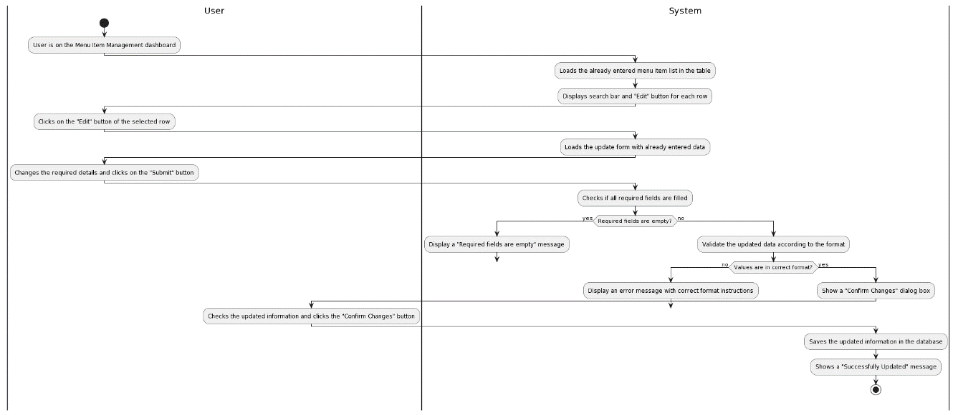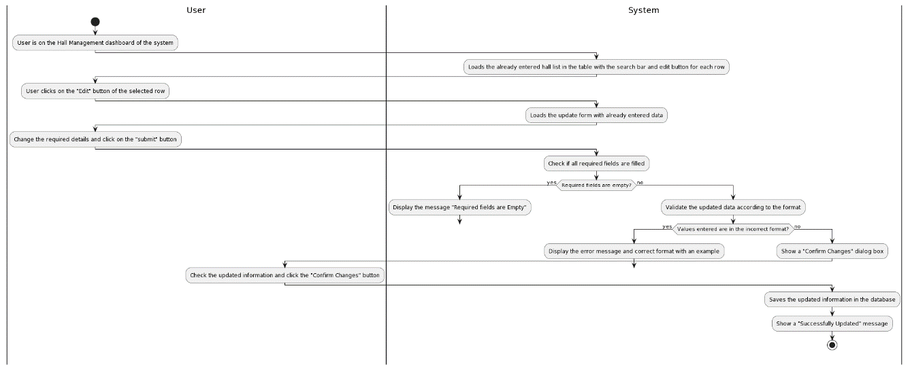

Figure 3. 53:Activity Diagram for Update Package

Figure 3. 54:Activity Diagram for Update Menu Item

Figure 3. 55:Activity Diagram for Update Hall

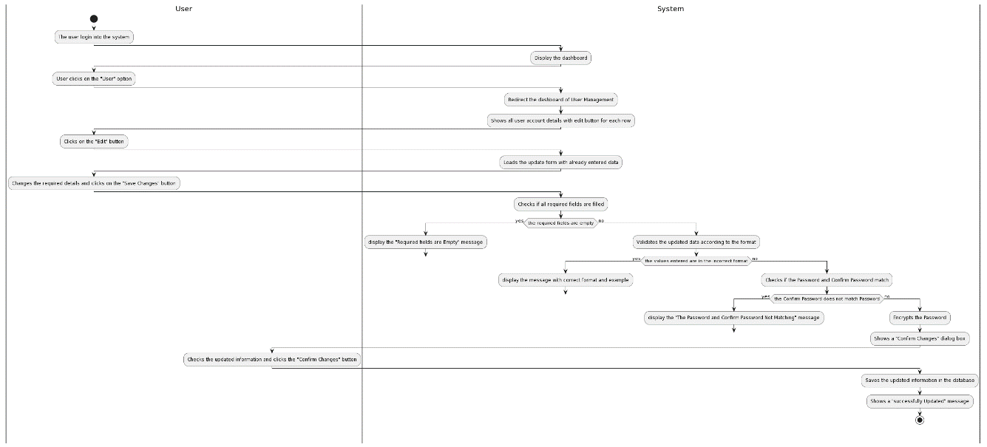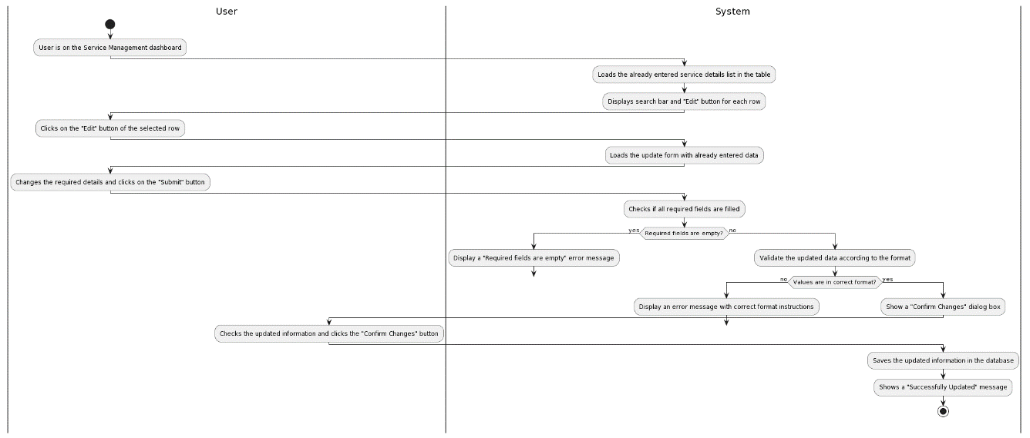

Figure 3. 56:Activity Diagram for Update User

Figure 3. 57:Update Service

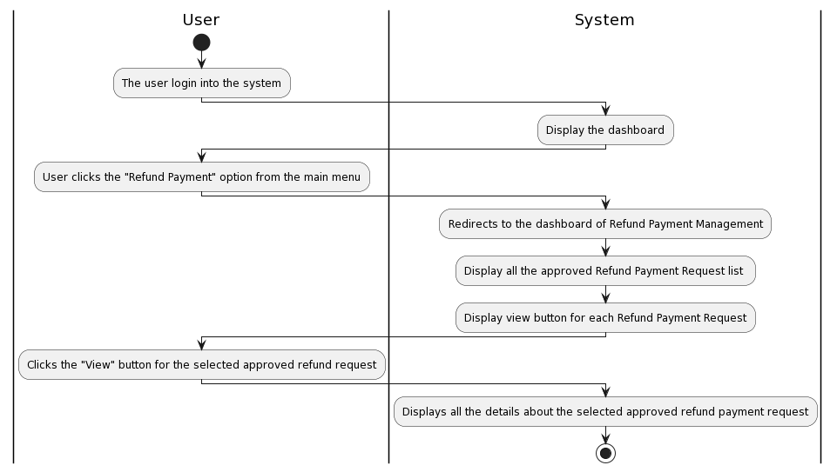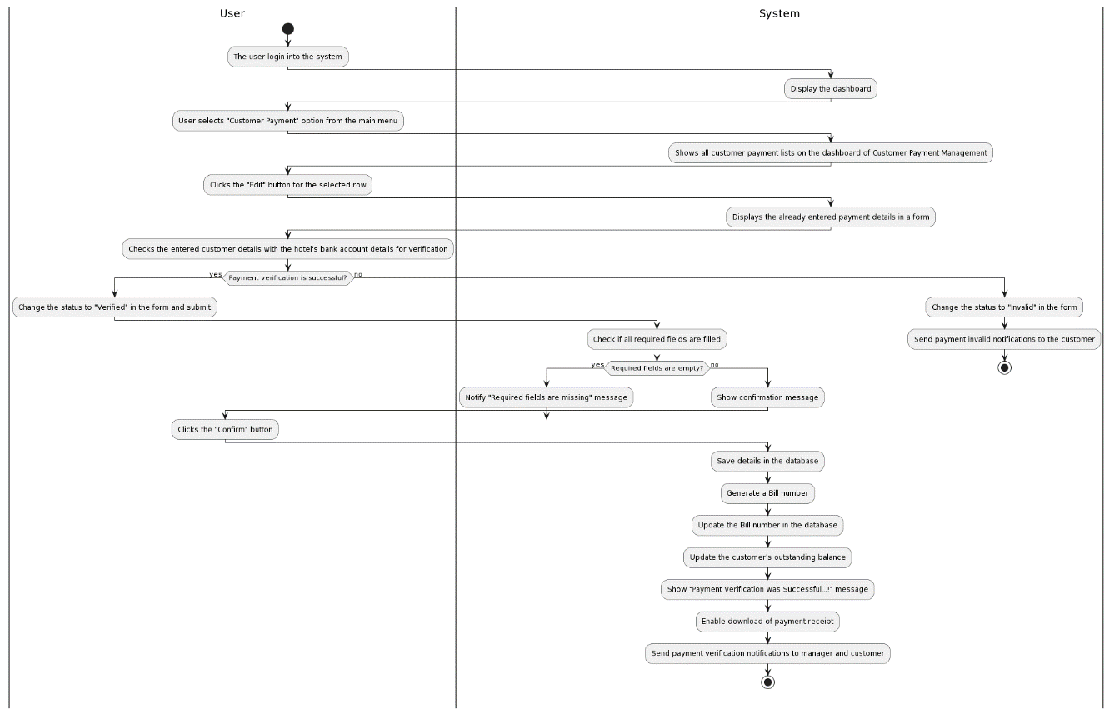

Figure 3. 58:Activity Diagram for View Approved Refund Payments

Figure 3. 59:Activity Diagram for Verify Received Customer Payments

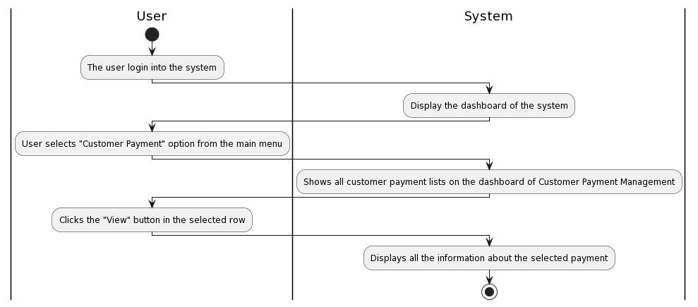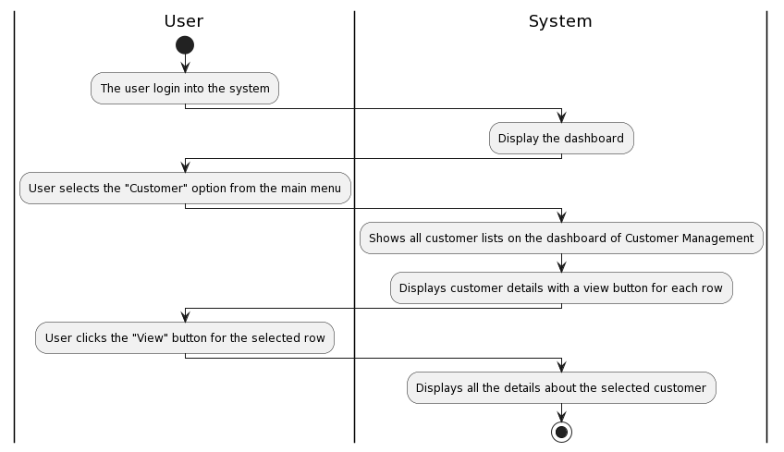

Figure 3. 60: Activity Diagram for View Customer Payments

Figure 3. 61:Activity Diagram for View Customer Details

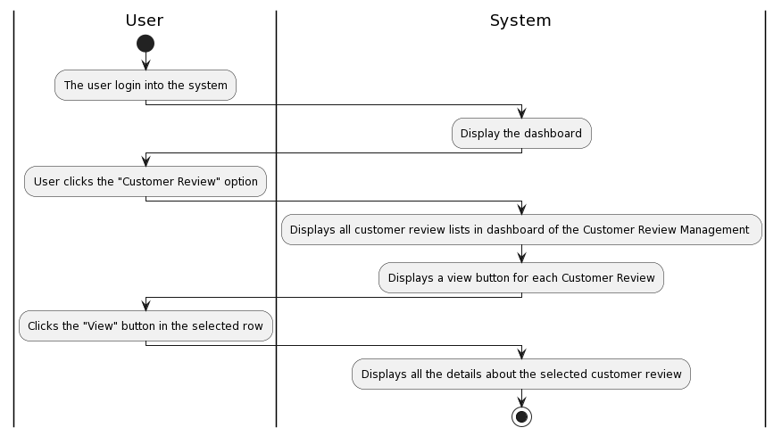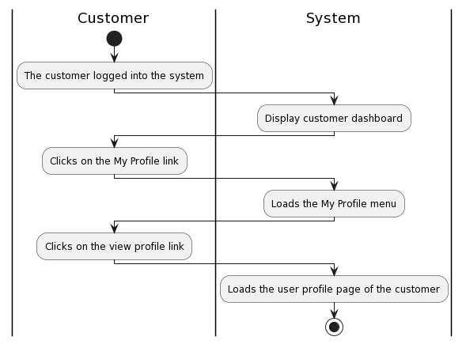

Figure 3. 62:Activity Diagram for View Customer Review

Figure 3. 63:Activity Diagram for View Customer Profile

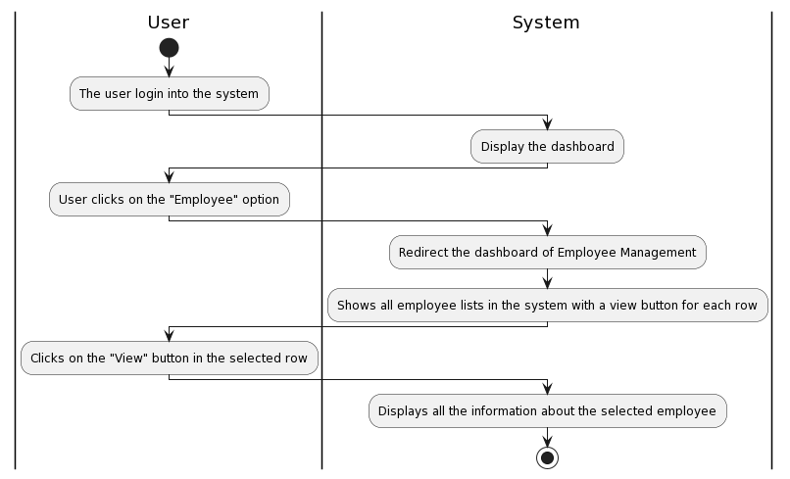

Figure 3. 64: Activity Diagram for View Employee

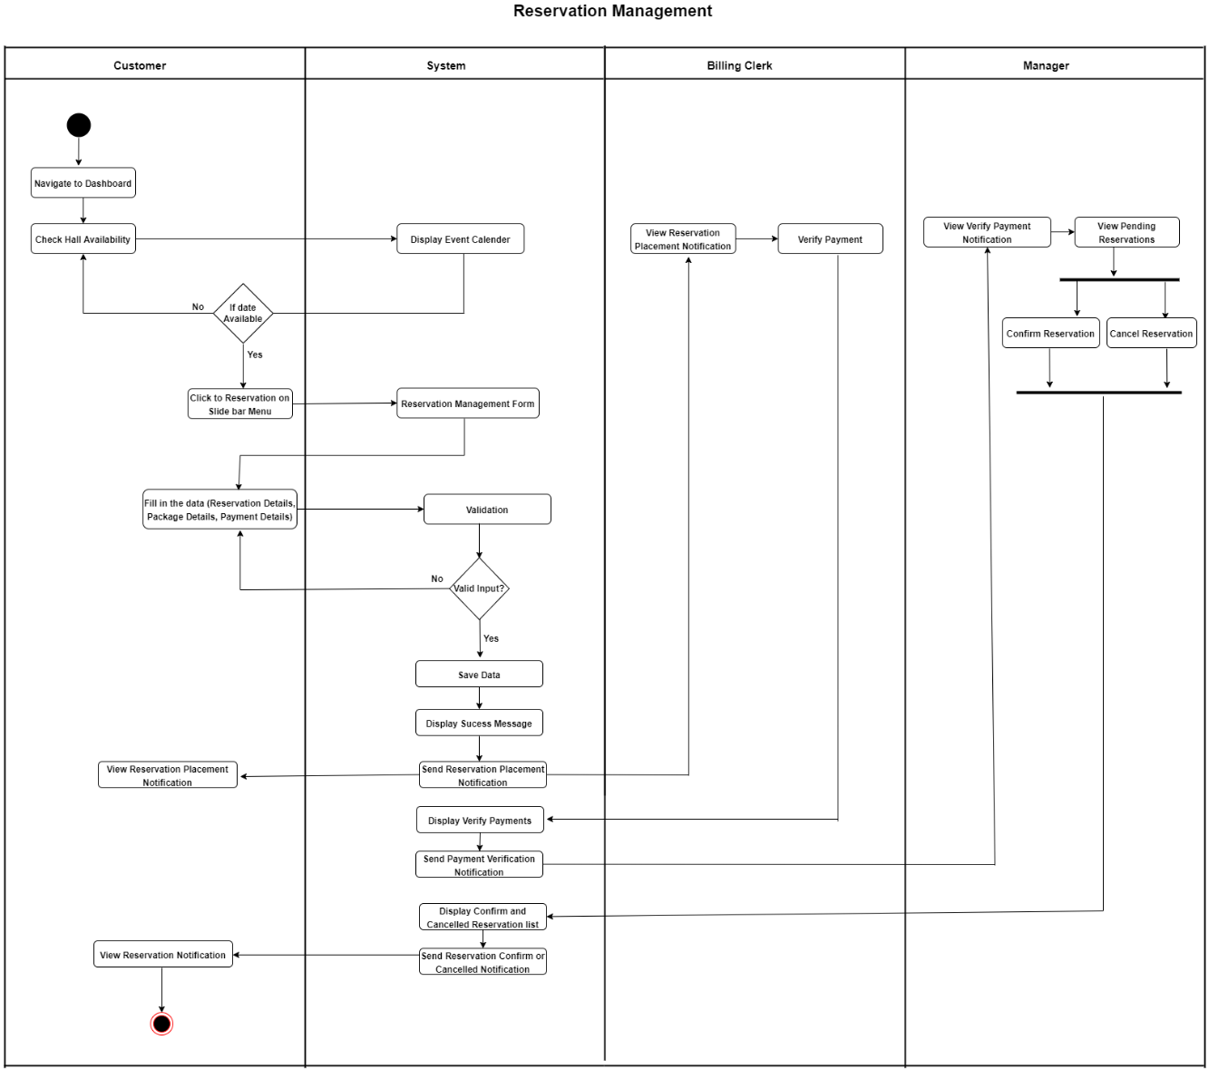

Figure 3. 65:Activity Diagram for Making a Reservation

### Database Design

Figure 3. 66:Entity Relationship Diagram for Proposed System

## User Interface Design

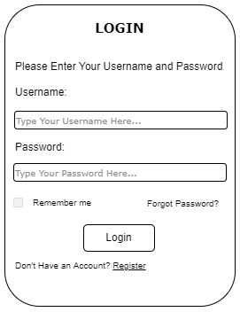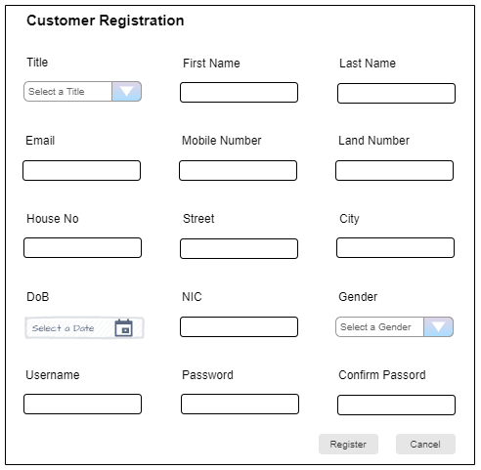

Figure 3. 67:Customer Registration Form

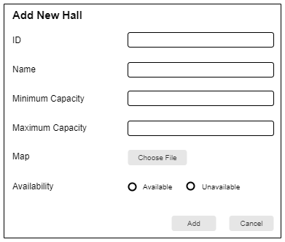

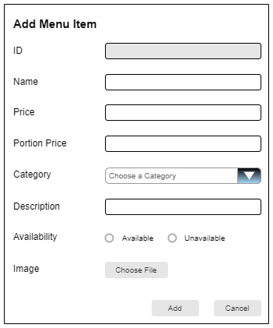

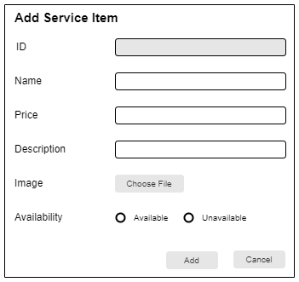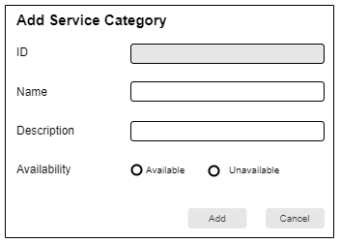

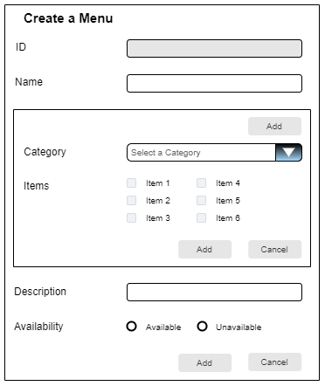

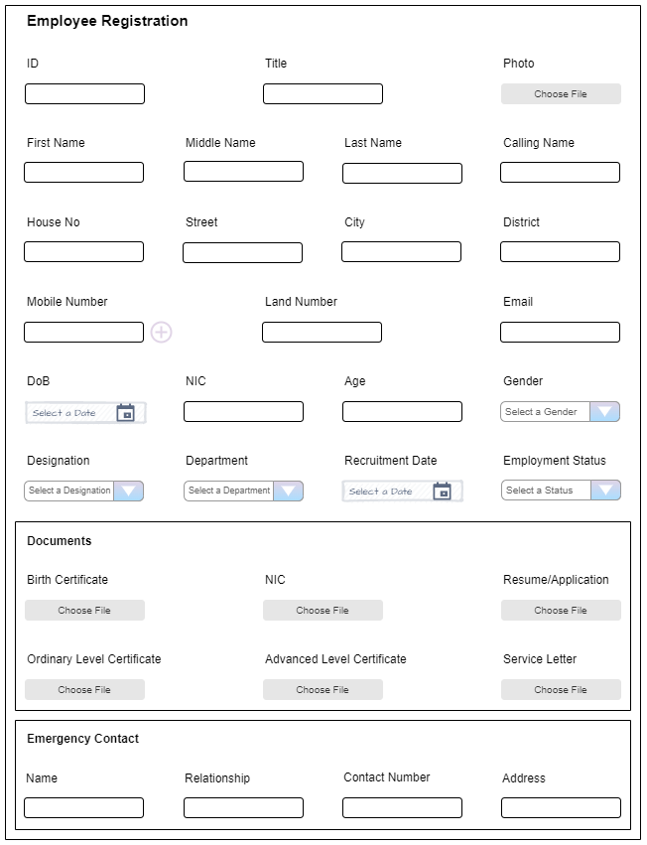

# Chapter 04 – Implementation

The implementation phase is where the requirements identified in the analysis chapter are brought to reality according to the designs in the previous chapter, using suitable software and hardware.



## Implementation Environment

Implementation environment can be divided into two main categories as software and hardware.

### Software Environment

The web-based reservation management system for the Flash Reception Hall has been developed using a variety of technologies, including HTML, CSS, and Bootstrap 5 for the design and styling of the system, PHP for server-side scripting, JS, jQuery, and AJAX for dynamic and responsive elements, and NetBeans as the IDE. During the development phase, the system was hosted locally using the WAMP server, and MySQL was utilized as the DBMS.

* WAMP Server

A stack of software is used for web development and hosting web applications. Since the system is developed on Windows and PHP is used as the programming language, WAMP is considered ideal to be used as the web server. Additionally, a PhpMyAdmin interface is provided for accessing the database. This interface allows the testing of queries directly on the database, which proved helpful in resolving implementation issues.

* PHP

The web-based reservation management system has chosen PHP as its programming language due to several advantages it offers. It has been widely adopted in the web development industry, establishing itself as a reliable and trusted choice. Robust web development capabilities are provided by PHP, enabling the creation of secure and feature-rich applications. Seamless integration with other technologies allows the system to leverage various technologies. Strong community support ensures access to abundant resources, libraries, and documentation. PHP performs well even under heavy traffic loads, improving the performance and scalability of the system. The hosting flexibility is provided by PHP, enabling deployment on different platforms and hosting providers.

* MySQL

The most suitable database for managing reservation-related data effectively was MySQL, which was chosen with the selection of the web server and the programming language as PHP. MySQL is known for its reliability, security, and compatibility.

* HTML

The implementation of the system utilizes HTML 5, which is used to create the structure and content of the system, instructing the browser on how to display the content. The choice of HTML 5 was influenced by its ease of learning and use, extensive browser support, and seamless integration with other technologies like CSS.

* CSS

CSS was utilized to style the web pages, enabling the definition of styles that best meet the requirements. It is a lightweight solution that does not impact the overall performance and efficiency of the system. Additionally, CSS is compatible with a wide range of browsers, minimizing cross-browser compatibility issues.

* Bootstrap

The Bootstrap library is essentially a CSS library that enables the application of styles through the use of pre-defined classes, eliminating the need to define them in a separate CSS style sheet. In addition to this functionality, Bootstrap can be used to implement responsiveness in the system. Moreover, Bootstrap offers an icon library that includes a variety of attractive icons. In the case of this system, the Bootstrap 5 version has been employed.

* jQuery

The jQuery library, which offers numerous features, enhances system interaction by making it more dynamic. Additionally, jQuery supports AJAX functionality. In the system, jQuery has been utilized for QR code generation, as well as for printing and exporting reports.

* AJAX

The use of AJAX allows for partial content updates, refreshing specific parts of the web page without the need to reload the entire page. However, this feature has not been implemented in the system. AJAX is only utilized in the report generation sections of the system.

* NetBeans IDE

The NetBeans IDE is a free and open-source tool that offers user-friendly features. It assists in avoiding common syntax errors such as missing brackets or semicolons by providing error messages and underlining detected issues. Furthermore, NetBeans offers helpful suggestions during coding, saving time and improving the implementation process.

Apart from the above-mentioned Technologies and environment, the following additional third-party plugins were used in the project,

* PHP Mailer

This plugin was used to send emails from the system while verifying the reservations, issuing the invoices, etc.

* QR Generator and Instascan QR Scanner

The QR Generator and Scanner plugins enabled the generation of QR codes for reservations, serving as guest passes and tracking additional services on the event day. The scanner facilitated scanning and retrieving the relevant reservation number.

* PDF Generator

The PDF Generator plugin was employed to export reports, invoices, and bills as PDF documents.

* Chart js

The Chart js plugin was utilized to generate business statistics charts, providing management with insights into business growth and failures.

### Hardware Environment

The hardware environment used to develop the web-based reservation management system is as follows,

* Intel(R) Core (TM) i7-7500U CPU @ 2.70GHz 2.90 GHz processor
* 8 GB RAM
* 1366 × 768 resolution display
* 1 TB Hard Disk Drive

## Module Structure

The system comprises various modules, including customer management, reservation handling, package management, payment processing, menu management, service management, menu item management, hall management, employee management, user management, and supplier management. The component diagram presented below illustrates the interactions between the key modules of the system, providing a comprehensive overview of the system's architecture.

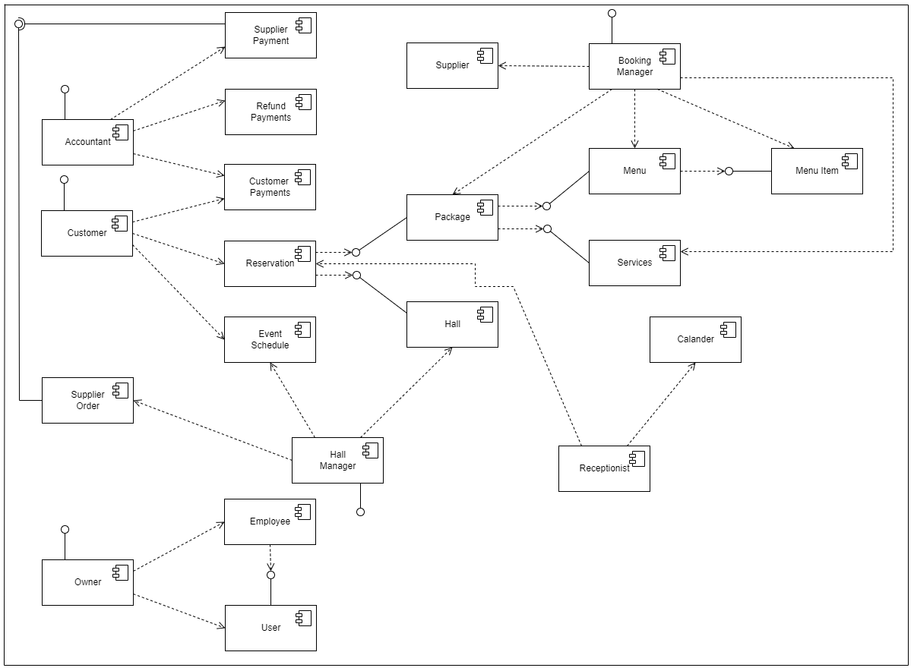

Figure 4. 1:Component Diagram for New Reservation Management System

## Important Code Segments

Important code segments will be included here.

* **Login of System Users**

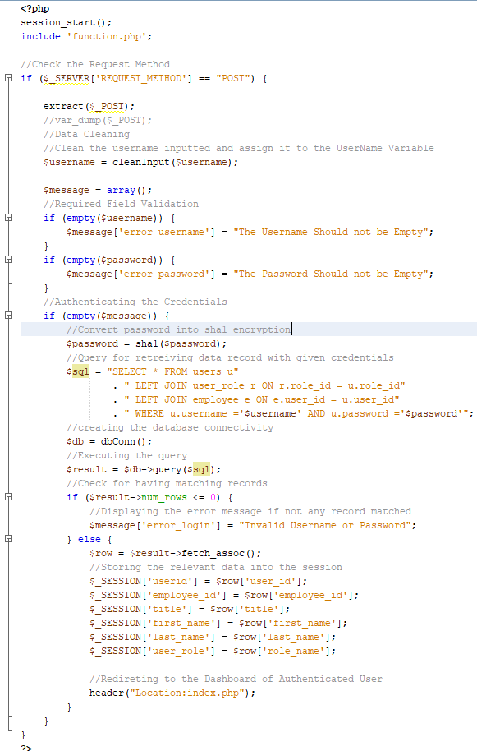

Figure 4. 2:Code of the Login Authentication in System

* 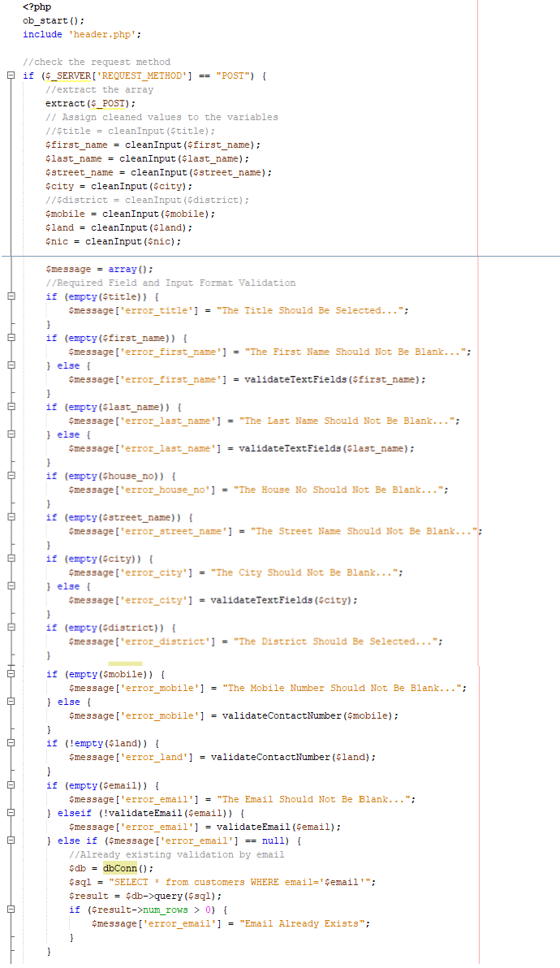**Customer Registration**

Figure 4. 3:Code of the Customer Registration in the System - part 1

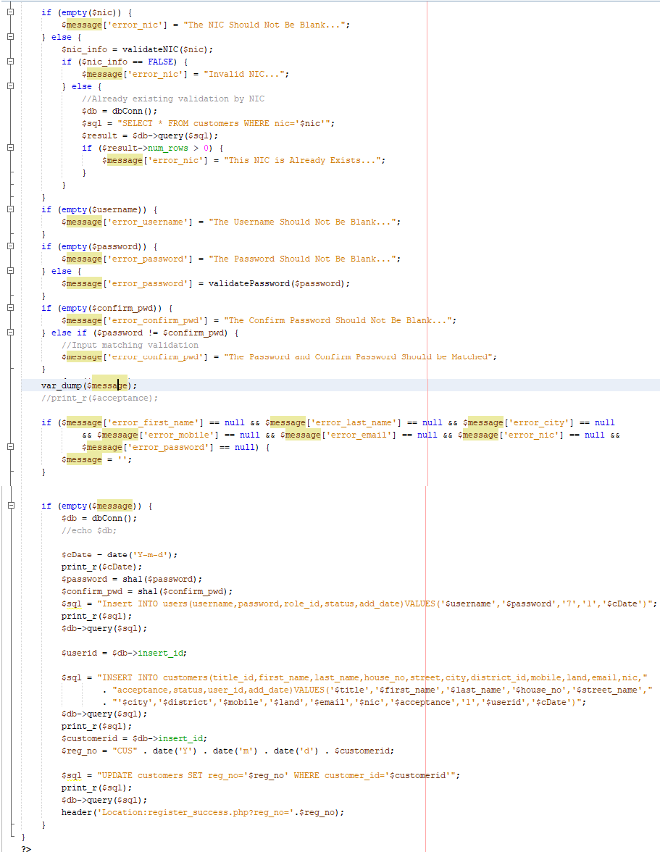

Figure 4. 4:Code of the Customer Registration in the System - part 2

* **Check Availability**

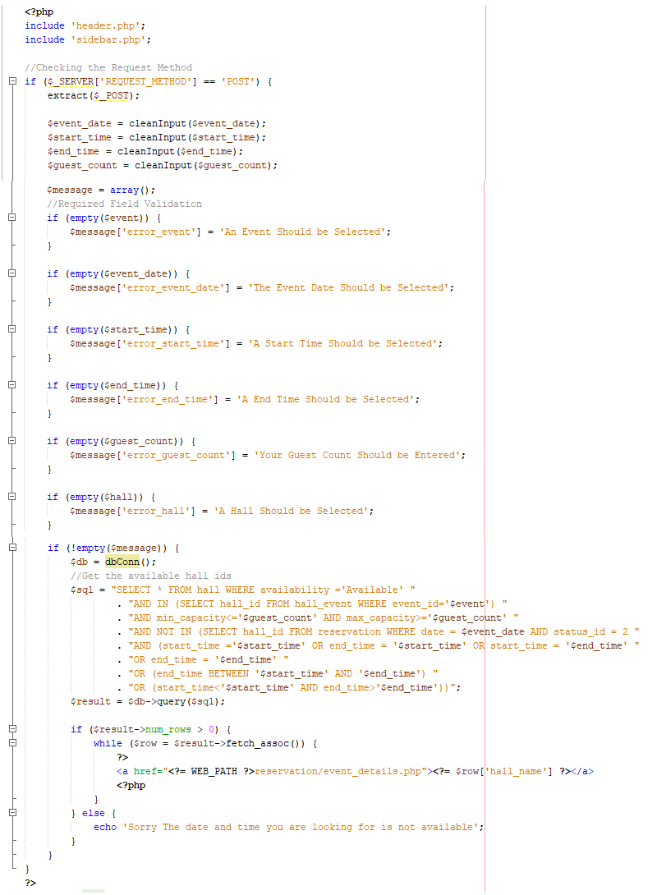

Figure 4. 5:Code of the Checking Availability of Hall

* 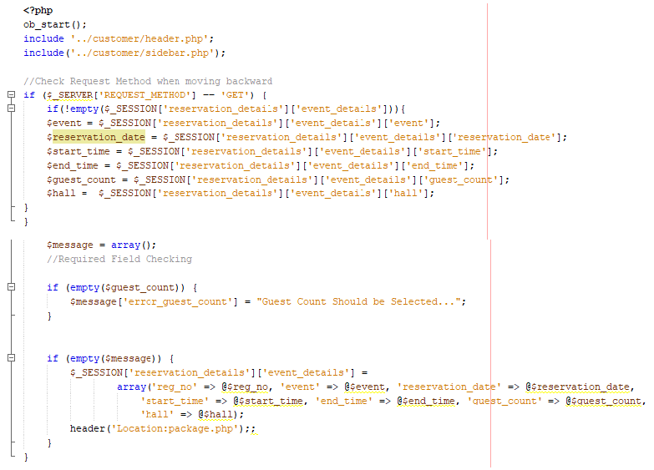**Reservation Placement**

Figure 4. 6:Capturing Event Details of a Reservation

Figure 4. 7:Capturing the Selection of Package for the Reservation

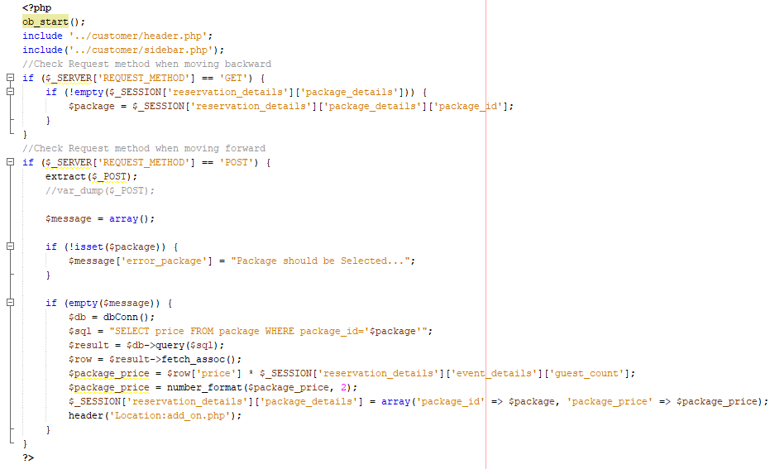

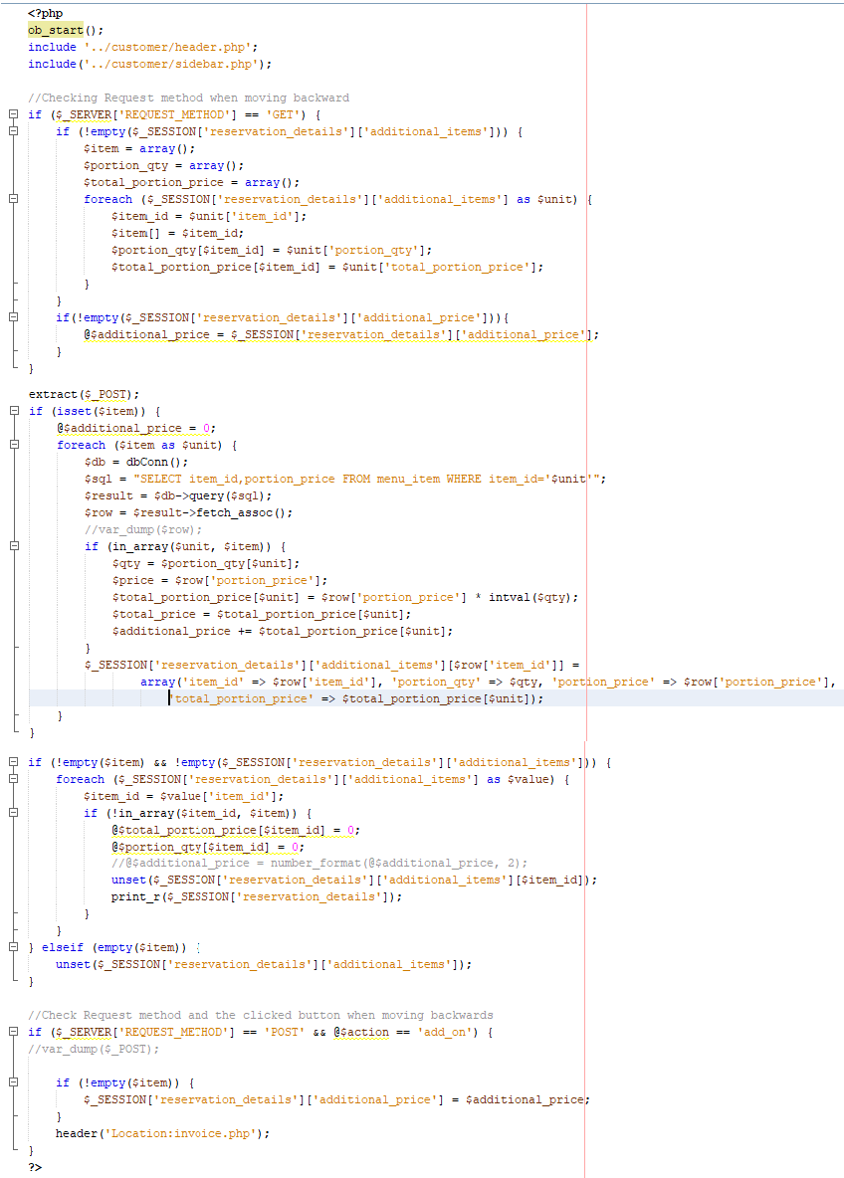

Figure 4. 8:Capturing Additional Item Requirements for the Reservation

## Reuse of the Existing Codes

Reusing the existing code is a fundamental practice of software development projects, allowing developers to take benefit from pre-existing solutions and components to accelerate the development process and enhance overall efficiency. Here are some examples of reusing existing codes within this project.

* Function for Clean Inputs

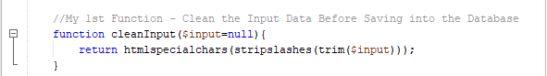This function is used to eliminate unnecessary spaces, and characters accidentally inserted into the database by the user. When processing the data after a user submits the form the first thing done is cleaning the input in every module. So instead of writing it every time “cleanInput(String)” function can be called by passing the input value as a string parameter

Figure 4. 9: Clean Input Function

* Function for Create Database Connectivity

This function is used to create the connection with the database. Every time we retrieve the data from the database, inserting, updating, and even dynamically loading the data to the interfaces we have to establish the database connection. So that this way it is easy to create the database connection by simply calling “dbConn ()”.

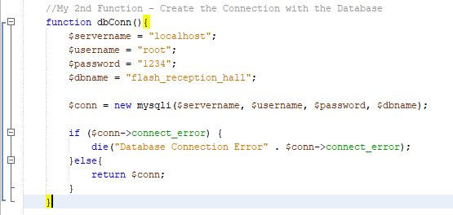

Figure 4. 10:dbConn Function

* Function for Upload Images

The system is required to provide the feature to upload images of employees, menu items, halls, and events. Instead of writing the following code each time, it is convenient to use it as a reusable function when there is an image upload. This could be amended and enhanced further to upload different types of files in addition to images also. As for now, this is enough to meet the requirements.

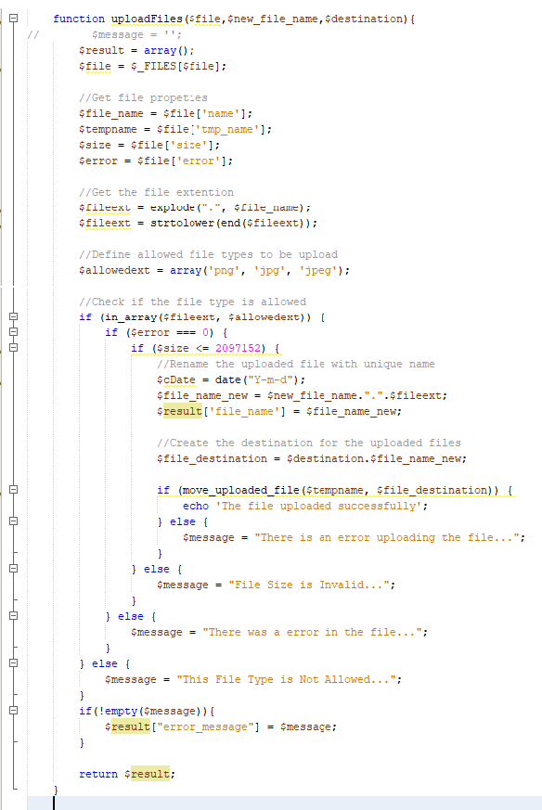

Figure 4. 11:Upload Files Function

* Function for Validate a Password

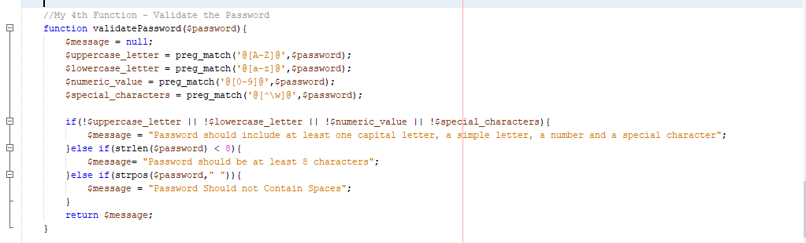This function is defined to verify that the password is strong enough to maintain the security of the data. When a customer registers to the system, when a user forgot their password and tries to reset it, and also when a user tries to change their password through their profiles this function should be called to measure the password strength.

Figure 4. 12:Validate Password Function

* Function for Validate a Text Input

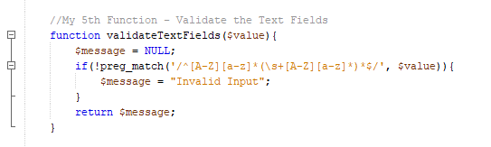This function will be used to verify that users will not be entering the numerical values or special characters which are required to insert only text values otherwise meaningless data would be inserted into the database by accident.

Figure 4. 13:Function for Text Field Validating

* Function for Validating a Contact Number

This function will be verifying that the contact numbers that the users are entering through the forms are in the same and correct format.

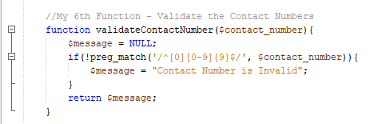

Figure 4. 14:Function for Contact Number Format Validation

* Function for Validate an Email

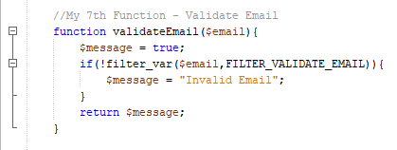This function will validate that an email that is entered by a user is in the correct format.

Figure 4. 15:Function for Validate the Format of an Email

* Function for Validate a NIC, Birthdate, and Gender

We can use this validation to verify the NIC is in the correct format and the meantime it could check the accuracy of the birthdate and the gender of a person while registering them.

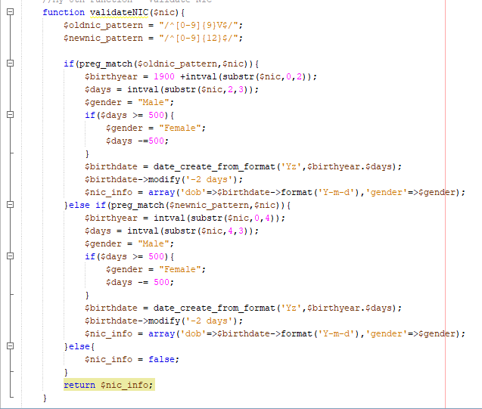

Figure 4. 16: Function for Validating NIC

* Function for Identifying the Updated Fields

This was defined mainly to generate the success message while updating existing data in the system. This will check what fields are updated in the process.

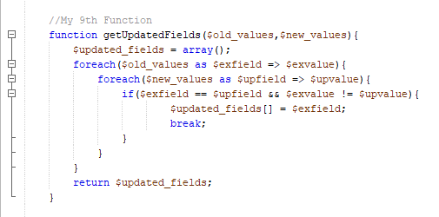

Figure 4. 17: Function for Get the Fields Updated by the User

* Function for Generate a Random Password

This function is defined to generate a random password by the system. It was suggested because each time when an employee gets registered in the system the user has to create a unique password otherwise.

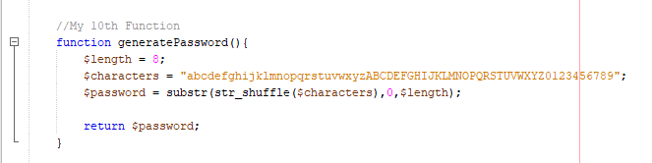

Figure 4. 18:Function for Generating a Random Password

## Implementation of the Design

According to the designs done in the previous chapter system was implemented. The process can be shown in the following examples.

* Login Form

For the view of the login previously designed the login form as a wireframe and after that in the implementation, it has implemented as much as similar to the design. And for the functionality database have created according to the ER diagram so that the user table contains the username and password of each user. When an authenticated user logged into the system, he can provide the correct username and password through the login page. After that, the inputs are matched with the credentials in the user table and if matched it will redirect the user to the relevant dashboard.

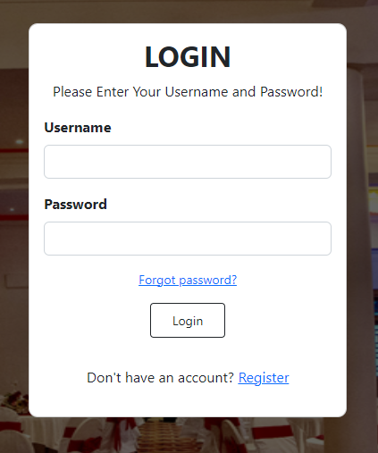

Figure 4. 19:Wireframe of the Login Form

Figure 4. 20:Implemented UI for the Login

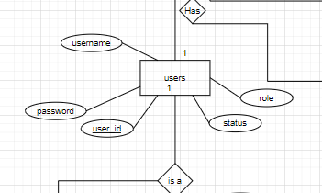

Figure 4. 21:users Entity in the ER Diagram

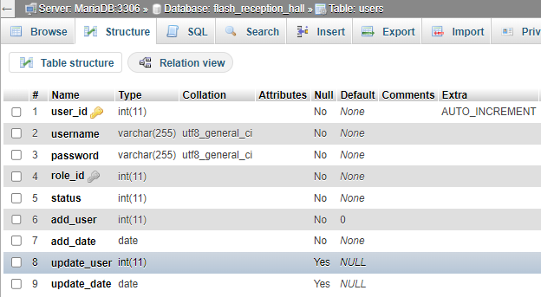

Figure 4. 22:Database table for the users

* Dashboard

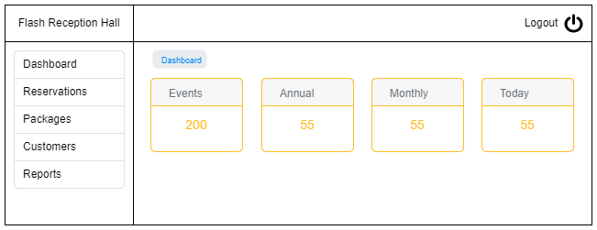The view of the dashboard was previously designed the dashboard as a wireframe and after that in the implementation, it has implemented as much as similar to the design. After the user successfully logged into the system, the customized dashboard will be loaded according to the user’s privileges.

Figure 4. 23:Wireframe for the Dashboard of Booking Manager

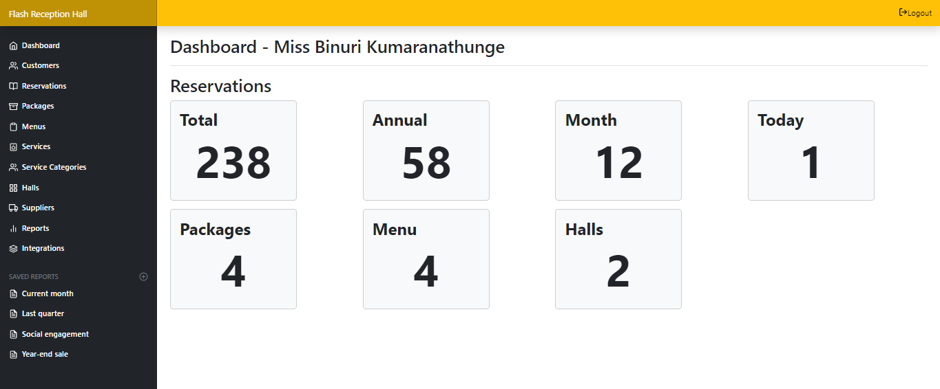

Figure 4. 24:Implemented Dashboard for the Booking Manager

* Add Menu Item

For the view of the Add menu item form previously designed the form as a wireframe and after that in the implementation, it has implemented as much as similar to the design. And for the functionality database have created according to the ER diagram so that the data will be added to the menu item table in the database. When an authenticated user logged into the system, he can insert data through the form. The items in the database will be shown in a table and there is an edit button to make any changes to the existing item.

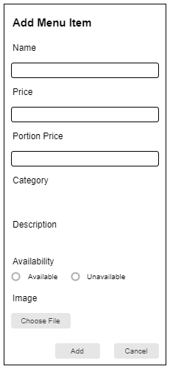

Figure 4. 25:Add Form of the Menu Items

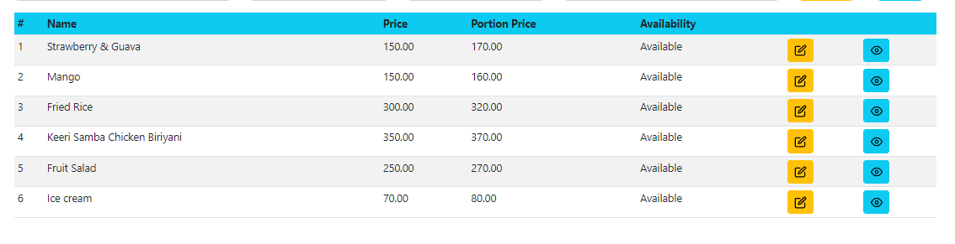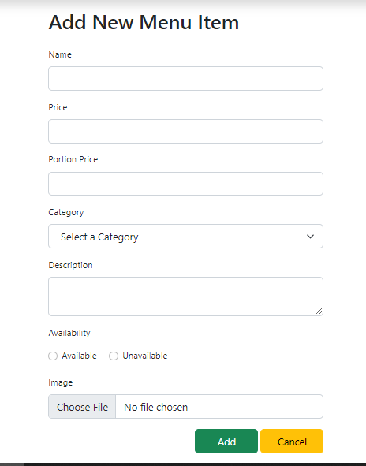

Figure 4. 26:Implemented UI for the Add Form of the Menu Items

Figure 4. 27:Implemented UI for the Menu Item View

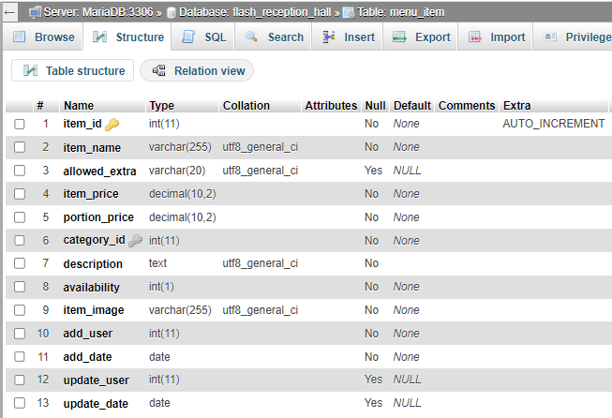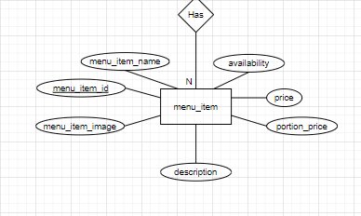

Figure 4. 28:Menu Item Table in the Database

Figure 4. 29:Menu Item Entity in the ER Diagram

## Use of Best Practices

Here are some of the coding best practices used in the implementation phase of the system.

* Maintain Proper Line Indentations

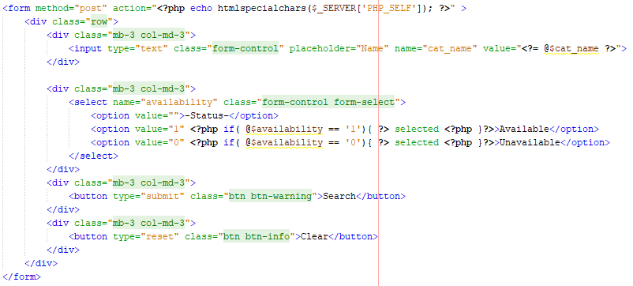Every line is properly indented in the following code. It can be done while typing the codes and also the IDE provides the facility of format to do it automatically.

Figure 4. 30:Line Indentations in Code

* Using Consistent and Meaningful Naming Conventions

Descriptive and meaningful names for variables and functions were used to enhance the code readability. The following example will prove that it has been followed throughout the coding process.

Figure 4. 31:Meaningful Naming Convention Practice Used in a Function

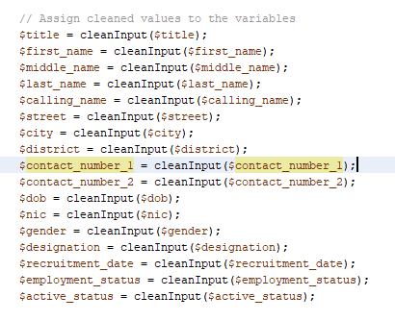

Figure 4. 32: Meaningful Naming Convention Used in Variable Definition

* Commenting

It has added clear and concise comments to explain the purpose and functionality of the code when necessary.

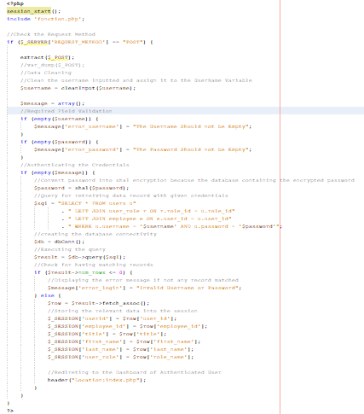

Figure 4. 33:Commenting Used in the Code of Login Page

# Chapter 05 – Evaluation

The process of evaluation includes the testing of the developed system to assess its compliance with customer requirements and ensure its error-free operation. Testing is conducted using various test cases specifically designed for different scenarios. It is essential to ensure that the entire software is covered during testing and that all aspects have been thoroughly examined.

## 5.1. Testing approaches

The web-based hotel reservation system has been tested according to four test levels, namely unit testing, integration testing, system testing, and acceptance testing. A brief description of all four levels is provided below.

1. **Unit Testing** – Individual units/components of the system are tested.
2. **Integration Testing** – Individual units are combined, and testing is performed on a group of components that interact together.
3. **System Testing** – The entire system is tested as a whole.
4. **Acceptance Testing** – The system is tested by system users to confirm its acceptability.

## 5.2. Test Plan

A test plan involves the definition of a set of conditions or variables, which are subsequently utilized by a tester to assess whether the requirements of a system under test are met or if it functions properly. By developing test cases, issues in the requirements or design of an application can also be identified. Through this comprehensive approach, the system undergoes thorough evaluation, potential problems are discovered, and necessary improvements are implemented to enhance its functionality and ensure adherence to the specified requirements.

**User Login**

|  |  |  |  |
| --- | --- | --- | --- |
| **Test No** | **Test Description** | **Expected Result** | **Status** |
| 1 | Submit login form with empty fields | An error message will appear by displaying the error | Done |
| 2 | Enter an invalid username or password | An error message will appear by displaying the error | Done |
| 3 | Enter a valid username and password | Users can Log into the system | Done |
| 4 | Log in to the system with a valid username | Display logged username on the top status bar | Done |
| 5 | Click on “Logout” in the header section. | Redirect to the login page | Done |

Table 5. 1:Test Plan for Login

**Register as Customer**

|  |  |  |  |
| --- | --- | --- | --- |
| **Test No** | **Test Description** | **Expected Result** | **Status** |
| 1 | Submit the form with empty fields. | An error message will display in every empty field. | Done |
| 2 | Enter an invalid Contact No | An error message will display entered invalid field. | Done |
| 3 | Enter an invalid NIC | An error message will display entered invalid field. | Done |
| 4 | Enter an invalid email | An error message will display entered invalid field. | Done |
| 5 | Enter an invalid Password | An error message will display entered invalid field. | Done |
| 6 | Enter the valid NIC | An error message will display entered fields already exist. | Done |
| 7 | Enter the valid email | An error message will display entered fields already exist. | Done |
| 8 | Enter the valid Username and Password | An error message will display entered fields already exist. | Done |
| 9 | Enter the Confirm Password. | An error message will display Confirm Password is not matching Password | Done |
| 10 | Click on the “Register” button. | Display success message. | Done |

Table 5. 2:Test Plan for Register Customer Form

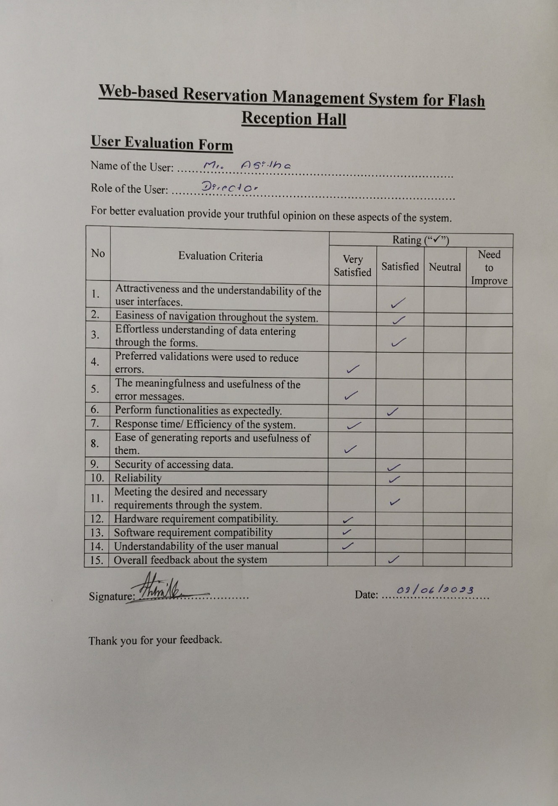

Figure 5. 1:User Evaluation Form - Director

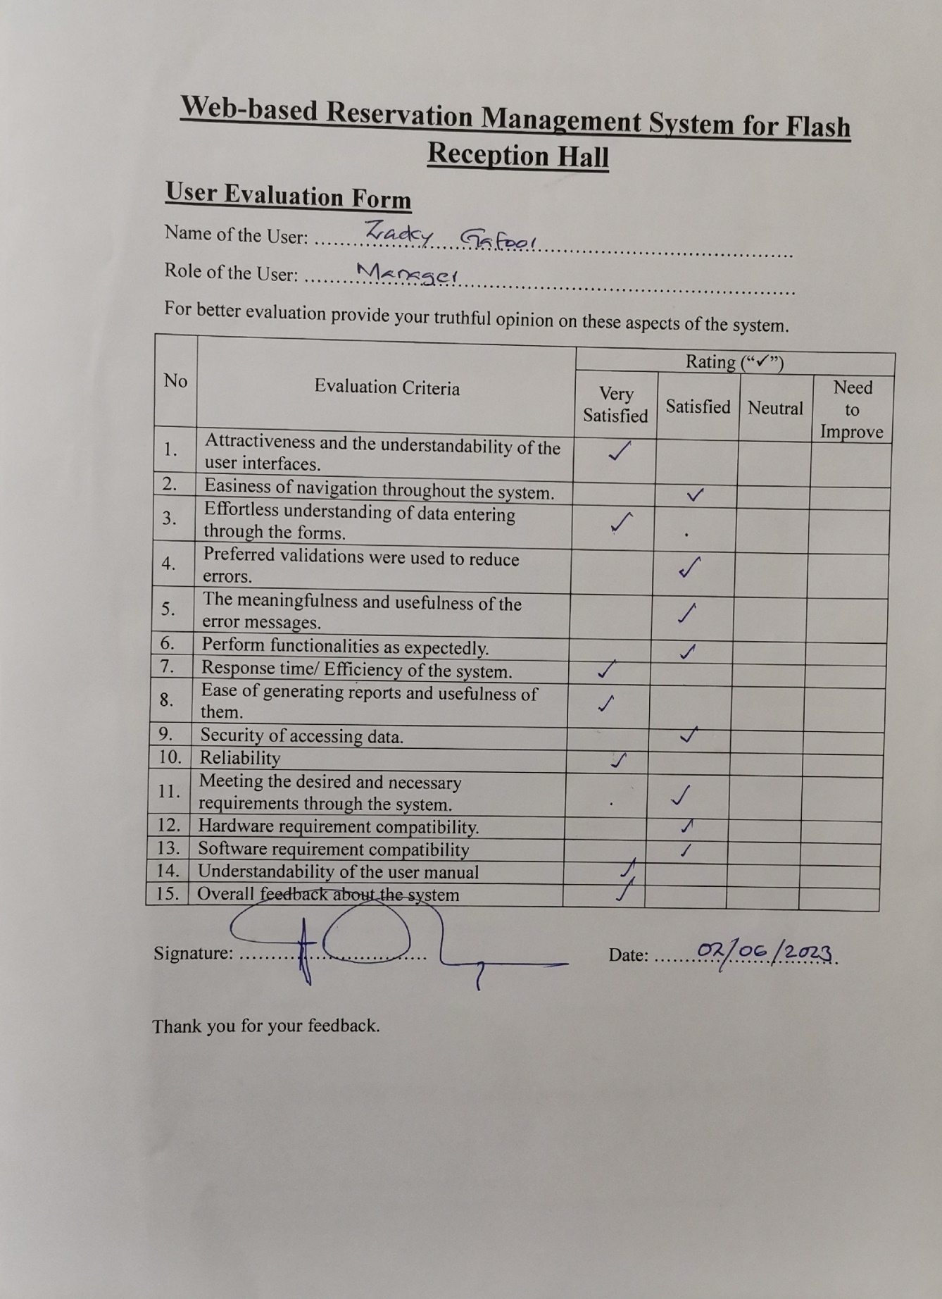

Figure 5. 2:User Evaluation Form - Booking Manager

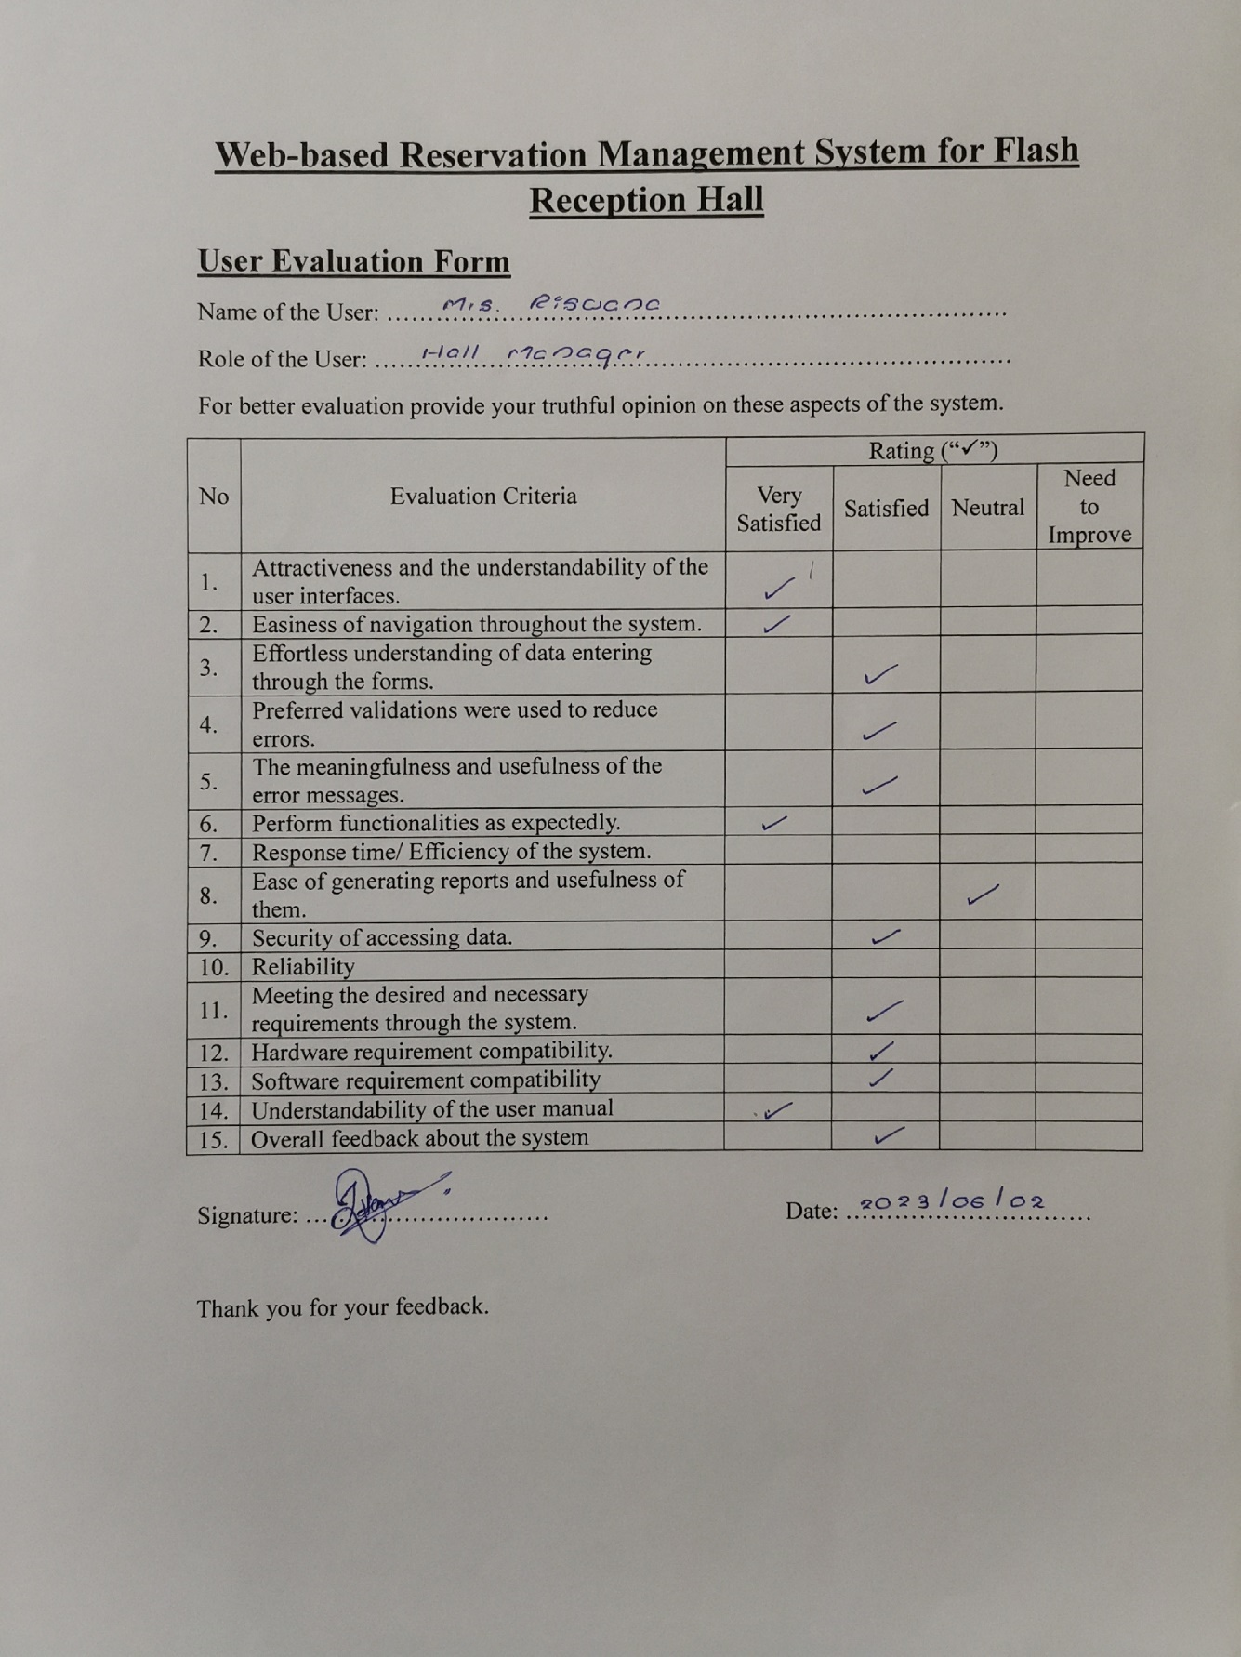

Figure 5. 3:User Evaluation Form - Hall Manager

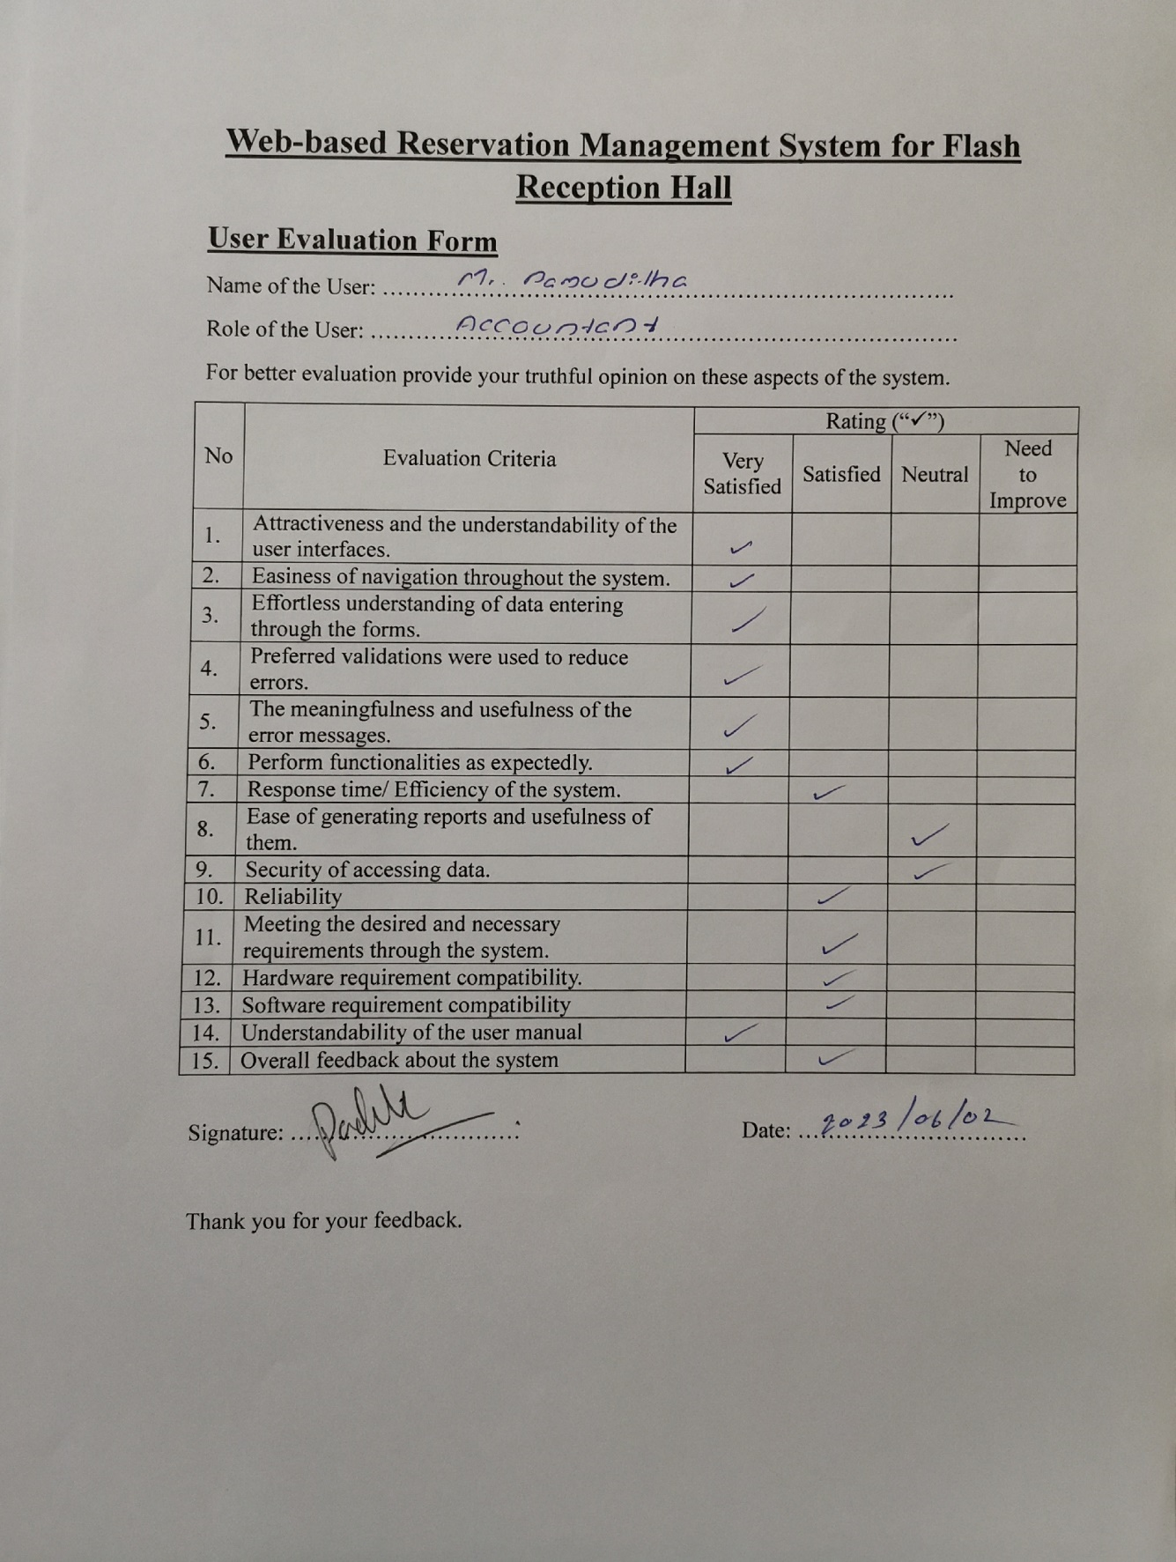

Figure 5. 4:User Evaluation Form - Accountant

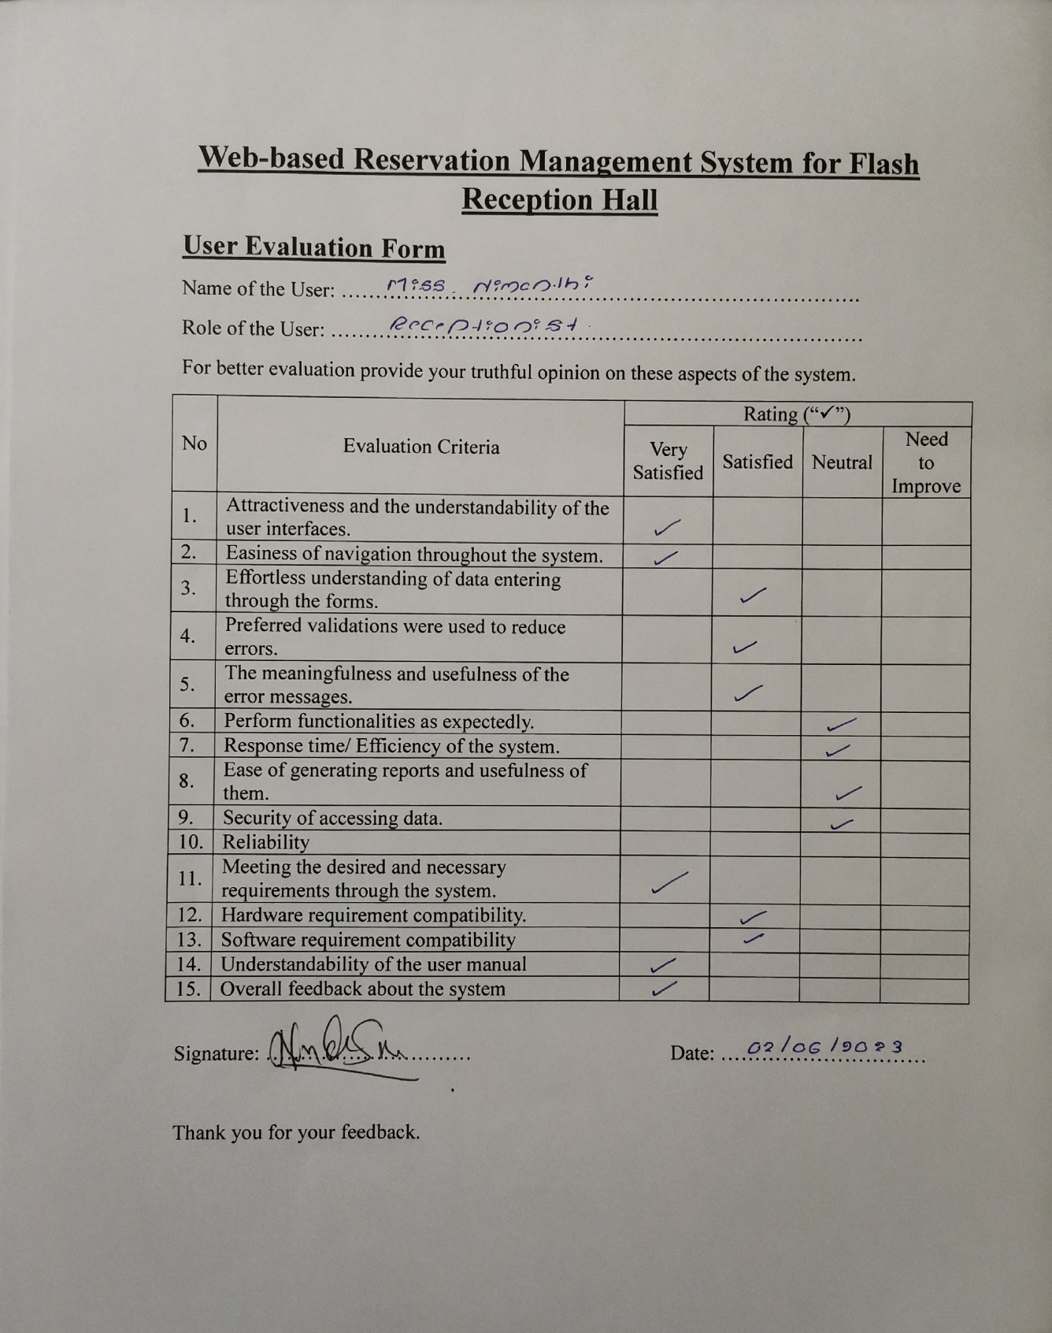

Figure 5. 5:User Evaluation Form - Receptionist

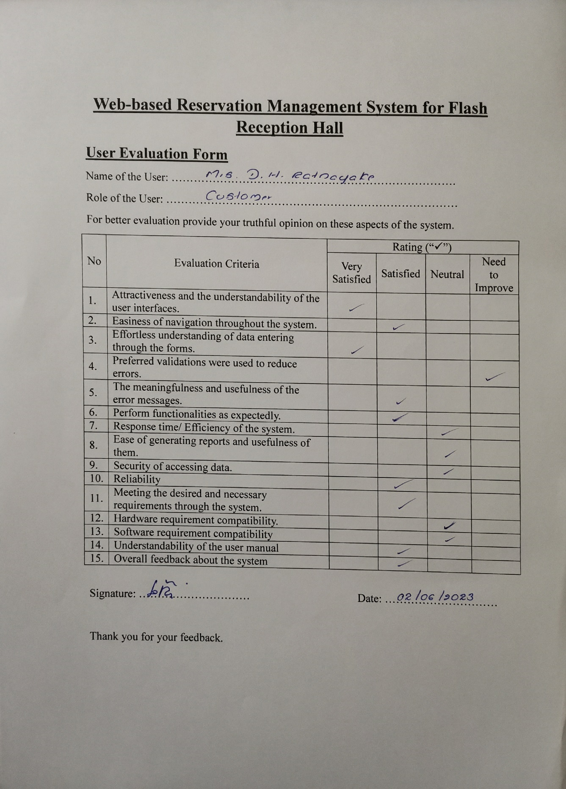

Figure 5. 6:User Evaluation Form - Customer 1

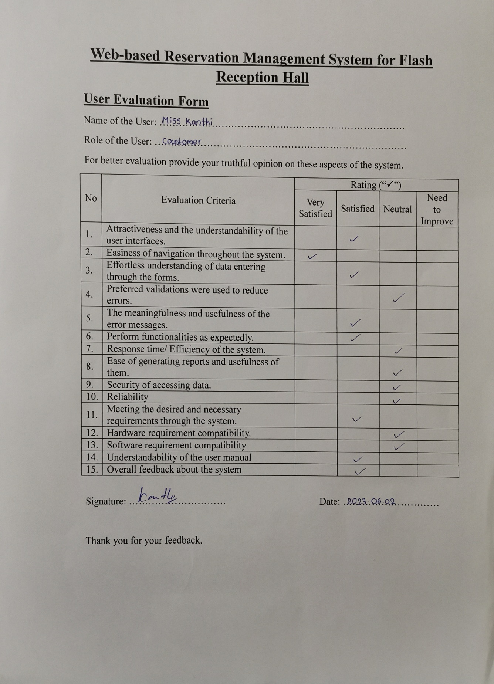

Figure 5. 7:User Evaluation Form - Customer 2

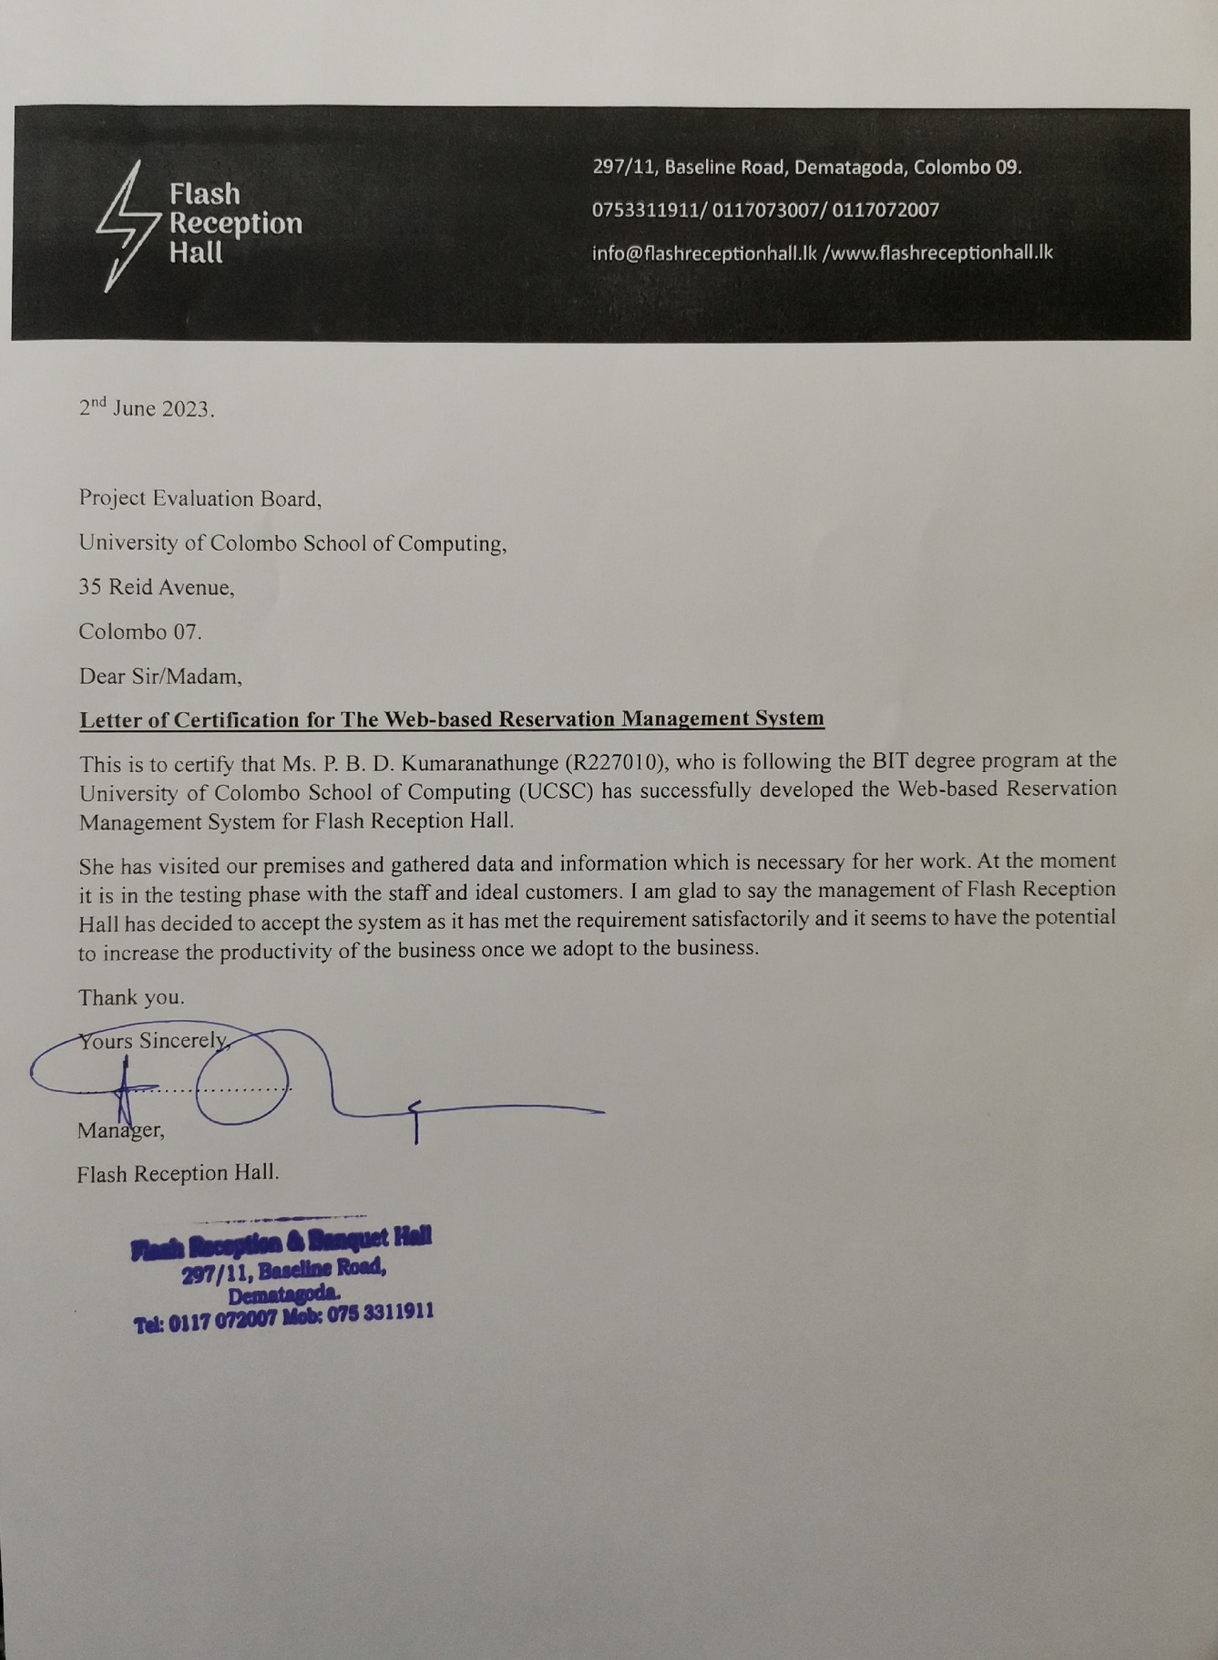

Figure 5. 8:Client Certificate

# Chapter 6 - Conclusion

The significance of system review lies in its ability to aid in the identification of both system issues and successful components. Additionally, future developments with improved knowledge are made possible through a systematic review. This chapter focuses on the discussion of the critical evaluation of the system and the lessons learned throughout the overall project development.

## Critical evaluation of the system

The web-based Hotel Reservation system implemented for Flash Reception Hall has effectively met the majority of the staff's requirements. They have found the system's features to be highly user-friendly, with a particular appreciation for the ease of use and the ability to present and summarize information effectively. However, there have been some instances where certain components of the system, which relied on completing previous activities, introduced complexities in handling. Despite these challenges, when evaluating the system as a whole, it can be concluded that it has successfully satisfied most of the features expected by the staff. The overall performance of the web-based Hotel Reservation system has been deemed satisfactory and in line with the client’s requirements.

## 6.2 Future Work

By continually improving and updating its features, any development project can be made more valuable. After being discussed with the client, several aspects have been identified for future enhancements. One key improvement is the addition of online payment functionality. Currently, payment receipts are accepted through uploads, but there is no provision for making online payments. To address this, a decision has been made to incorporate an online payment facility using a payment gateway. This enhancement will be particularly beneficial for online learning students as they will be provided with a convenient and secure way to make payments.

Another enhancement that has been decided upon is the inclusion of SMS reminders. Currently, reminders and notifications are sent via email. However, as part of future expansion, an SMS gateway will be integrated into the system. Convenience will be greatly enhanced, especially for parents and students attending classroom lectures, as they will receive reminders and notifications through SMS. This will enable them to stay updated on important information more conveniently and promptly. These planned enhancements for the future will further improve the functionality and user experience of the system, making it more efficient and accommodating to the needs of both online and offline learners

## 6.3. Lessons learned

The knowledge and experience gained throughout the project were precious. An opportunity was given to me to practically apply the knowledge learned throughout the past years in the BIT degree program, providing me with a better understanding of the software development life cycle. Additionally, in terms of soft skills, my communication skills were improved through the multiple meetings conducted to gather and refine the requirements. Furthermore, my reporting and areas of managerial skills were also able to be improved. Moreover, the development side of things was also ventured into. The development of the proposed system allowed me the chance to learn about development techniques that were not previously proficient in.

# Appendices

## Appendix A - System Manual

Detailed installation instructions are provided by the system manual, which is a technical document for anyone interested in trying out the web-based hotel reservation system or wishing to extend its code. Comprehensive details on how to install the system step by step will be offered in this manual. To successfully install the software, certain requirements must be met.

**Hardware requirements**

|  |  |
| --- | --- |
| **Hardware** | **Minimum requirements** |
| Processor | Intel® Core ™ i3 |
| Memory | 2GB or above |
| Hard Disk | 250GB or above |
| Display | 1024*768 resolution monitor |
| Internet | ADSL connection (Minimum speed 512kbps) |

Table A. 1:Hardware Requirements

**Software requirements**

|  |  |
| --- | --- |
| **Hardware** | **Minimum requirements** |
| Operating System | Microsoft Windows 7 or Above Operating System |
| Web Server | WAMP v3.2.0 or above |
| Web Browser | Google Chrome / Firefox |
| Code Editor | Apache NetBeans IDE 8.0.2 |

Table A. 2:Software Requirements

**Step 1: Installing web browser**

Download and install the one of above-recommended web browsers from

www.google.com or www.mozilla.com.

**Step 2: Installing a web server**

Download and install the WAMP Windows version from www.apachefriends.org. Give the installation path to C:\ of the computer. Please refer to the installation guide provided on the above website before installing WAMP on your computer.

**Step 3: File extraction**

Open the CD and copy the flash_reception_hall folder and paste it to the directory path “C:\wamp\www”.

**Step 4: Database installation**

* Open the web browser and type URL “http://localhost/phpmyadmin” (and enter username and password if you set username and password).
* Create an empty database by providing name as”flash_recption_hall” and navigate to the “import” tab and click “choose file” button. Then browse the CD and select the “flash_reception_hall.sql” file by opening Database folder.
* Then press “Go” button located in the bottom of the page.

**Step 5: Launching System**

* Go to the “C:\wamp\” and open the control panel to click start buttons of Apache and MySQL to start.
* To view system - Open the web browser and type URL “http://localhost/flash_reception_hall/system” and press enter.

## Appendix B - User Manual

This document provides the user manual for the developed system.

**System Login**

****Open the web browser that configured in the installation. Type the URL http://localhost/flash_reception_hall/system/ and navigate. After navigation user can visit the login page which is shown in figure B.1. User can login into the system by entering username and password. If you provide wrong user name or a password you will not able to login.

Figure B. 1:Login Form

**Dashboard**

****When user log to the system as a booking manager, Dashboard and Sidebar shows login user account name and navigation links. Following figure B.2 shows the landing page for the booking manager.

Figure B. 2:Landing Page of the Booking Manager

**Package View Page**

When booking manager navigates to the package page the page would be loaded as following figure B.3. In the table there is an edit button it can navigate user to the update form.

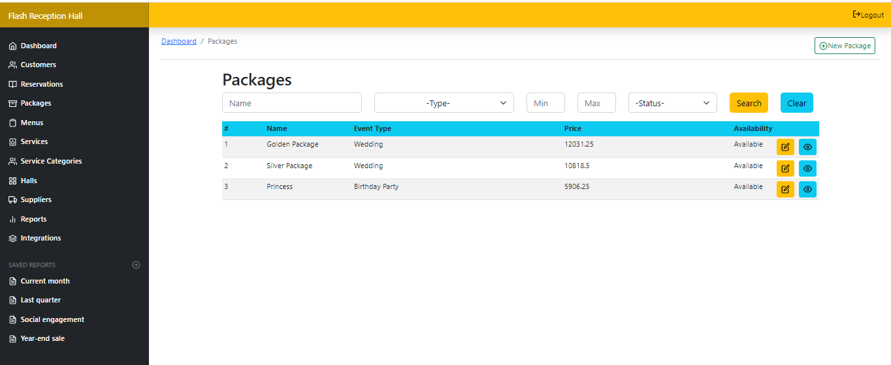

Figure B. 3:Package View Page

**Create New Package Page**

When booking manager clicks on the new package button the view page it will navigate the user to the create package form as following figure B.4.

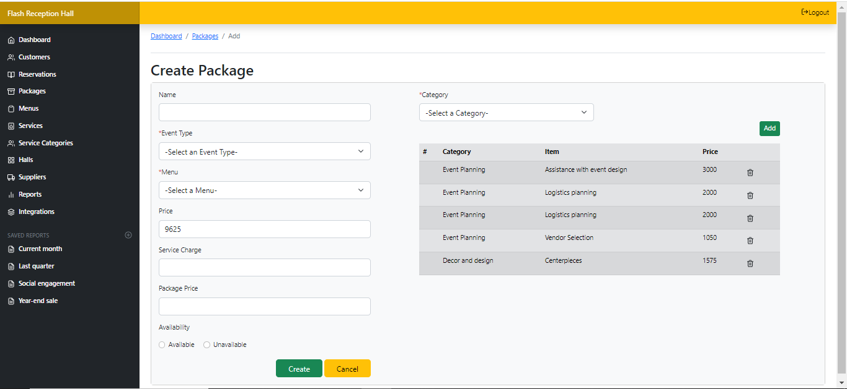

Figure B. 4:Create New Package Page

**Update Existing Package Page**

When booking manager clicks on the edit button view page it will navigate the user to the update package form as following figure B.4.

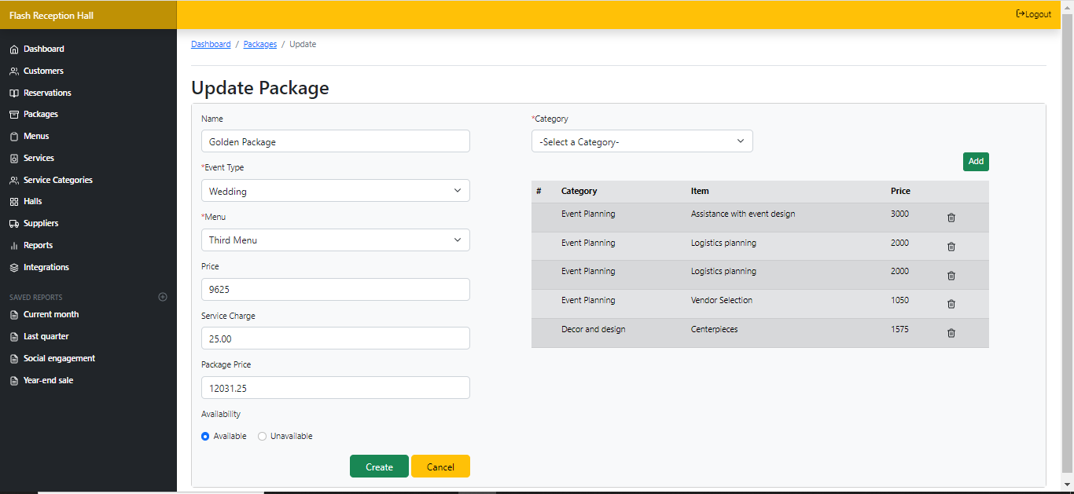

Figure B. 5:Update Package Page

## Appendix C - Management Reports

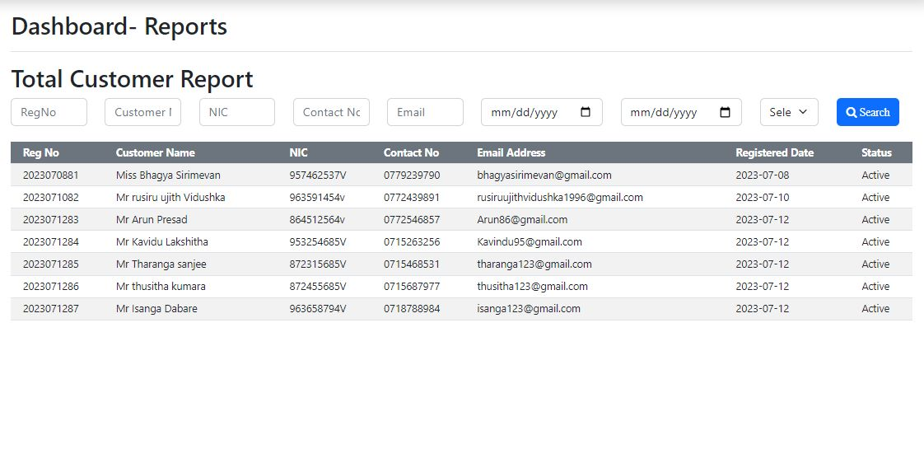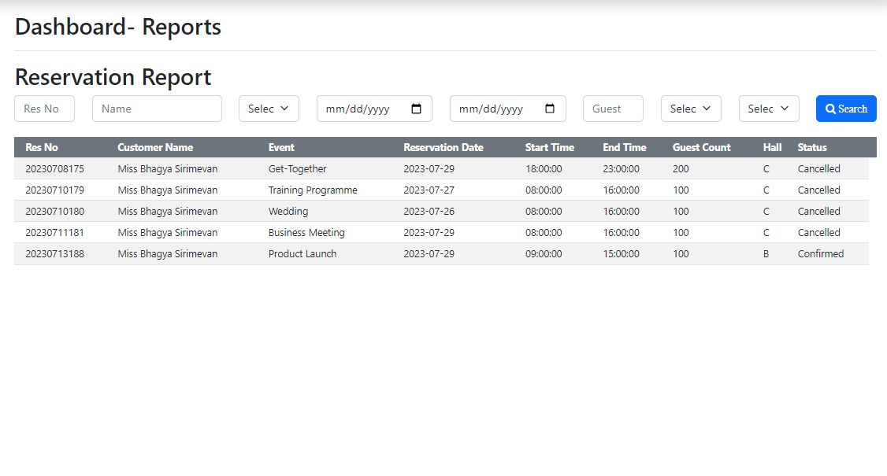

Figure C. 1:Total Registered Customer Report

Figure C. 2: Canceled Reservations Report

Figure C. 3: Total Income Report of Flash Reception Hall

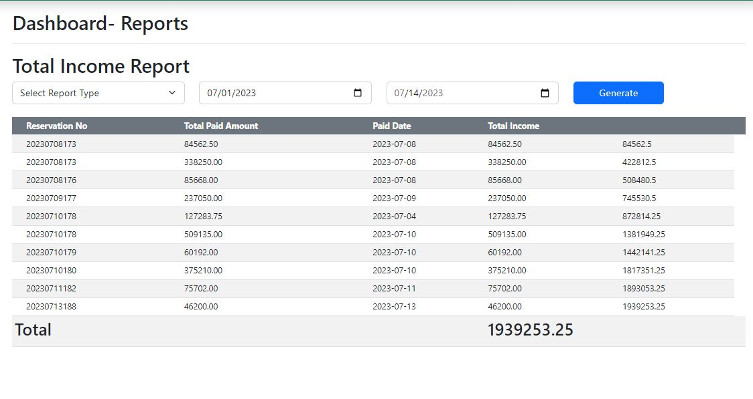

# Appendix D – Test Result

Login

|  |  |  |  |
| --- | --- | --- | --- |
| Test No | Test Description | Expected Result | Actual Result |
| 1 | Submit login form with empty fields | An error message will appear by displaying the error |  |
| 2 | Enter an invalid username or password | An error message will appear by displaying the error |  |
| 3 | Enter a valid username and password | Users can Log into the system |  |
| 4 | Log in to the system with a valid username | Display logged username on the top of the dashboard |  |
| 5 | Click on “Logout” in the header section. | Redirect to the login page |  |

Table D. 1:Test result for Login

Register as Customer

|  |  |  |  |
| --- | --- | --- | --- |
| Test No | Test Description | Expected Result | Actual Result |
| 1 | Submit the form with empty fields. | An error message will display in every empty field. |  |
| 2 | Enter an invalid Contact No | An error message will display entered invalid field. |  |
| 3 | Enter an invalid NIC | An error message will display entered invalid field. |  |
| 4 | Enter an invalid Password | An error message will display entered invalid field. |  |
| 5 | Enter the valid NIC but already registered NIC | An error message will display entered fields already exist |  |
| 6 | Enter the valid email but already registered email | An error message will display entered fields already exist. |  |
| 8 | Enter the Confirm Password. | An error message will display Confirm Password is not matching Password |  |
| 9 | Click on the “Register” button | Display success message. |  |

Table D. 2:Test Results for Register Customer Form

# References

|  |  |
| --- | --- |
| [1] | "Sanora Restaurant and Pub," 2022. [Online]. Available: http://www.sanora.lk/. [Accessed 12 January 2023]. |
| [2] | "Online Hotel Reservation and Booking Management System," Side Projectors, 07 August 2015. [Online]. Available: https://www.sideprojectors.com/project/2962/online-hotel-reservation-and-booking-management-system. [Accessed 29 January 2023]. |
| [3] | J. Hotels, "Jetwing Hotels," Antyra Solutions, [Online]. Available: https://www.jetwinghotels.com/. [Accessed 11 December 2022]. |
| [4] | "Geeksforgeeks," [Online]. Available: https://www.geeksforgeeks.org/software-engineering-iterative-waterfall-model/. [Accessed 25 January 2023]. |
| [5] | "TutorialsPoint," [Online]. Available: https://www.tutorialspoint.com/software_architecture_design/quick_guide.htm. [Accessed 30 January 2023]. |